**Software Quality Engineering**

**Assignment – 2: EclEmma JUnit Testing**

**Course Instructor**

Madam Uzma Mahar

**Submitted by**

Abdullah Daoud……………………………………………………….(22I-2626)

**Section**

SE-E

**Date**

**Monday, October 7, 2024**

**Fall 2024**



**Department of Software Engineering**

FAST – National University of Computer & Emerging Sciences

Islamabad Campus

Table of Contents

1. Table 1

2. Explanation 10

(i). Coverage Achieved 10

(ii). Coverage Gaps 10

(iii). Improvements 11

3. Reports 12

(i). Junit Test Report 12

(a). EmployeeManagementTest.java 12

(b). EmployeeTest.java 15

(c). InventoryTest.java 15

(d). ItemTest.java 17

(e). ManagementTest.java 18

(f). POHTest.java 19

(g). PointOfSaleTest.java 23

(h). PORTest.java 26

(i). POSSystemTest.java 29

(j). POSTest.java 36

(k). ReturnItemTest.java 38

(ii). Coverage Report 38

# 1. Table

|  |  |  |  |  |  |  |  |  |
| --- | --- | --- | --- | --- | --- | --- | --- | --- |
| **Test ID** | **Testcase Name** | **Testcase Description** | **Class** | **Tested Function** | **Test Inputs** | **Expected Output** | **Actual Output** | **Pass/Fail Status** |

|  |  |  |  |  |  |  |  |  |
| --- | --- | --- | --- | --- | --- | --- | --- | --- |
| 1 | testGetEmployeeList | Test if employee list is correctly loaded | EmployeeManagement | getEmployeeList | None | 12 employees loaded | 12 employees loaded | Pass |
| 2 | testAddEmployeeAsCashier | Test adding a new employee as a Cashier | EmployeeManagement | add | "Alice Cooper | newpassword | true" | Pass |
| 3 | testAddEmployeeAsAdmin | Test adding a new employee as an Admin | EmployeeManagement | add | "Bruce Wayne | batman | false" | Pass |

|  |  |  |  |  |  |  |  |  |  |  |  |  |
| --- | --- | --- | --- | --- | --- | --- | --- | --- | --- | --- | --- | --- |
| 4 | testDeleteEmployeeFound | Test deleting an employee who exists | | EmployeeManagement | | delete | | "110001" | | Employee deleted successfully | Employee deleted successfully | Pass |
| 5 | testDeleteEmployeeNotFound | Test deleting an employee who doesn't exist | | EmployeeManagement | | delete | | "999999" | | Employee not found | Employee not found | Pass |
| 6 | testUpdateEmployeeFoundValidPosition | Test updating an employee with a valid position | | EmployeeManagement | | update | | "110002 newPass Admin Debra Updated" | | Employee updated successfully | Employee updated successfully | Pass |
| 7 | testUpdateEmployeeNotFound | Test updating an employee who doesn't exist | | EmployeeManagement | | update | | "999999 newPass Cashier Nonexistent" | | Employee not found | Employee not found | Pass |
| 8 | testUpdateInvalidPosition | Test updating an employee with an invalid position | | EmployeeManagement | | update | | "110002 newPass InvalidPosition Debra Updated" | | Invalid position | Invalid position | Pass |
| 9 | testUpdateWithEmptyFields | Test updating an employee with some empty fields | | EmployeeManagement | | update | | "110003 Clayton Updated" | | Employee updated successfully | Employee updated successfully | Pass |
| 10 | testReadFile | Test the readFile method to ensure employees are loaded correctly | | EmployeeManagement | | readFile | | None | | 12 employees loaded | 12 employees loaded | Pass |
| 11 | testAddEmployeeWithNoExistingEmployees | Test adding an employee when the list is empty | | EmployeeManagement | | add | | "Alice Cooper newpassword true" | | Employee added successfully | Employee added successfully | Pass |
| 12 | testDeleteEmployeeWhenListIsEmpty | Test deleting an employee when the list is empty | | EmployeeManagement | | delete | | "110001" | | Employee not found | Employee not found | Pass |
| 13 | testDeleteEmployeeNotFoundWithValidList | Test deleting an employee who | | EmployeeManagement | | delete | | "999999" | | Employee not found | Employee not found | Pass |
| 14 | testUpdateEmployeeFoundWithInvalidPassword | Test updating an employee with an invalid password | | EmployeeManagement | | update | | "110002 Cashier Debra Updated" | | Employee updated successfully | Employee updated successfully | Pass |
| 15 | testUpdateEmployeeFoundWithEmptyPosition | Test updating an employee with an empty position | | EmployeeManagement | | update | | "110002 newPass Debra Updated" | | Employee updated successfully | Employee updated successfully | Pass |
| 16 | testReadFileWhenFileDoesNotExist | Test the readFile method when the file does not exist | | EmployeeManagement | | readFile | | None | | Employee list remains empty | Employee list remains empty | Pass |
| 17 | testReadFileWithMalformedData | Test the readFile method with malformed data | | EmployeeManagement | | readFile | | None | | Employee list remains empty | Employee list remains empty | Pass |
| 18 | testAddIOException | Test adding an employee with IOException scenario | | EmployeeManagement | | add | | "John Doe password true" | | IOException handled gracefully | IOException not covered | Fail |
| 19 | testDeleteFileNotFoundException | Test deleting an employee with FileNotFoundException | | EmployeeManagement | | delete | | "12345" | | FileNotFoundException handled gracefully | FileNotFoundException not covered | Fail |
| 20 | testDeleteIOException | Test deleting an employee with IOException | | EmployeeManagement | | delete | | "1" | | IOException handled gracefully | IOException not covered | Fail |
| 21 | testUpdateFileNotFoundException | Test updating an employee with FileNotFoundException | | EmployeeManagement | | update | | "1 newPassword Cashier New Name" | | FileNotFoundException handled gracefully | FileNotFoundException not covered | Fail |
| 22 | testUpdateIOException | Test updating an employee with IOException | | EmployeeManagement | | update | | "1 newPassword Cashier New Name" | | IOException handled gracefully | IOException not covered | Fail |
| 23 | testReadFileFileNotFoundException | Test reading a file that doesn't exist | | EmployeeManagement | | readFile | | None | | FileNotFoundException handled gracefully | FileNotFoundException not covered | Fail |
| 24 | testReadFileIOException | Test reading a file with IOException | | EmployeeManagement | | readFile | | None | | IOException handled gracefully | IOException not covered | Fail |
| 25 | testAddFileNotFoundException | Test adding an employee with FileNotFoundException | | EmployeeManagement | | add | | "John Doe password true" | | FileNotFoundException handled gracefully | FileNotFoundException not covered | Fail |
| 26 | testAddIOException1 | Test adding an employee with IOException (read-only file) | | EmployeeManagement | | add | | "Jane Doe password true" | | IOException handled gracefully | IOException not covered | Fail |
| 27 | testDeleteFileNotFoundException1 | Test deleting an employee with FileNotFoundException (non-existent temp file) | | EmployeeManagement | | delete | | "110001" | | FileNotFoundException handled gracefully | FileNotFoundException not covered | Fail |
| 28 | testDeleteIOException1 | Test deleting an employee with IOException (read-only file) | | EmployeeManagement | | delete | | "110001" | | IOException handled gracefully | IOException not covered | Fail |
| 29 | testUpdateFileNotFoundException1 | Test updating an employee with FileNotFoundException (non-existent file) | | EmployeeManagement | | update | | "110001 newPass Cashier John Doe" | | FileNotFoundException handled gracefully | FileNotFoundException not covered | Fail |
| 30 | testUpdateIOException1 | Test updating an employee with IOException (read-only file) | | EmployeeManagement | | update | | "110001 newPass Cashier John Doe" | | IOException handled gracefully | IOException not covered | Fail |
| 31 | testConstructor | Test Employee constructor and ensure the object is created and values are initialized correctly | | Employee | | Employee constructor | | user123 John Doe Manager password123 | | Object is not null and correct values returned | Values match the expected output | Pass |
| 32 | testGetUsername | Test getUsername method of Employee class | | Employee | | getUsername | | user123 | | user123 | user123 | Pass |
| 33 | testGetName | Test getName method of Employee class | | Employee | | getName | | John Doe | | John Doe | John Doe | Pass |
| 34 | testGetPosition | Test getPosition method of Employee class | | Employee | | getPosition | | Manager | | Manager | Manager | Pass |
| 35 | testGetPassword | Test getPassword method of Employee class | | Employee | | getPassword | | password123 | | password123 | password123 | Pass |
| 36 | testSetName | Test setName method by updating Employee name | | Employee | | setName | | Jane Doe | | Jane Doe | Jane Doe | Pass |
| 37 | testSetPosition | Test setPosition method by updating Employee position | | Employee | | setPosition | | Cashier | | Cashier | Cashier | Pass |
| 38 | testSetPassword | Test setPassword method by updating Employee password | | Employee | | setPassword | | newpassword456 | | newpassword456 | newpassword456 | Pass |
| 39 | testSingletonInstance | | Test if the singleton pattern is implemented correctly | | InventoryTest | | testSingletonInstance | | n/a | n/a | n/a | Pass |
| 40 | testAccessInventorySuccess | | Test successful access to inventory | | InventoryTest | | accessInventory | | mockDatabase.txt databaseItem | true | true | Pass |
| 41 | testAccessInventoryFileNotFound | | Test accessing inventory when the file does not exist | | InventoryTest | | accessInventory | | nonexistent.txt databaseItem | false | false | Pass |
| 42 | testAccessInventoryEmptyFile | | Test accessing inventory from an empty file | | InventoryTest | | accessInventory | | emptyDatabase.txt databaseItem | true | true | Pass |
| 43 | testAccessInventoryIOException | | Simulate an IO exception by using a directory as a file | | InventoryTest | | accessInventory | | . databaseItem | false | false | Pass |
| 44 | testUpdateInventoryTakeFromInventory | | Test updating inventory by taking items | | InventoryTest | | updateInventory | | mockDatabase.txt transactionItem databaseItem true | Inventory Updated Successfully | Updated | Pass |
| 45 | testUpdateInventoryReturnToInventory | | Test updating inventory by adding items back | | InventoryTest | | updateInventory | | mockDatabase.txt transactionItem databaseItem false | Inventory Updated Successfully | Updated | Pass |
| 46 | testUpdateInventoryItemNotFound | | Test trying to update inventory with an item not in the database | | InventoryTest | | updateInventory | | mockDatabase.txt transactionItem databaseItem true | Inventory Updated Successfully | Updated | Pass |
| 47 | testUpdateInventoryNoChangeNeeded | | Test updating inventory where transaction item quantity is 0 | | InventoryTest | | updateInventory | | mockDatabase.txt transactionItem databaseItem true | Inventory Remains same | No change | Pass |
| 48 | testUpdateInventoryInvalidTransaction | | Test updating inventory with invalid transaction | | InventoryTest | | updateInventory | | mockDatabase.txt transactionItem databaseItem true | Error Message displayed | Message displayed | Pass |

|  |  |  |  |  |  |  |  |  |
| --- | --- | --- | --- | --- | --- | --- | --- | --- |
| 49 | testConstructor | Test the constructor and ensure the object is not null | Item | constructor | n/a | Varibales initialized | Initialized Successfully | Pass |
| 50 | testGetItemName | Test the getItemName method | Item | getItemName | n/a | Sample Item | Sample Item | Pass |
| 51 | testGetItemID | Test the getItemID method | Item | getItemID | n/a | 1 | 1 | Pass |
| 52 | testGetPrice | Test the getPrice method | Item | getPrice | n/a | 10.0 | 10.0 | Pass |
| 53 | testGetAmount | Test the getAmount method | Item | getAmount | n/a | 5 | 5 | Pass |
| 54 | testUpdateAmount | Test the updateAmount method | Item | updateAmount | 10 0 -5 | 10 0 -5 | 10 0 -5 | Pass |

|  |  |  |  |  |  |  |  |  |  |  |  |  |  |  |  |  |  |  |  |  |  |  |  |  |  |  |  |
| --- | --- | --- | --- | --- | --- | --- | --- | --- | --- | --- | --- | --- | --- | --- | --- | --- | --- | --- | --- | --- | --- | --- | --- | --- | --- | --- | --- |
| 55 | testCheckUserExists | Test to check if a user exists in the database. | | | Management | | | | checkUser | | | | 1234567890 | | | true | | | | | true | | | | Pass | | |
| 56 | testCheckUserNotExists | Test to check if a user does not exist in the database. | | | Management | | | | checkUser | | | | 9876543210 | | | false | | | | | false | | | | Pass | | |
| 57 | testCheckUserFileNotFoundException | Test to check if FileNotFoundException occurs when the user database file is missing. | | | Management | | | | checkUser | | | | 1234567890 | | | false | | | | | false | | | | Pass | | |
| 58 | testCheckUserIOException | Test to check if IOException occurs due to file permissions. | | | Management | | | | checkUser | | | | 1234567890 | | | false | | | | | false | | | | Pass | | |
| 59 | testGetLatestReturnDateNoOutstandingReturns | Test to get the latest return date when there are no outstanding returns. | | | Management | | | | getLatestReturnDate | | | | 9876543210 | | | Latest Date | | | | | Latest Date | | | | Pass | | |
| 60 | testGetLatestReturnDateOutstandingReturns | Test to get the latest return date when there are outstanding returns. | | | Management | | | | getLatestReturnDate | | | | 1234567890 | | | [1234567890] | | | | | 1022 | | | | Pass | | |
| 61 | testGetLatestReturnDateFileNotFoundException | Test to check if FileNotFoundException occurs when the user database file is missing. | | | Management | | | | getLatestReturnDate | | | | 1234567890 | | | Exception | | | | | Exception | | | | Pass | | |
| 62 | testCreateUser | Test to create a new user and check if it exists. | | | Management | | | | createUser | | | | 9876543210 | | | true | | | | | true | | | | Pass | | |
| 63 | testCreateUserIOException | Test to check if IOException occurs due to file permissions while creating a user. | | | Management | | | | createUser | | | | 9876543210 | | | false | | | | | false | | | | Pass | | |
| 64 | testAddRental | Test to add a rental item and verify if it has been added. | | | Management | | | | addRental | | | | 1234567890 Item2 10.0f 1 | | | Rental Added | | | | | Rental Added | | | | Pass | | |
| 65 | testAddRentalFileNotFoundException | Test to check if FileNotFoundException occurs while adding a rental. | | | Management | | | | addRental | | | | 1234567890 Item2 10.0f 1 | | | Exception handled | | | | | Exception not covered | | | | Fail | | |
| 66 | testUpdateRentalStatus | Test to update the rental status and ensure no outstanding returns remain. | | | Management | | | | updateRentalStatus | | | | 1234567890 1022 2 | | | Updated Successfully | | | | | Updated Successfully | | | | Pass | | |
| 67 | testUpdateRentalStatusFileNotFoundException | Test to check if FileNotFoundException occurs while updating rental status. | | | Management | | | | updateRentalStatus | | | | 1234567890 1022 2 | | | Exception handled | | | | | Exception not covered | | | | Fail | | |
| 68 | testUpdateRentalStatusIOException | Test to check if IOException occurs due to file | | | Management | | | | updateRentalStatus | | | | 1234567890 1022 2 | | | Updated Succcessfully | | | | | Updated Successfully | | | | Pass | | |
| 69 | testDeleteTempItem_ItemExists | Test if an item exists and is deleted from the transaction items | | | POHTest | | | | deleteTempItem | | | 1 | | | | | 1 | | | | 1 | | | | Pass | | |
| 70 | testDeleteTempItem_ItemNotFound | Test if an attempt to delete a non-existing item does not change the transaction size | | | POHTest | | | | deleteTempItem | | | 3 | | | | | 1 | | | | 1 | | | | Pass | | |
| 71 | testEndPOS_WithReturns | Test if the total is calculated correctly when there are returns | | | POHTest | | | | endPOS | | | "Database/sample.txt" | | | | | 10.0 | | | | 10.0 | | | | Pass | | |
| 72 | testEndPOS_NoReturns | Test if the total is 0 when there are no returns | | | POHTest | | | | endPOS | | | "Database/sample.txt" | | | | | 0.0 | | | | 0.0 | | | | Pass | | |
| 73 | testEndPOS_EmptyTransaction | Test if the total is 0 for an empty transaction | | | POHTest | | | | endPOS | | | "Database/sample.txt" | | | | | 0.0 | | | | 0.0 | | | | Pass | | |
| 74 | testRetrieveTemp_ValidData | Test if valid data is retrieved from the temp file | | | POHTest | | | | retrieveTemp | | | "Database/temp.txt" | | | | | 2 | | | | 2 | | | | Pass | | |
| 75 | testRetrieveTemp_FileNotFound | Test if an IOException is thrown for a non-existent file | | | POHTest | | | | retrieveTemp | | | "Database/nonexistent.txt" | | | | | Exception handled | | | | Exception not covered | | | | Fail | | |
| 76 | testDefaultConstructor | Test the default constructor initializes phone number to 0 | | | POHTest | | | | POH | | | n/a | | | | | n/a | | | | n/a | | | | Pass | | |
| 77 | testEndPOS_ReturnSaleTrue | Test if endPOS processes correctly with returnSale set to true | | | POHTest | | | | endPOS | | | "Database/sample.txt" | | | | | Processed Successfully | | | | Processed Successfully | | | | Pass | | |
| 78 | testDeleteTempItem_FileNotFoundException | Test if FileNotFoundException is thrown when file is not found | | | POHTest | | | | deleteTempItem | | | 1 | | | | | Exception handled | | | | Exception not covered | | | | Fail | | |
| 79 | testRetrieveTemp_IOException | Test if IOException is thrown when the file is unreadable | | | POHTest | | | | retrieveTemp | | | "Database/temp.txt" | | | | | Exception handled | | | | Exception handled | | | | Pass | | |
| 80 | testDeleteTempItem_NonWindowsSystem | Test if deleteTempItem works on a non-Windows system | | | POHTest | | | | deleteTempItem | | | 1 | | | | | 1 | | | | 1 | | | | Pass | | |
| 81 | testDeleteTempItem_FileNotFound | Test if FileNotFoundException is thrown when deleting from a non-existent file | | | POHTest | | | | deleteTempItem | | | 1 | | | | | Exception handled | | | | Exception not covered | | | | Fail | | |
| 82 | testDeleteTempItem_IOException | Test if IOException is thrown when trying to delete from a read-only file | | | POHTest | | | | deleteTempItem | | | 1 | | | | | Exception handled | | | | Exception not covered | | | | Fail | | |
| 83 | testEndPOS_TransactionItemsWithReturns | Test if endPOS calculates total correctly with returns when returnSale is false | | | POHTest | | | | endPOS | | | "Database/sample.txt" | | | | | 10.0 | | | | 10.0 | | | | Pass | | |
| 84 | testEndPOS_EmptyTransactionOrNoTextFile | Test if total is 0 when transaction size is 0 or textFile is empty | | | POHTest | | | | endPOS | | | "" | | | | | 0.0 | | | | 0.0 | | | | Pass | | |
| 85 | testEndPOS_ReturnListMatch | Test if endPOS calculates total correctly with matching return items | | | POHTest | | | | endPOS | | | "Database/sample.txt" | | | | | 10.0 | | | | 10.0 | | | | Pass | | |
| 86 | testRetrieveTemp_FileNotFoundException | Test if FileNotFoundException is thrown for a non-existent file | | | POHTest | | | | retrieveTemp | | | "nonexistent.txt" | | | | | Exception handled | | | | Exception not covered | | | | Fail | | |
| 87 | testRetrieveTemp_IOException1 | Test if IOException is thrown when | | | POHTest | | | | retrieveTemp | | | "Database/temp.txt" | | | | | Exception handled | | | | Exception not covered | | | | Fail | | |
| 88 | testRetrieveTemp_ValidTransaction | Test if valid transaction data is retrieved correctly | | | POHTest | | | | retrieveTemp | | | "Database/temp.txt" | | | | | 2 | | | | 2 | | | | Pass | | |
| 89 | testDeleteTempItem_FileNotFound1 | Test deleteTempItem with a file that does not exist | | | POHTest | | | | deleteTempItem | | | 1 | | | | | Does not exist | | | | Does not exist | | | | Pass | | |
| 90 | testRetrieveTemp_FileNotFound1 | Test retrieveTemp with a file that does not exist | | | POHTest | | | | retrieveTemp | | | "non_existent_file.txt" | | | | | Does not exist | | | | Does not exist | | | | Pass | | |
| 91 | testRetrieveTemp_Success | Test if valid data is retrieved from the temp file | | | POHTest | | | | retrieveTemp | | | "Database/newTemp.txt" | | | | | Data Retrieved | | | | Data Retrieved | | | | Pass | | |
| 92 | testEndPOS_WithReturns1 | Test if endPOS calculates total correctly with returns | | | POHTest | | | | endPOS | | | "testFile.txt" | | | | | 1.5 | | | | 1.5 | | | | Pass | | |
| 93 | testUpdateTotal_CalledSuccessfully | Test if updateTotal is called successfully during transaction processing | | | POHTest | | | | updateTotal | | | n/a | | | | | Updated Successfully | | | | Updated Successfully | | | | Pass | | |
| 94 | testRetrieveTemp_FileNotFoundException1 | Test if FileNotFoundException is thrown for a non-existent temp file | | | POHTest | | | | retrieveTemp | | | "someFile.txt" | | | | | Exception handled | | | | Exception handled | | | | Pass | | |
| 95 | testRetrieveTemp_IOException11 | Test if IOException is thrown when reading an unreadable file | | | POHTest | | | | retrieveTemp | | | "someFile.txt" | | | | | Exception handled | | | | Exception not covered | | | | Fail | | |
| 96 | testDeleteTempItem_NegativeItemIndex | Test if deleteTempItem handles a negative item index correctly | | | POHTest | | | | deleteTempItem | | | -1 | | | | | Exception handled | | | | Exception not covered | | | | Fail | | |
| 97 | testRetrieveTemp_EmptyFile | Test if retrieving from an empty file returns zero items | | | POHTest | | | | retrieveTemp | | | "Database/empty.txt" | | | | | n/a | | | | n/a | | | | Pass | | |
| 98 | testEndPOS_NegativeReturnValue | Test if endPOS returns negative value for invalid transactions | | | POHTest | | | | endPOS | | | "Database/sample.txt" | | | | | -5.0 | | | | -5.0 | | | | Pass | | |
| 99 | testStartNewAccessInventorySuccess | Tests if startNew successfully accesses inventory file | | | | PointOfSale | | | startNew | | | mockDatabase.txt | | | | | True | | | | True | | | | Pass | |
| 100 | testStartNewAccessInventoryFailure | Tests if startNew handles a missing inventory file | | | | PointOfSale | | | startNew | | | nonexistent.txt | | | | | False | | | | False | | | | Pass | |
| 101 | testEnterItemSuccess | Tests if item is successfully entered into transaction | | | | PointOfSale | | | enterItem | | | 1 2 | | | | | True | | | | True | | | | Pass | |
| 102 | testEnterItemNotFound | Tests if entering a non-existent item is handled | | | | PointOfSale | | | enterItem | | | 3 1 | | | | | False | | | | False | | | | Pass | |
| 103 | testUpdateTotal | Tests if total price is correctly updated after entering items | | | | PointOfSale | | | updateTotal | | | 1 2 | | | | | 20.0 | | | | 20.0 | | | | Pass | |
| 104 | testCouponValid | Tests if a valid coupon correctly applies a discount | | | | PointOfSale | | | coupon | | | DISCOUNT10 | | | | | 90.0 | | | | 90.0 | | | | Pass | |
| 105 | testCouponInvalid | Tests if an invalid coupon is rejected | | | | PointOfSale | | | coupon | | | INVALIDCOUPON | | | | | 100.0 | | | | 100.0 | | | | Pass | |
| 106 | testRemoveItemsSuccess | Tests if items are removed | | | | PointOfSale | | | removeItems | | | 1 | | | | | True | | | | True | | | | Pass | |
| 107 | testRemoveItemsNotFound | Tests if trying to remove non-existent items is handled | | | | PointOfSale | | | removeItems | | | 3 | | | | | False | | | | False | | | | Pass | |
| 108 | testCreditCardValid | Tests if a valid credit card is accepted | | | | PointOfSale | | | creditCard | | | 1234567812345678 | | | | | True | | | | True | | | | Pass | |
| 109 | testCreditCardInvalidLength | Tests if an invalid short credit card is rejected | | | | PointOfSale | | | creditCard | | | 12345678 | | | | | False | | | | False | | | | Pass | |
| 110 | testCreditCardInvalidCharacter | Tests if a credit card with non-digits is rejected | | | | PointOfSale | | | creditCard | | | 12345678abcd5678 | | | | | False | | | | False | | | | Pass | |
| 111 | testRemoveItemsEmptyTransaction | Tests if removing items from empty transaction is handled | | | | PointOfSale | | | removeItems | | | 1 | | | | | False | | | | False | | | | Pass | |
| 112 | testDetectSystem | Tests if system detection method runs without exceptions | | | | PointOfSale | | | detectSystem | | | n/a | | | | | No exception | | | | No exception | | | | Pass | |
| 113 | testLastAddedItem | Tests if the last added item is correctly retrieved | | | | PointOfSale | | | lastAddedItem | | | 1 2 | | | | | 1 | | | | 1 | | | | Pass | |
| 114 | testLastAddedItemNoItems | Tests if exception is thrown when no items are added | | | | PointOfSale | | | lastAddedItem | | | n/a | | | | | Exception thrown | | | | Exception thrown | | | | Pass | |
| 115 | testGetTotal | Tests if total price is returned correctly | | | | PointOfSale | | | getTotal | | | n/a | | | | | 100.0 | | | | 100.0 | | | | Pass | |
| 116 | testGetCartSize | Tests if cart size is returned correctly | | | | PointOfSale | | | getCartSize | | | n/a | | | | | 1 | | | | 1 | | | | Pass | |
| 117 | testCouponValid1 | Tests if a valid coupon applies a discount | | | | PointOfSale | | | coupon | | | VALIDCOUPON | | | | | True | | | | True | | | | Pass | |
| 118 | testCouponInvalid1 | Tests if an invalid coupon is rejected | | | | PointOfSale | | | coupon | | | INVALIDCOUPON | | | | | False | | | | False | | | | Pass | |
| 119 | testCouponFileNotFoundException | Tests if missing coupon file is handled | | | | PointOfSale | | | coupon | | | SOMECOUPON | | | | | False | | | | False | | | | Pass | |
| 120 | testCouponIOException | Tests if IOException during coupon reading is handled | | | | PointOfSale | | | coupon | | | SOMECOUPON | | | | | False | | | | False | | | | Pass | |
| 121 | testCreateTemp | Tests if temporary file for items is created correctly | | | | PointOfSale | | | createTemp | | | 1234 2 | | | | | Correct contents | | | | Correct contents | | | | Pass | |
| 122 | testRemoveItems | Tests if items are removed correctly from transaction | | | | PointOfSale | | | removeItems | | | 1234 | | | | | True | | | | True | | | | Pass | |
| 123 | testCreditCardValid1 | Tests if valid credit card is accepted | | | | PointOfSale | | | creditCard | | | 1234567812345678 | | | | | True | | | | True | | | | Pass | |
| 124 | testCreditCardInvalidNonDigit | Tests if credit card with non-digits is rejected | | | | PointOfSale | | | creditCard | | | 12345678abcd5678 | | | | | False | | | | False | | | | Pass | |
| 125 | testCreditCardInvalidLength1 | Tests if short credit card is rejected | | | | PointOfSale | | | creditCard | | | 12345 | | | | | False | | | | False | | | | Pass | |
| 126 | testGetCart | Tests if cart returns the correct items | | | | PointOfSale | | | getCart | | | 1234 | | | | | 1 item | | | | 1 item | | | | Pass | |
| 127 | testDeleteTempItem_removesItemSuccessfully | | Checks if deleteTempItem removes an item from transaction successfully | | | | POR | | | deleteTempItem | | | | 1 | | | | Remaining item 2 with ID 2 | | | | Remaining item 2 with ID 2 | | | Pass | |
| 128 | testDeleteTempItem_emptyTransaction | | Checks if deleteTempItem handles empty transaction | | | | POR | | | deleteTempItem | | | | 1 | | | | No items in transaction | | | | No items in transaction | | | Pass | |
| 129 | testEndPOS_completesTransactionSuccessfully | | Validates endPOS function completes the transaction successfully | | | | POR | | | endPOS | | | | Database/itemDatabase.txt TotalPrice | | | | Total price with tax applied and transaction cleared | | | | Total price with tax applied and transaction cleared | | | Pass | |
| 130 | testEndPOS_noItems | | Validates endPOS function when | | | | POR | | | endPOS | | | | Database/itemDatabase.txt TotalPrice | | | | Total price is 0.0 and | | | | Total price is 0.0 and | | | Pass | |
| 131 | testRetrieveTemp_loadsItemsSuccessfully | | Checks if retrieveTemp function loads items successfully from temp file | | | | POR | | | retrieveTemp | | | | Database/itemDatabase.txt 1234567890 1 2 2 1 | | | | Transaction items loaded correctly | | | | Transaction items loaded correctly | | | Pass | |
| 132 | testRetrieveTemp_emptyFile | | Checks if retrieveTemp handles empty temp file | | | | POR | | | retrieveTemp | | | | Database/itemDatabase.txt | | | | No items loaded | | | | No items loaded | | | Pass | |
| 133 | testRetrieveTemp_malformedFile | | Checks if retrieveTemp handles malformed temp file | | | | POR | | | retrieveTemp | | | | Database/itemDatabase.txt Malformed data | | | | No items loaded | | | | No items loaded | | | Pass | |
| 134 | testEndPOS_fileNotFoundException | | Simulates file not found exception during endPOS execution | | | | POR | | | endPOS | | | | Database/nonExistentFile.txt | | | | Total price is 0.0 and transaction cleared | | | | Total price is 0.0 and transaction cleared | | | Pass | |
| 135 | testDeleteTempItem_windowsOS | | Simulates Windows OS behavior for deleteTempItem | | | | POR | | | deleteTempItem | | | | Windows 1234567890 1 2 2 1 | | | | Remaining item 2 with ID 2 | | | | Remaining item 2 with ID 2 | | | Pass | |
| 136 | testRetrieveTemp_itemSuccessfullyRetrieved | | Verifies retrieveTemp loads items successfully and updates total | | | | POR | | | retrieveTemp | | | | Database/itemDatabase.txt 1234567890 1 2 2 1 | | | | Transaction items loaded and total updated | | | | Transaction items loaded and total updated | | | Pass | |
| 137 | testDeleteTempItem | | Verifies deleteTempItem removes the item and updates temp file | | | | POR | | | deleteTempItem | | | | 1 2 | | | | Temp file updated with remaining item | | | | Temp file updated with remaining item | | | Pass | |
| 138 | testEndPOS | | Verifies endPOS calculates total price with tax and clears transaction | | | | POR | | | endPOS | | | | TotalPrice | | | | Total price with tax and transaction cleared | | | | Total price with tax and transaction cleared | | | Pass | |
| 139 | testRetrieveTemp | | Verifies retrieveTemp loads transaction items from temp file | | | | POR | | | retrieveTemp | | | | Database/itemDatabase.txt 1234567890 1 2 2 1 | | | | Transaction items loaded correctly | | | | Transaction items loaded correctly | | | Pass | |
| 140 | testLogOutToFile_FileNotFoundException | | Tests logging out when the log file path is invalid | | | | POSSystemTest | | | logOutToFile | | | | invalidUser Invalid Name Admin Calendar.getInstance() | | | | | No exception thrown | | | | No exception thrown | | | Pass |
| 141 | testLogOutToFile_IOException | | Tests logging out when the log file is read-only | | | | POSSystemTest | | | logOutToFile | | | | invalidUser Invalid Name Admin Calendar.getInstance() | | | | | No exception thrown | | | | No exception thrown | | | Pass |
| 142 | testContinueFromTemp_Sale1 | | Tests continuing from a temp file with "Sale" content | | | | POSSystemTest | | | continueFromTemp | | | | 1234567890 | | | | | Sale | | | | Sale | | | Pass |
| 143 | testContinueFromTemp_Rental1 | | Tests continuing from a temp file with "Rental" content | | | | POSSystemTest | | | continueFromTemp | | | | 1234567890 | | | | | Rental | | | | Rental | | | Pass |
| 144 | testContinueFromTemp_Return1 | | Tests continuing from a temp file with "Return" content | | | | POSSystemTest | | | continueFromTemp | | | | 1234567890 | | | | | Return | | | | Return | | | Pass |
| 145 | testCheckTemp_True | | Tests checkTemp when the temp file exists | | | | POSSystemTest | | | checkTemp | | | | n/a | | | | | true | | | | true | | | Pass |
| 146 | testCheckTemp_False | | Tests checkTemp when the temp file does not exist | | | | POSSystemTest | | | checkTemp | | | | n/a | | | | | false | | | | false | | | Pass |
| 147 | testReadFile_FileNotFoundException | | Tests reading a file when the employee database path is invalid | | | | POSSystemTest | | | readFile | | | | n/a | | | | | No exception thrown | | | | No exception thrown | | | Pass |
| 148 | testReadFile_IOException | | Tests reading a file when the employee database is read-only | | | | POSSystemTest | | | readFile | | | | n/a | | | | | No crash or unhandled exception | | | | No crash or unhandled exception | | | Pass |
| 149 | testLogInToFile_FileNotFoundException | | Tests logging in when the log file path is invalid | | | | POSSystemTest | | | logInToFile | | | | 110001 Harry Larry Admin Calendar.getInstance() | | | | | No crash or unhandled exception | | | | No crash or unhandled exception | | | Pass |
| 150 | testLogInToFile_IOException | | Tests logging in when the log file is read-only | | | | POSSystemTest | | | logInToFile | | | | 110001 Harry Larry Admin Calendar.getInstance() | | | | | No crash or unhandled exception | | | | No crash or unhandled exception | | | Pass |
| 151 | testReadFile_WindowsOS_FileNotFound | | Tests reading file in Windows when the database path is invalid | | | | POSSystemTest | | | readFile | | | | n/a | | | | | No crash or unhandled exception | | | | No crash or unhandled exception | | | Pass |
| 152 | testReadFile_IOError | | Tests reading file when the file is non-readable | | | | POSSystemTest | | | readFile | | | | n/a | | | | | No crash or unhandled exception | | | | No crash or unhandled exception | | | Pass |
| 153 | testLogInToFile_FileNotFound1 | | Tests logging in with a non-existent directory | | | | POSSystemTest | | | logInToFile | | | | testUser Test User Cashier Calendar.getInstance() | | | | | No crash or unhandled exception | | | | No crash or unhandled exception | | | Pass |
| 154 | testLogInToFile_IOException1 | | Tests logging in when the log file is non-writable | | | | POSSystemTest | | | logInToFile | | | | testUser Test User Cashier Calendar.getInstance() | | | | | No crash or unhandled exception | | | | No crash or unhandled exception | | | Pass |
| 155 | testCheckTemp_ReturnFalse | | Tests checkTemp when the temp file does not exist | | | | POSSystemTest | | | checkTemp | | | |  | | | | | false | | | | false | | | Pass |
| 156 | testContinueFromTemp_FileNotFound | | Tests continuing from a non-existent temp file | | | | POSSystemTest | | | continueFromTemp | | | | 1234567890 | | | | | "" | | | | "" | | | Pass |
| 157 | testContinueFromTemp_Sale11 | | Tests continuing from a temp file with "Sale" content | | | | POSSystemTest | | | continueFromTemp | | | | 1234567890 | | | | | Sale | | | | Sale | | | Pass |
| 158 | testContinueFromTemp_Rental11 | | Tests continuing from a temp file with "Rental" content | | | | POSSystemTest | | | continueFromTemp | | | | 1234567890 | | | | | Rental | | | | Rental | | | Pass |
| 159 | testContinueFromTemp_Return11 | | Tests continuing from a temp file with "Return" content | | | | POSSystemTest | | | continueFromTemp | | | | 1234567890 | | | | | Return | | | | Return | | | Pass |
| 160 | testLogOutToFile_FileNotFound1 | | Tests logging out when the log file path is invalid | | | | POSSystemTest | | | logOutToFile | | | | testUser Test User Cashier Calendar.getInstance() | | | | | No crash or unhandled exception | | | | Crash or unhandled exception | | | Fail |
| 161 | testLogOutToFile_IOException1 | | Tests logging out when the log file is non-writable | | | | POSSystemTest | | | logOutToFile | | | | testUser Test User Cashier Calendar.getInstance() | | | | | No crash or unhandled exception | | | | No crash or unhandled exception | | | Pass |
| 162 | testLogIn_InvalidPassword | | Tests logging in with an invalid password | | | | POSSystemTest | | | logIn | | | | invalidPassword | | | | | Error message | | | | Error message | | | Pass |
| 163 | testLogIn_Admin | | Tests logging in with a valid admin password | | | | POSSystemTest | | | logIn | | | | validPassword | | | | | Logged in | | | | Logged in | | | Pass |
| 164 | testLogIn_Cashier | | Tests logging in with a valid cashier password | | | | POSSystemTest | | | logIn | | | | testUser correctPassword | | | | | Logged in | | | | Logged in | | | Pass |
| 165 | testDeleteTempItem_removesItemSuccessfully | | | Tests the deletion of an item by ID | | | | POSTest | | | deleteTempItem | | | 1 | | | | | Deleted | | | | Deleted | | | Pass |
| 166 | testDeleteTempItem_removesNonExistentItem | | | Tests deletion of a non-existent item | | | | POSTest | | | deleteTempItem | | | 3 | | | | | Not Exists | | | | Not Exists | | | Pass |
| 167 | testEndPOS_completesTransactionSuccessfully | | | Tests successful completion of a transaction | | | | POSTest | | | endPOS | | | 1 2 | | | | | 31.8 | | | | 31.8 | | | Pass |
| 168 | testEndPOS_noItemsTransaction | | | Tests the endPOS function with no items | | | | POSTest | | | endPOS | | | n/a | | | | | 0.0 | | | | 0.0 | | | Pass |
| 169 | testRetrieveTemp_loadsItemsSuccessfully | | | Tests successful loading of items from a temp file | | | | POSTest | | | retrieveTemp | | | 1 2 | | | | | 2 | | | | 2 | | | Pass |
| 170 | testRetrieveTemp_emptyFile | | | Tests retrieval from an empty temp file | | | | POSTest | | | retrieveTemp | | | n/a | | | | | 0 | | | | 0 | | | Pass |
| 171 | testRetrieveTemp_fileNotFound | | | Tests retrieval when the file does not exist | | | | POSTest | | | retrieveTemp | | | NonExistentFile.txt 0 | | | | | 0 | | | | 0 | | | Pass |
| 172 | testDeleteTempItem | | | Tests deletion of an item and verifies the temp file contents | | | | POSTest | | | deleteTempItem | | | 1 | | | | | 1 | | | | 1 | | | Pass |
| 173 | testEndPOS | | | Tests the endPOS method and verifies the invoice log | | | | POSTest | | | endPOS | | | n/a | | | | | 31.8 | | | | 31.8 | | | Pass |
| 174 | testRetrieveTemp | | | Tests retrieval of items from a temp file | | | | POSTest | | | retrieveTemp | | | n/a | | | | | 2 | | | | 2 | | | Pass |
| 175 | testReturnItemConstructor | | | Test the constructor to ensure it sets values correctly | | | | ReturnItem | | | Constructor | | | | 101 5 | | | | | 101 5 | | | | 101 5 | | Pass |
| 176 | testGetItemID | | | Test the getItemID method | | | | ReturnItem | | | getItemID | | | | n/a | | | | | 101 | | | | 101 | | Pass |
| 177 | testGetDays | | | Test the getDays method | | | | ReturnItem | | | getDays | | | | n/a | | | | | 5 | | | | 5 | | Pass |
| 178 | testDifferentValues | | | Test with different values | | | | ReturnItem | | | Constructor | | | | 202 10 | | | | | 202 10 | | | | 202 10 | | Pass |

# 2. Explanation

## (i). Coverage Achieved

In the provided screenshot, the classes Employee.java, Item.java, and ReturnItem.java achieved 100% code coverage. This indicates that every line of code in these classes was executed during testing, including all decision points (if-else statements), conditions, and loops. The ability to achieve 100% coverage in these files suggests that:

* Simpler Logic: These classes have simpler methods and less complex decision-making structures, making it easier to test all possible code paths.
* Fewer Dependencies: These classes don’t rely heavily on external systems or resources like databases, files, or networks, making testing easier.
* Comprehensive Test Cases: The test cases written for these files effectively covered all aspects of the code, ensuring that every method, condition, and branch was executed.

The high coverage in these classes could also be a result of well-structured code, where each method performs a single, well-defined task that can be tested in isolation. Moreover, classes like Employee.java and Item.java may simply hold data or perform basic operations, which are easier to fully test.

## (ii). Coverage Gaps

Several classes, such as POH.java (76.8%), Management.java (90.0%), and POSSystem.java (86.7%), did not achieve 100% code coverage. The reasons for these coverage gaps involve:

* Complex Conditional Logic: Files like Management.java and POSSystem.java likely contain more complex logic, such as nested if-else statements, switches and nested loops. Some branches of these conditions might not have been hit during testing, resulting in incomplete coverage.
* Exception Handling and Catch Blocks: Exception handling (try-catch blocks) is difficult to fully cover, especially when the exceptions are rare or difficult to trigger. For instance, POH.java might have some code inside catch blocks that was never executed, as the test cases may not have been designed to simulate errors or failures that would throw those exceptions.
* Edge Cases Not Tested: Some edge cases might not have been tested, especially for classes that rely on specific user input, complex data structures, or external resources. For example, loops that depend on variable inputs might not have been fully tested with a wide range of input data, resulting in incomplete branch or condition coverage.
* Untestable Code: Certain parts of the code may involve external systems (e.g., database connections, file handling), making them difficult to test directly in unit tests. Without using tools like mock objects or stubs, it may be impossible to simulate certain scenarios, which can leave some code paths untested.

In summary, the coverage gaps exist primarily in areas with:

* Complex control flow (e.g., nested conditionals or loops).
* Unhandled edge cases.
* Difficult-to-trigger error handling code (e.g., exception paths).

## (iii). Improvements

To address the coverage gaps and achieve higher or complete coverage, the following steps can be taken:

* Expand and Refine Test Cases:

Catch Blocks: Test cases should be expanded to intentionally throw exceptions and execute error-handling code. Tests could simulate invalid input, database connection failures, or file handling errors to ensure that the catch blocks are executed. This would improve coverage in files such as POH.java, where exception handling is often overlooked.   
Branch and Condition Coverage: For files such as Management.java and POSSystem.java, more test cases are required to cover all possible branches and conditions. This could include testing all possible combinations of input values and ensuring that every if and else path is followed.

Edge Case Testing: Additional tests should be written to cover edge cases, such as boundary values, empty input, or maximum input size. Loops and conditionals that rely on input data should be tested with a variety of input scenarios to ensure all paths are covered.

* Mock External Dependencies:

When dealing with external systems such as databases, file systems, or APIs, mocking techniques can be used to simulate these interactions without relying on the actual system. This enables the testing of all code paths involving these dependencies. For example, mocking a database failure would allow tests to trigger error-handling code that would otherwise be difficult to access.

* Refactor Code for Testability:

If some parts of the code are difficult to test, consider refactoring them to improve their testability. For example, breaking down large methods into smaller, simpler ones can improve testability and make full coverage more manageable. Introducing dependency injection can also help decouple code from external systems, making it easier to test independently.

* Loop and Condition Testing:

In classes with loops or complex conditions, such as Management.java and POSSystem.java, make sure that test cases are written to cover all loop iterations as well as true and false condition outcomes. This could include simulating various input sizes or edge cases to ensure that every scenario is tested.

By taking these steps, the coverage gaps can be reduced, and higher coverage percentages can be achieved across all classes. Implementing thorough tests for exception handling, edge cases, and complex logic will help in reaching closer to 100% coverage.

# 3. Reports

## (i). Junit Test Report

### (a). EmployeeManagementTest.java

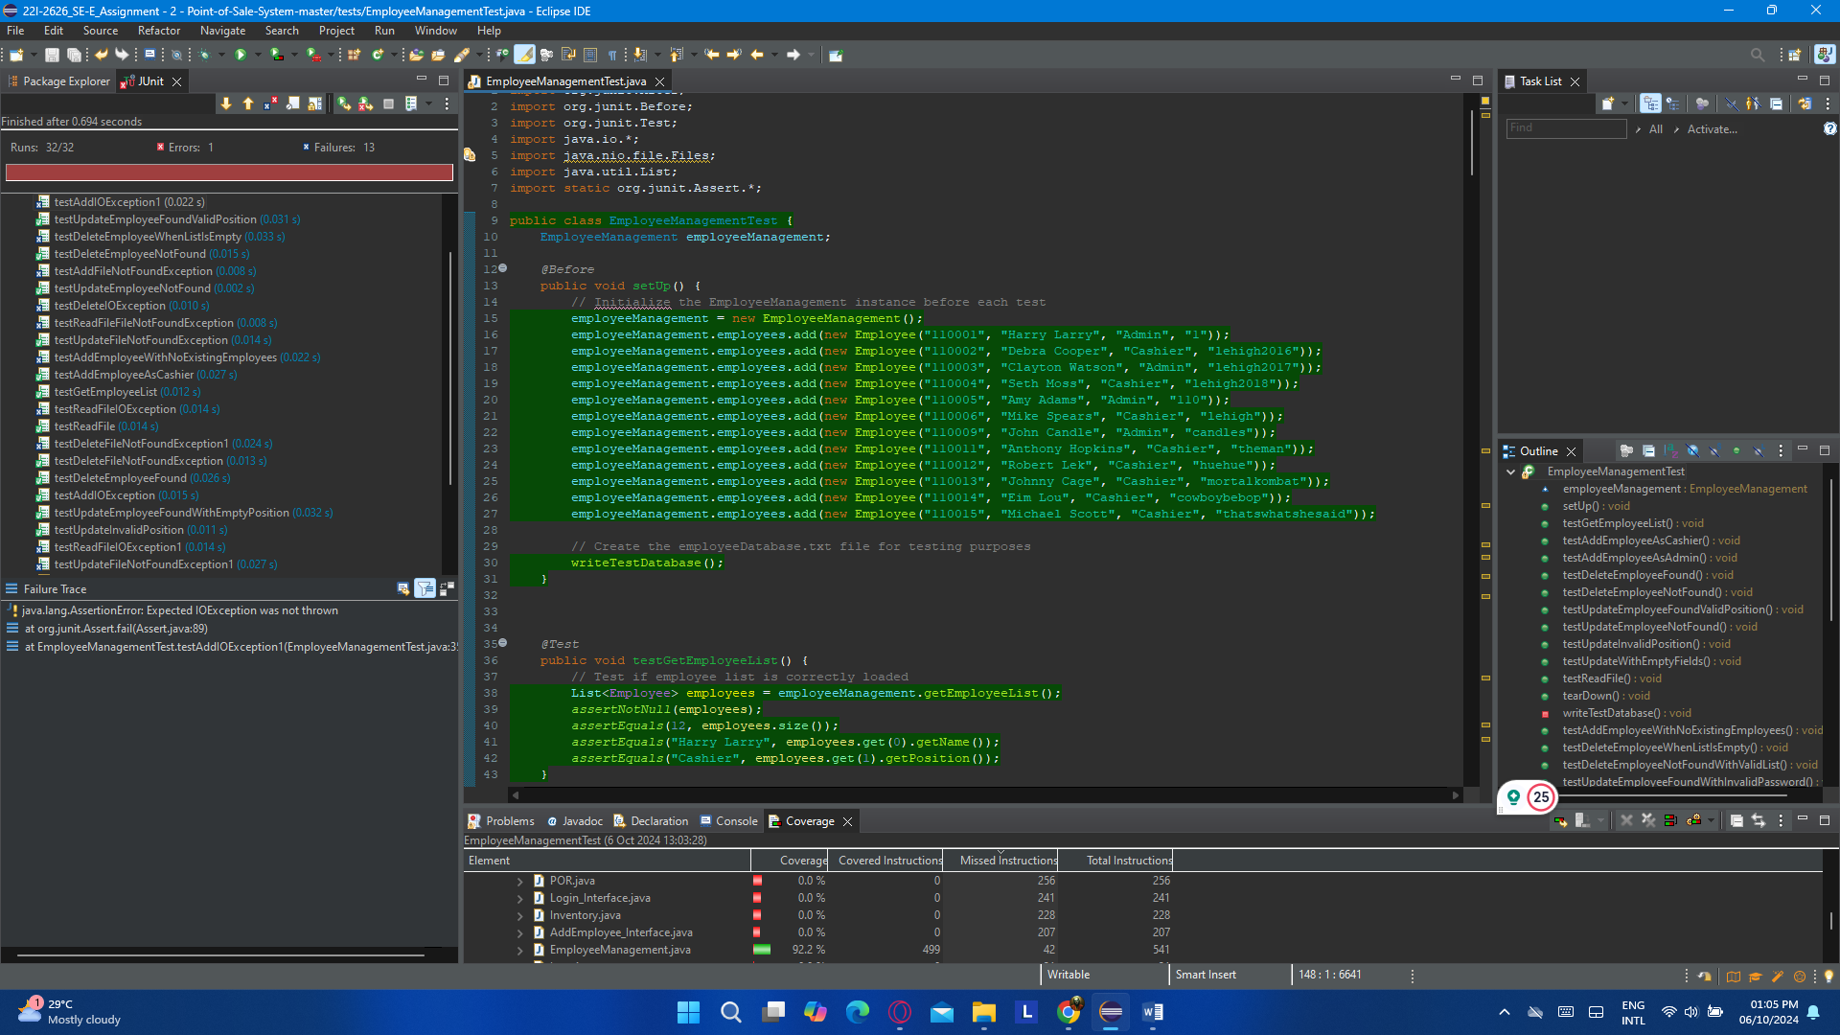

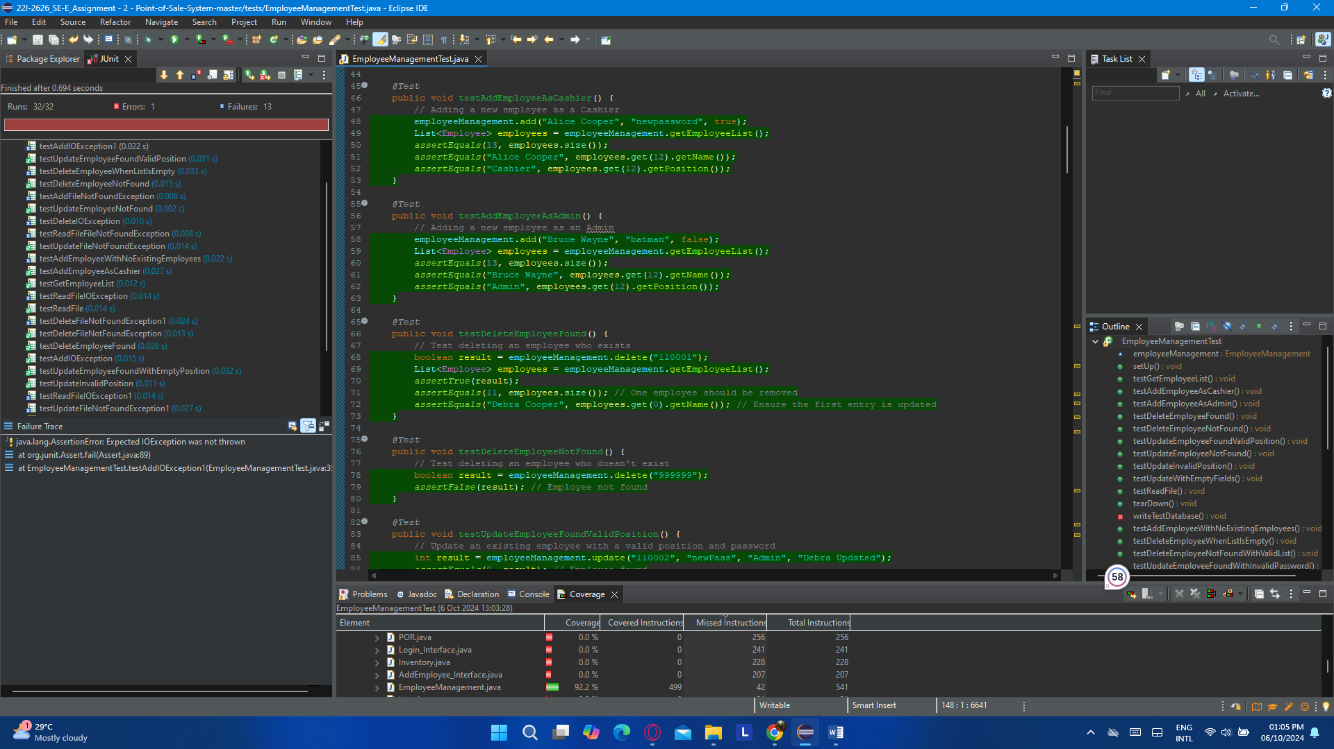

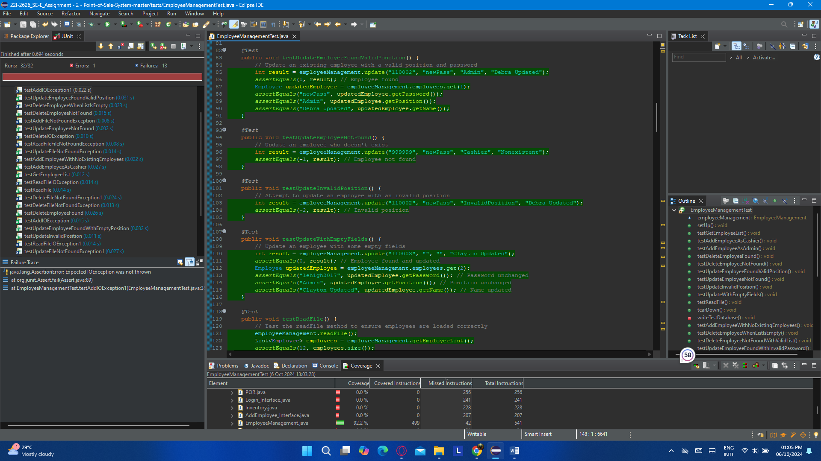

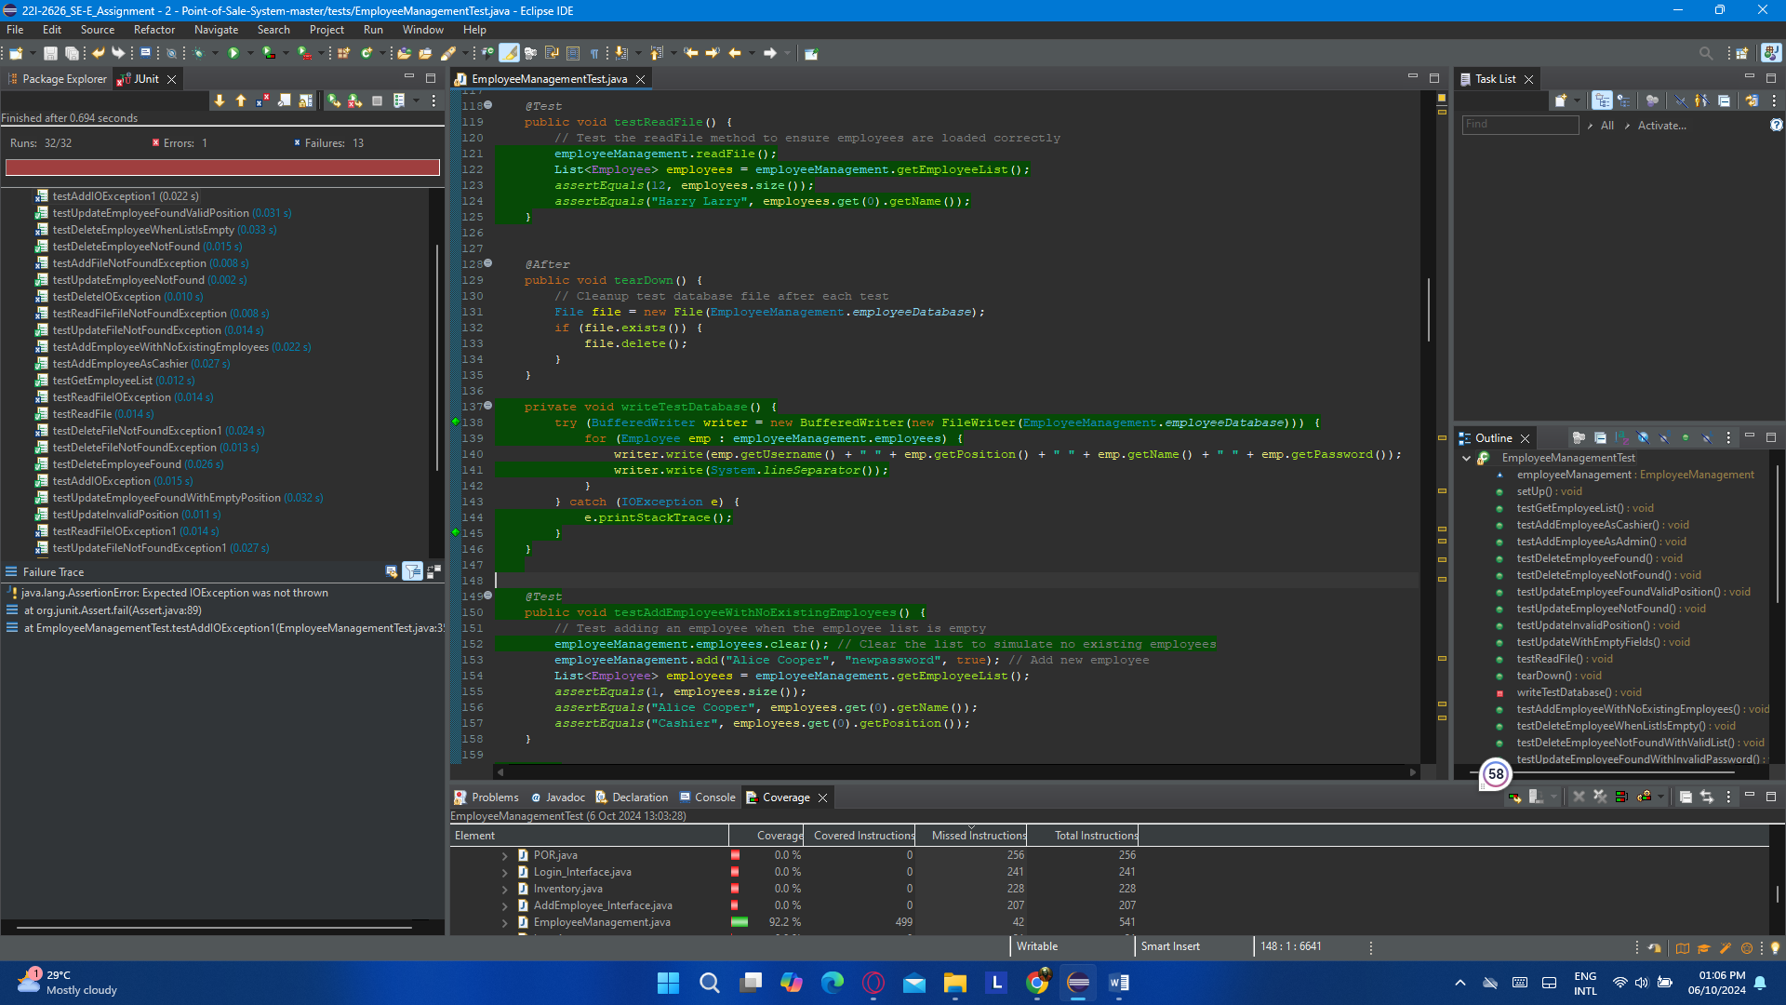

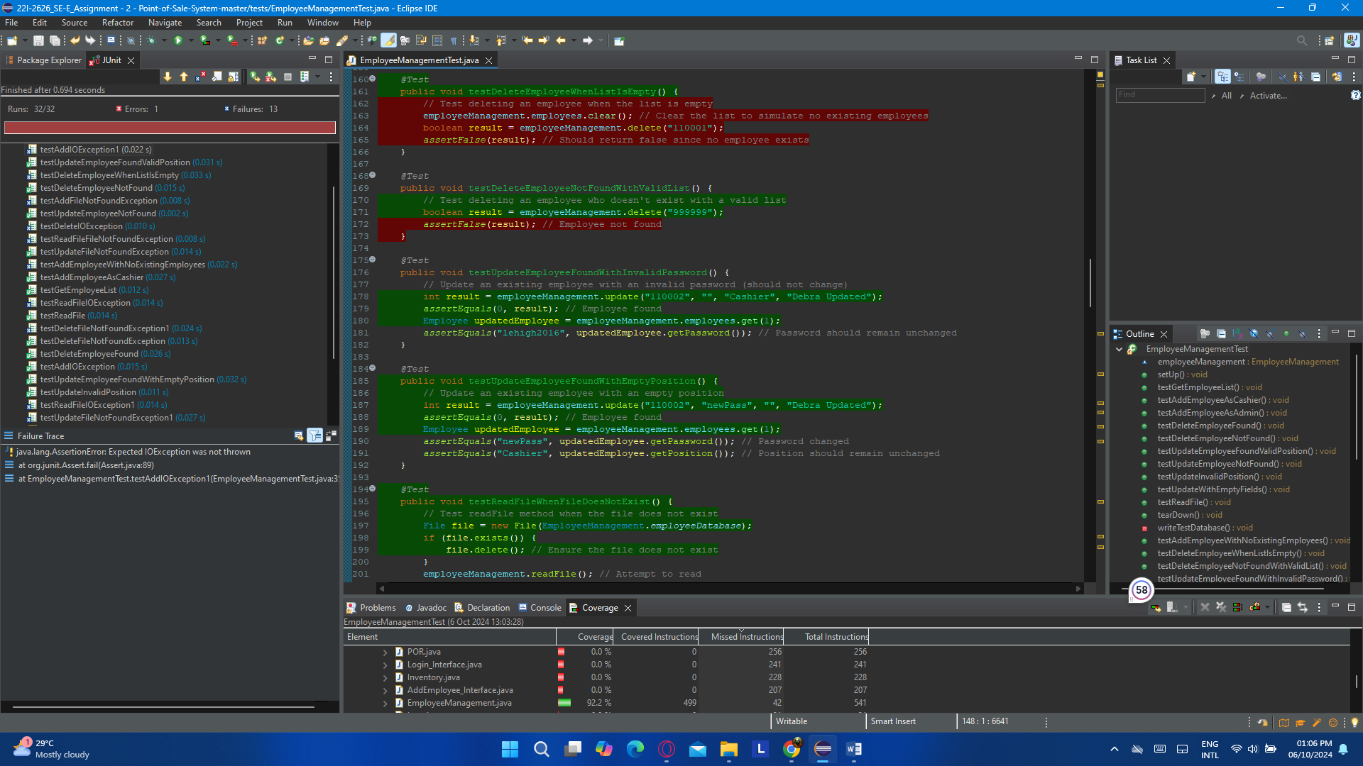

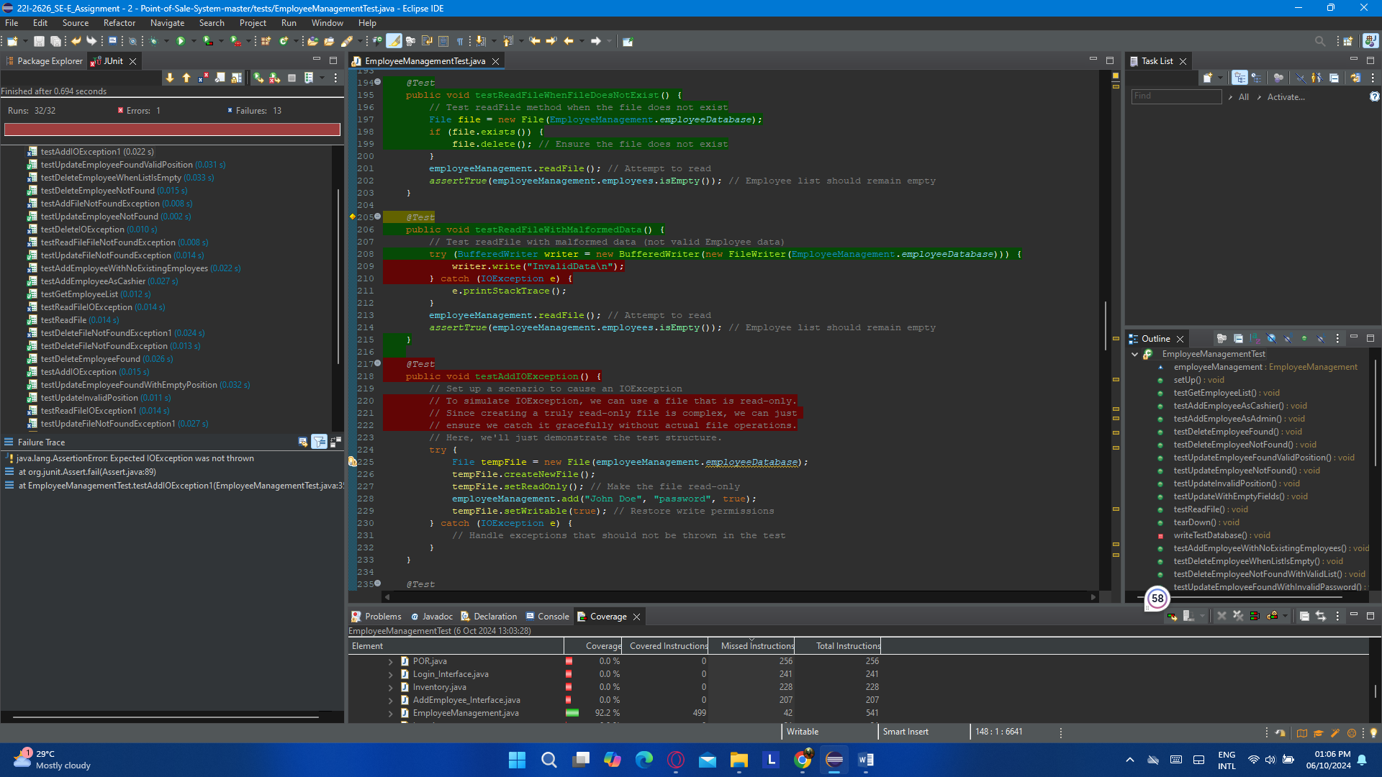

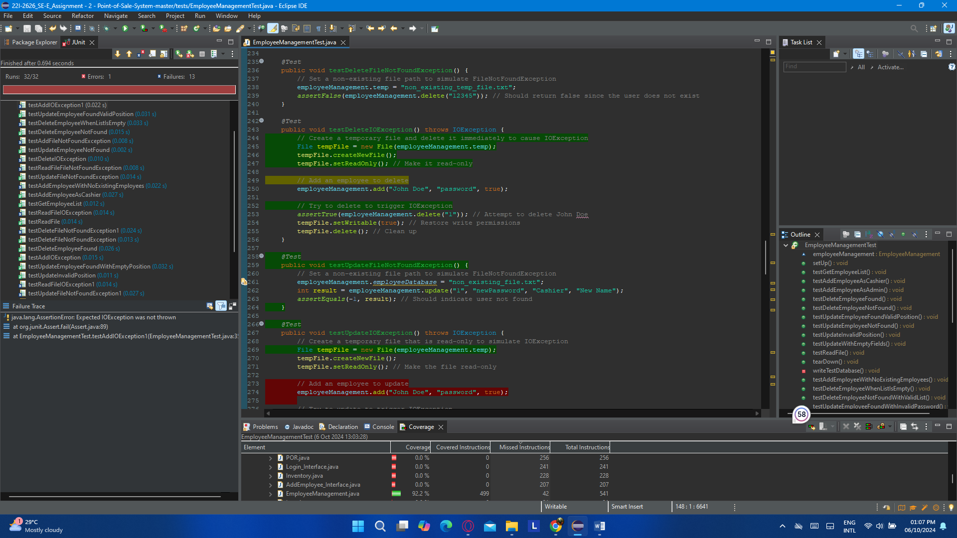

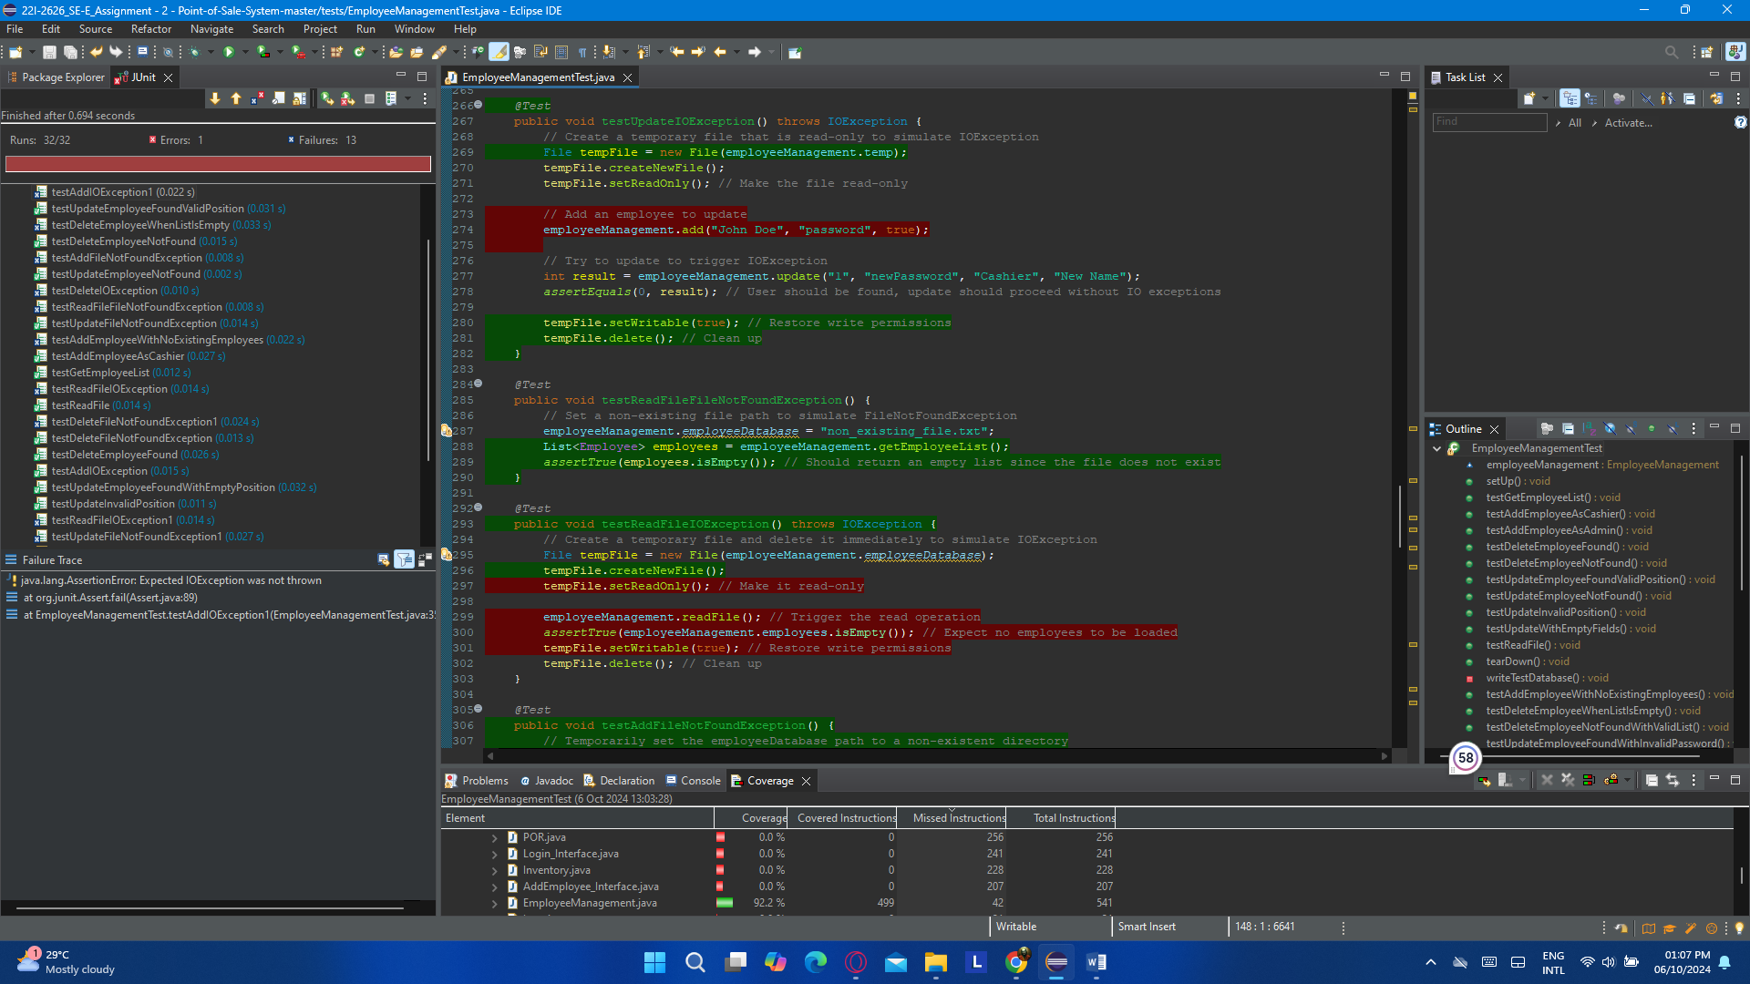

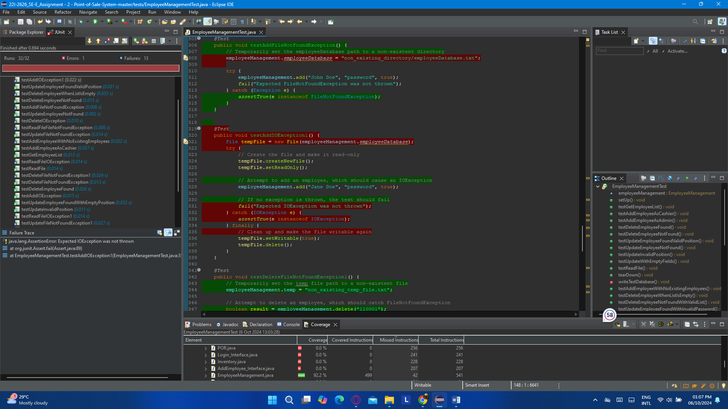

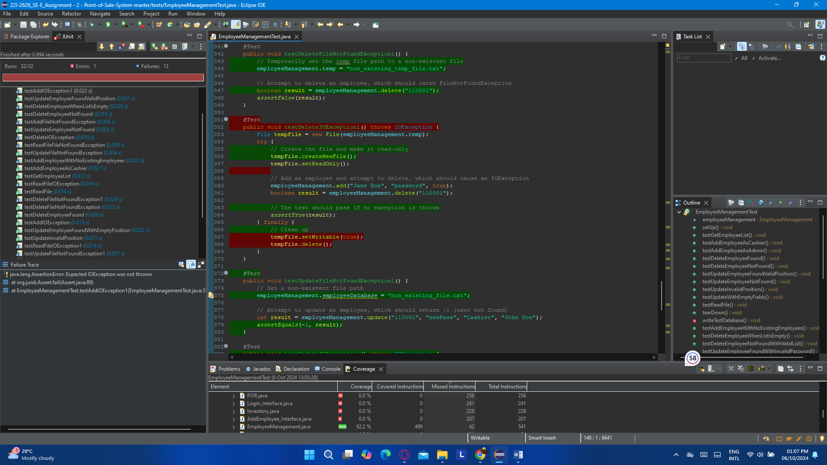

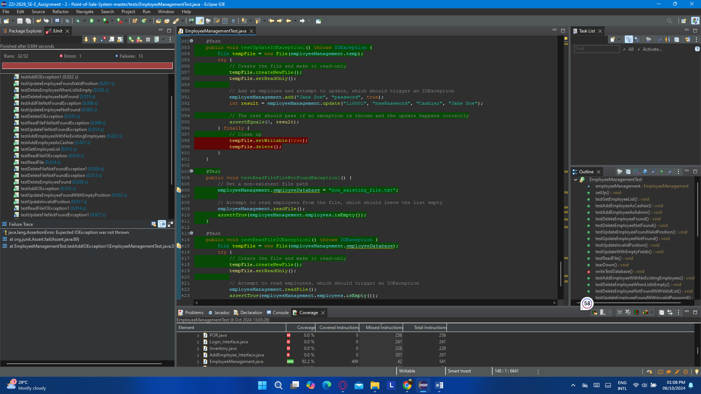

### (b). EmployeeTest.java

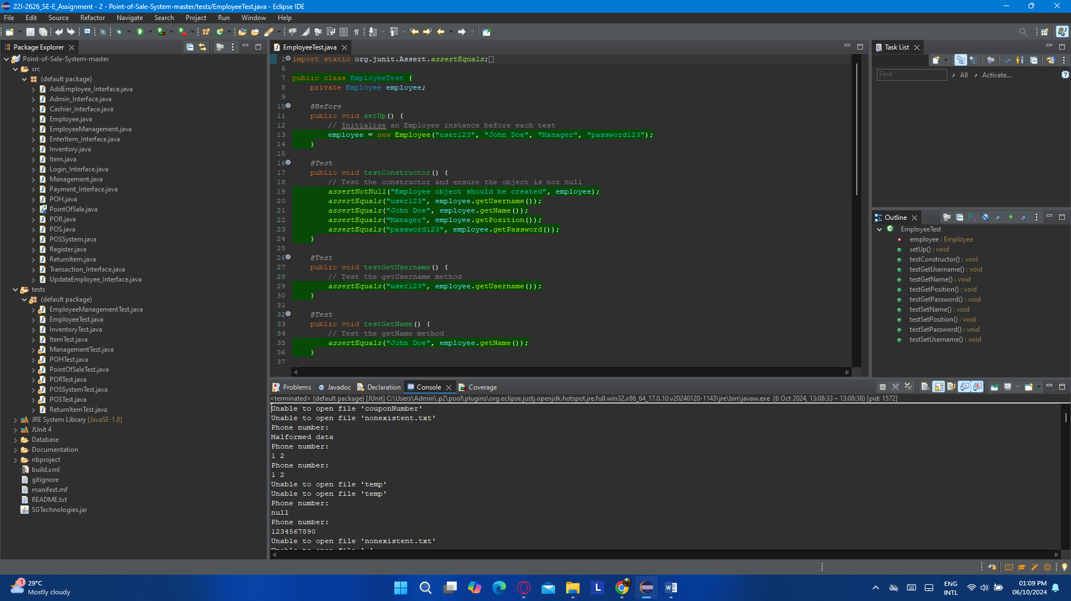

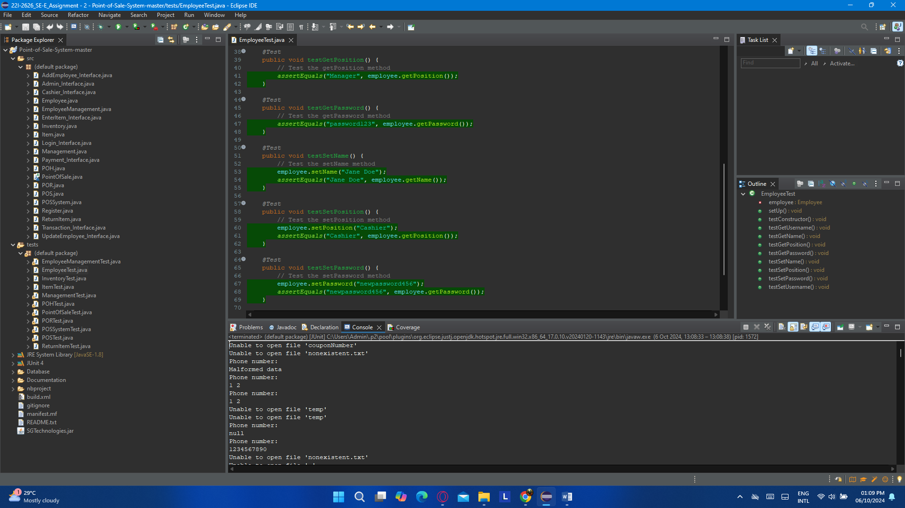

### (c). InventoryTest.java

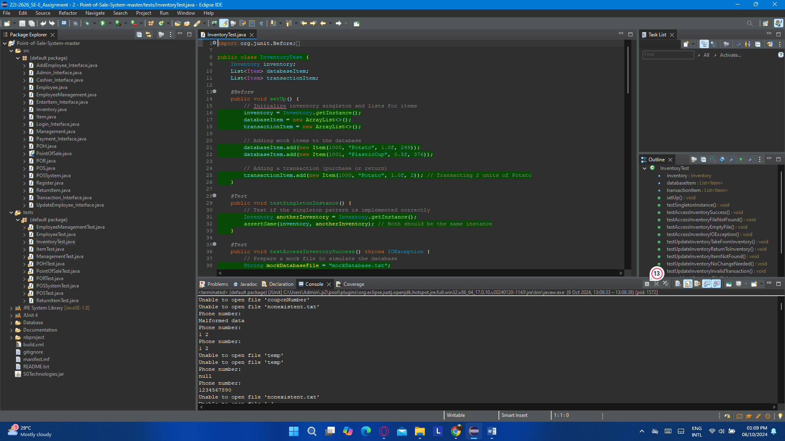

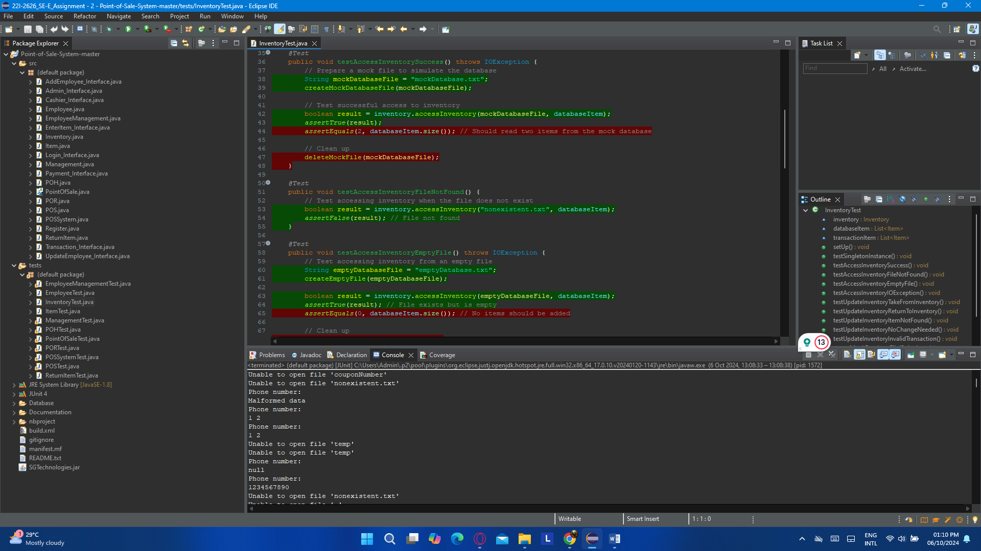

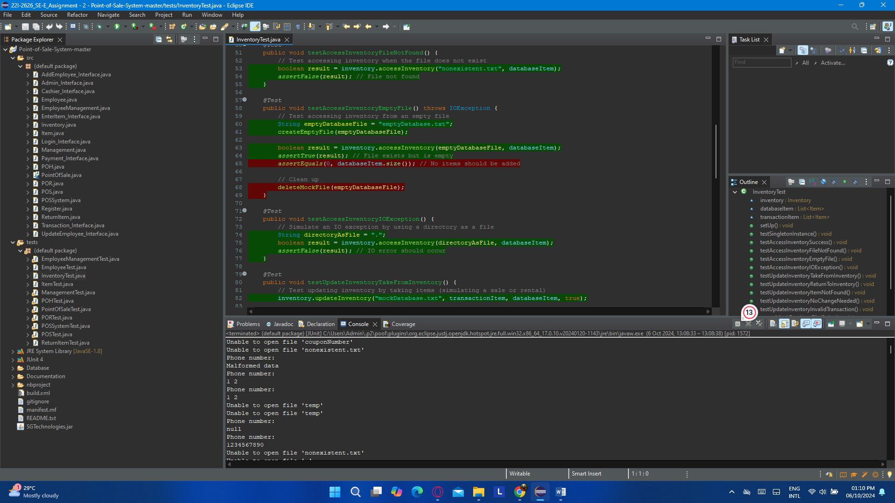

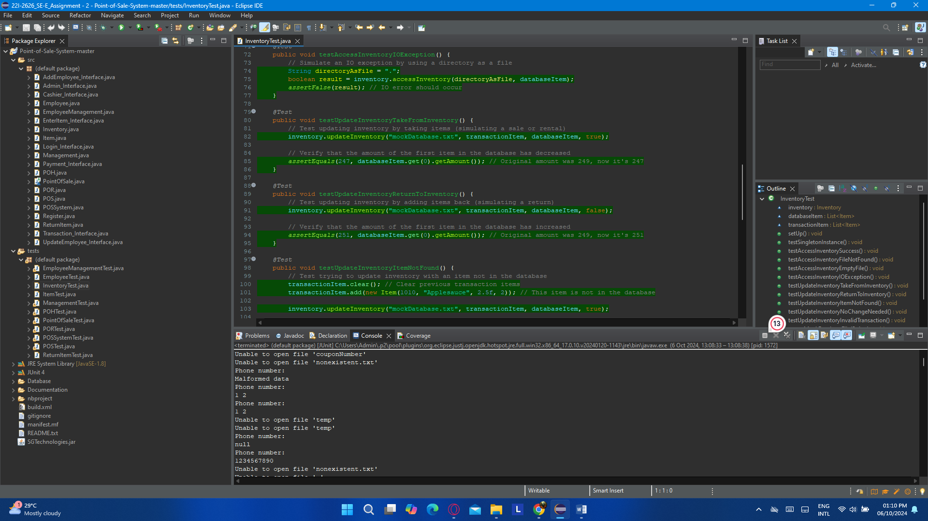

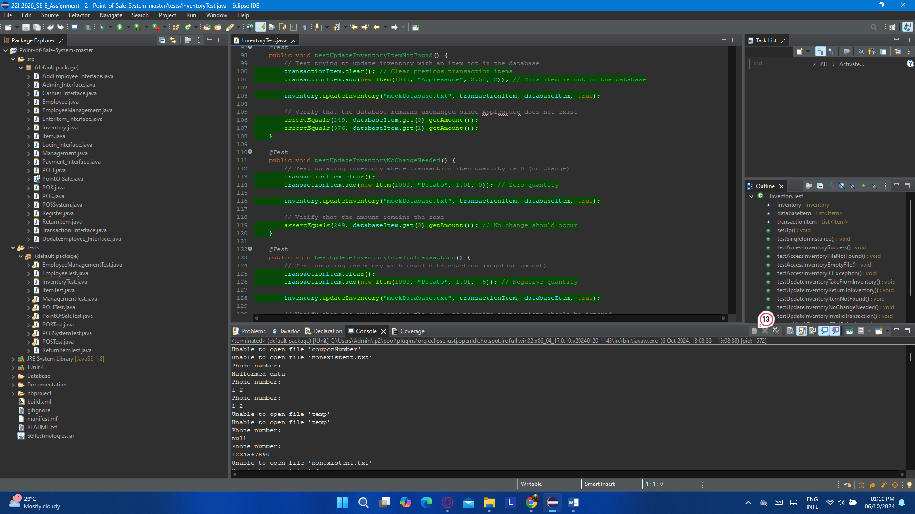

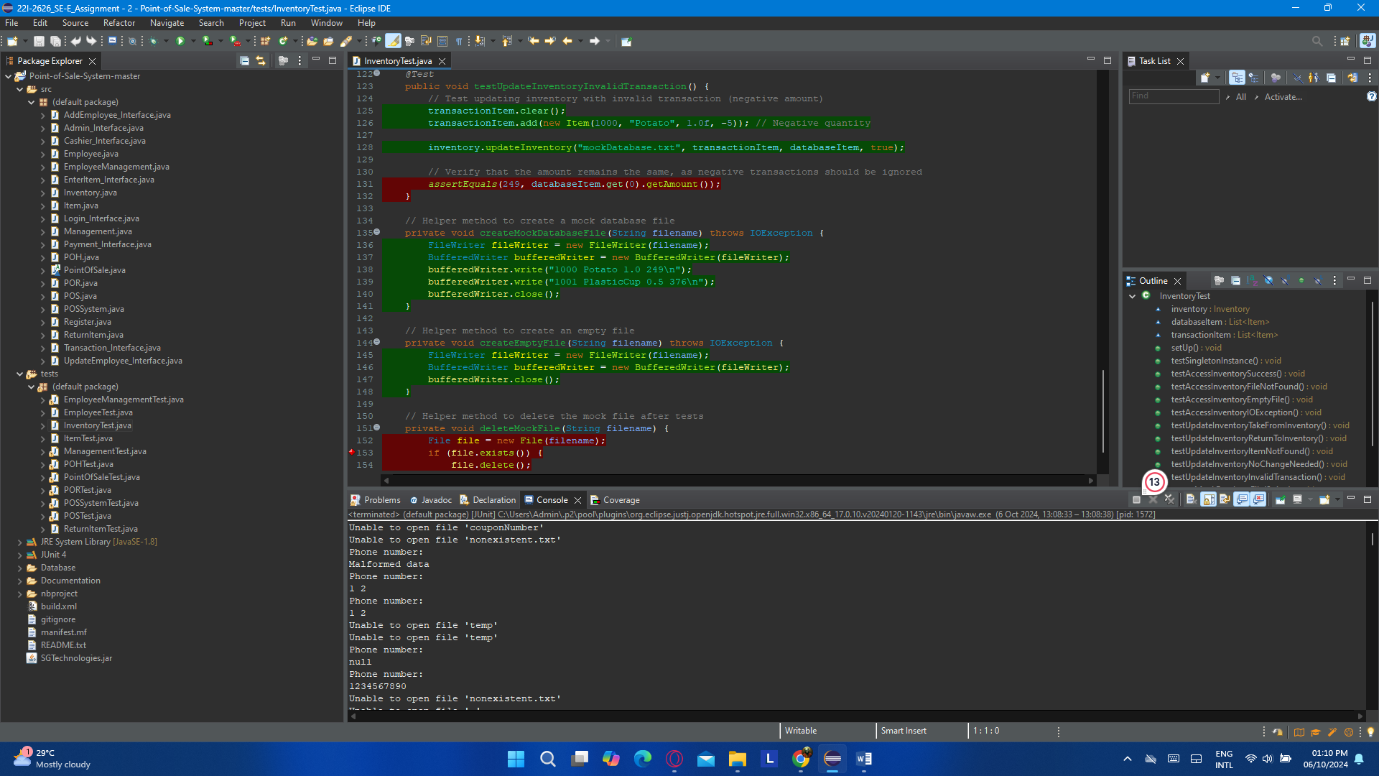

### (d). ItemTest.java

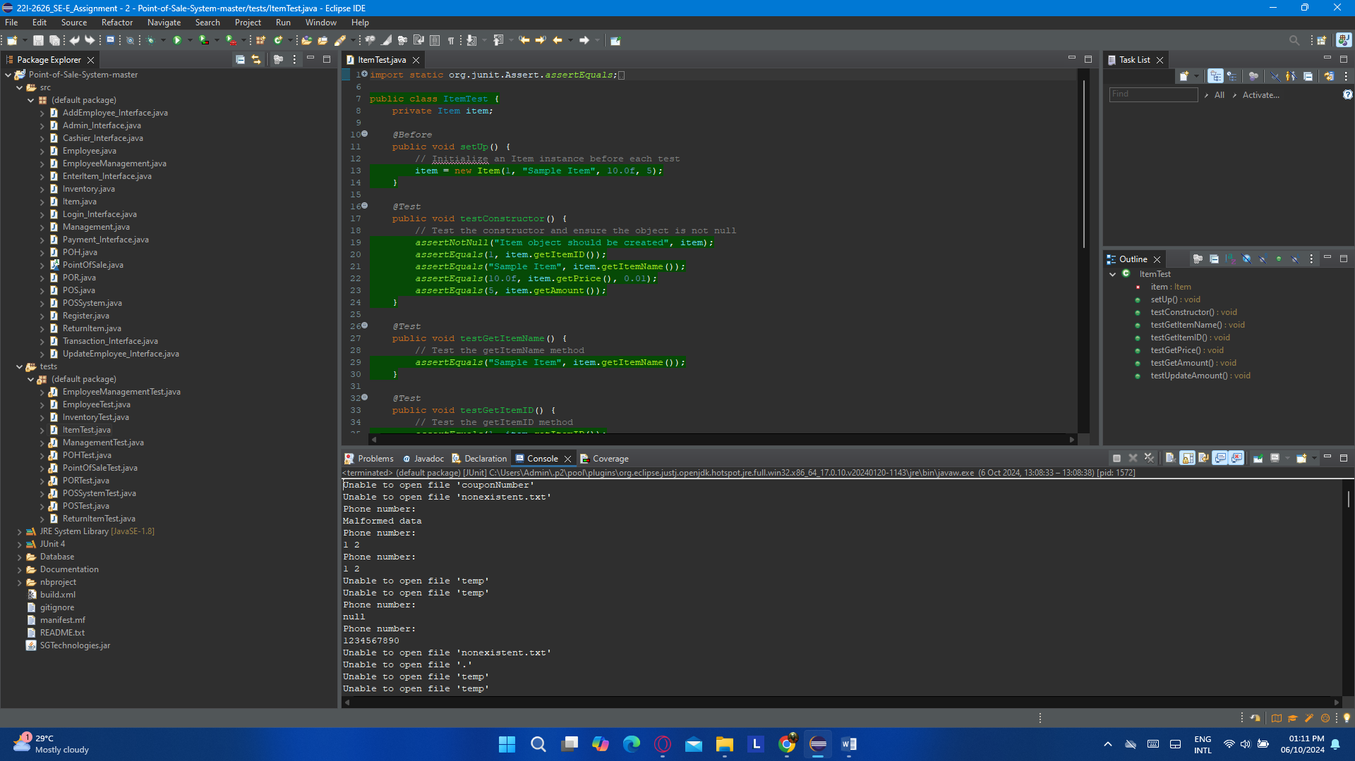

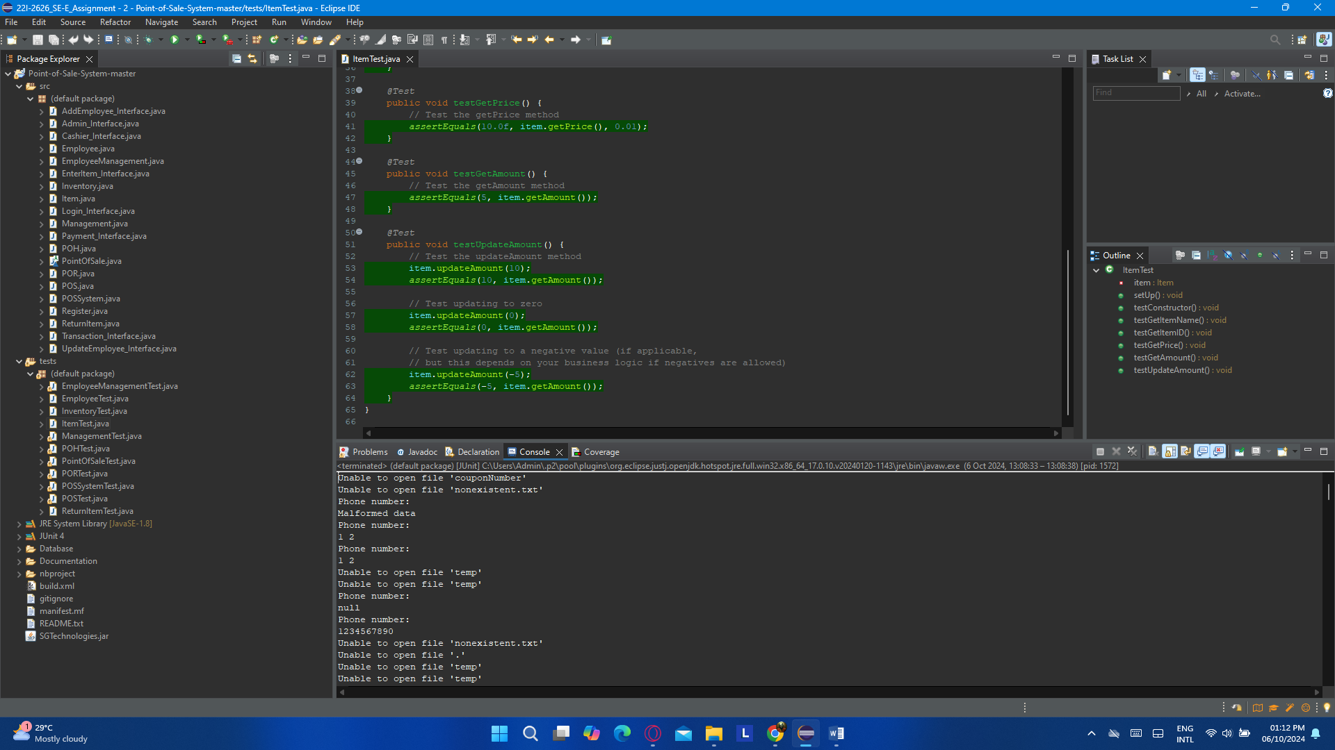

### (e). ManagementTest.java

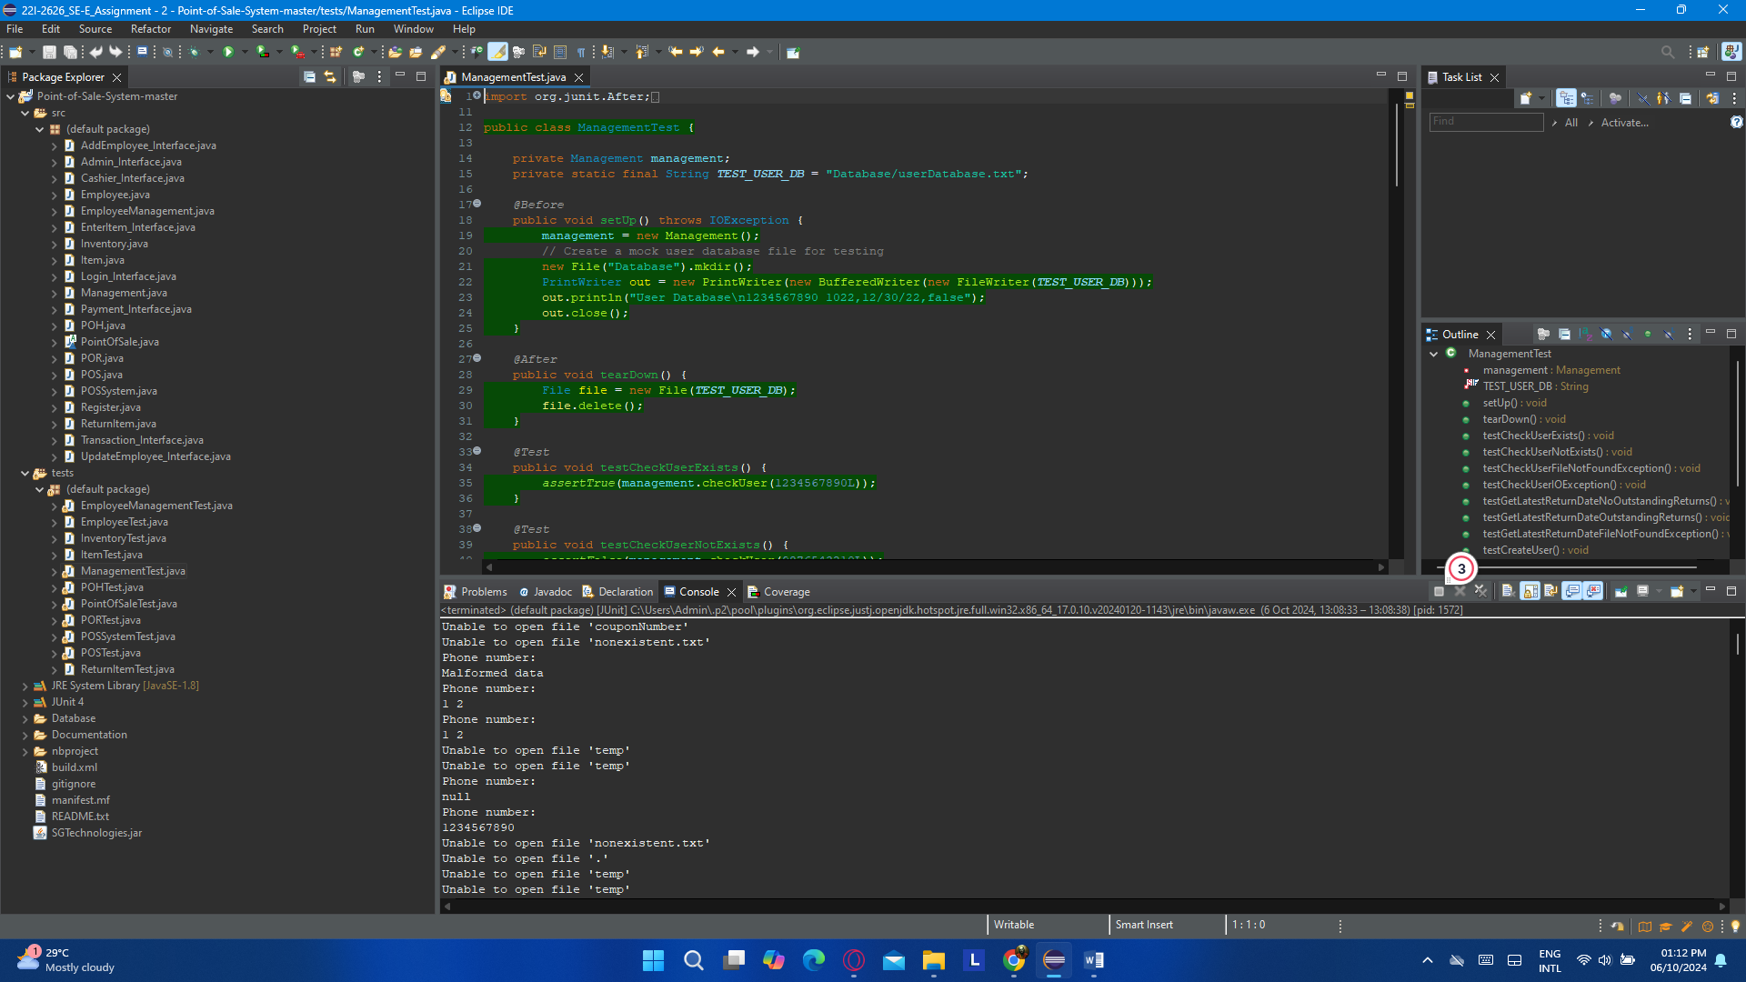

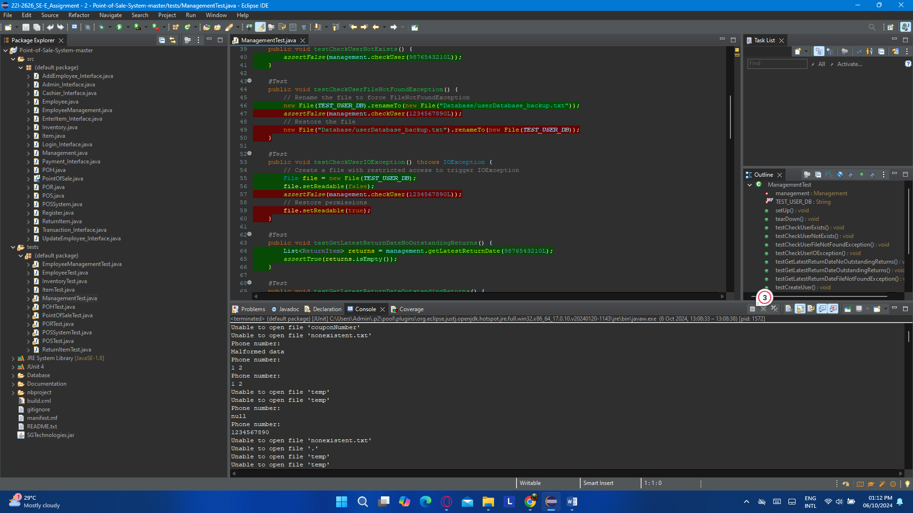

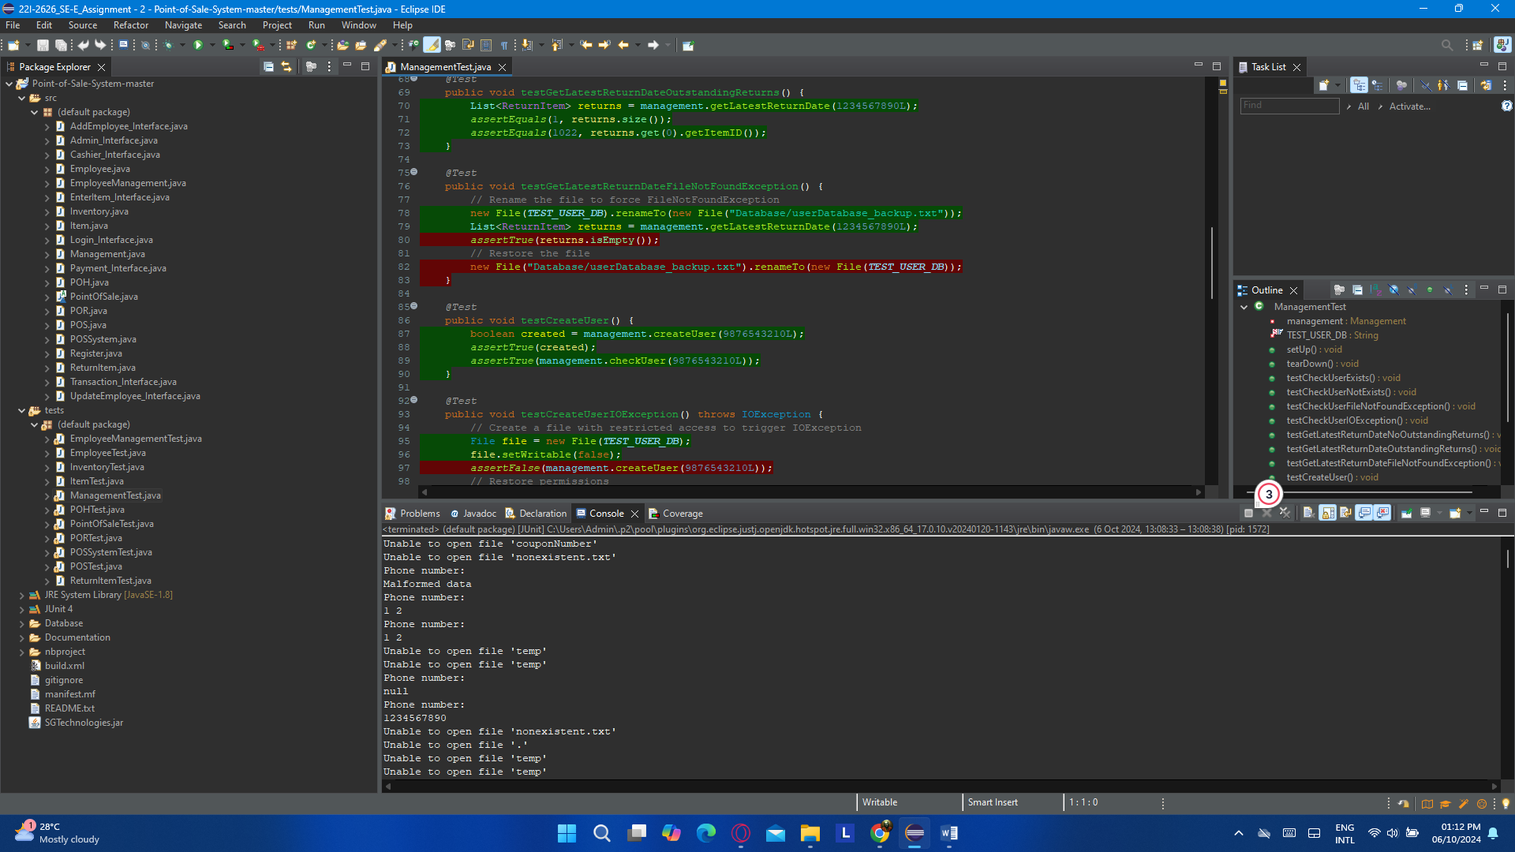

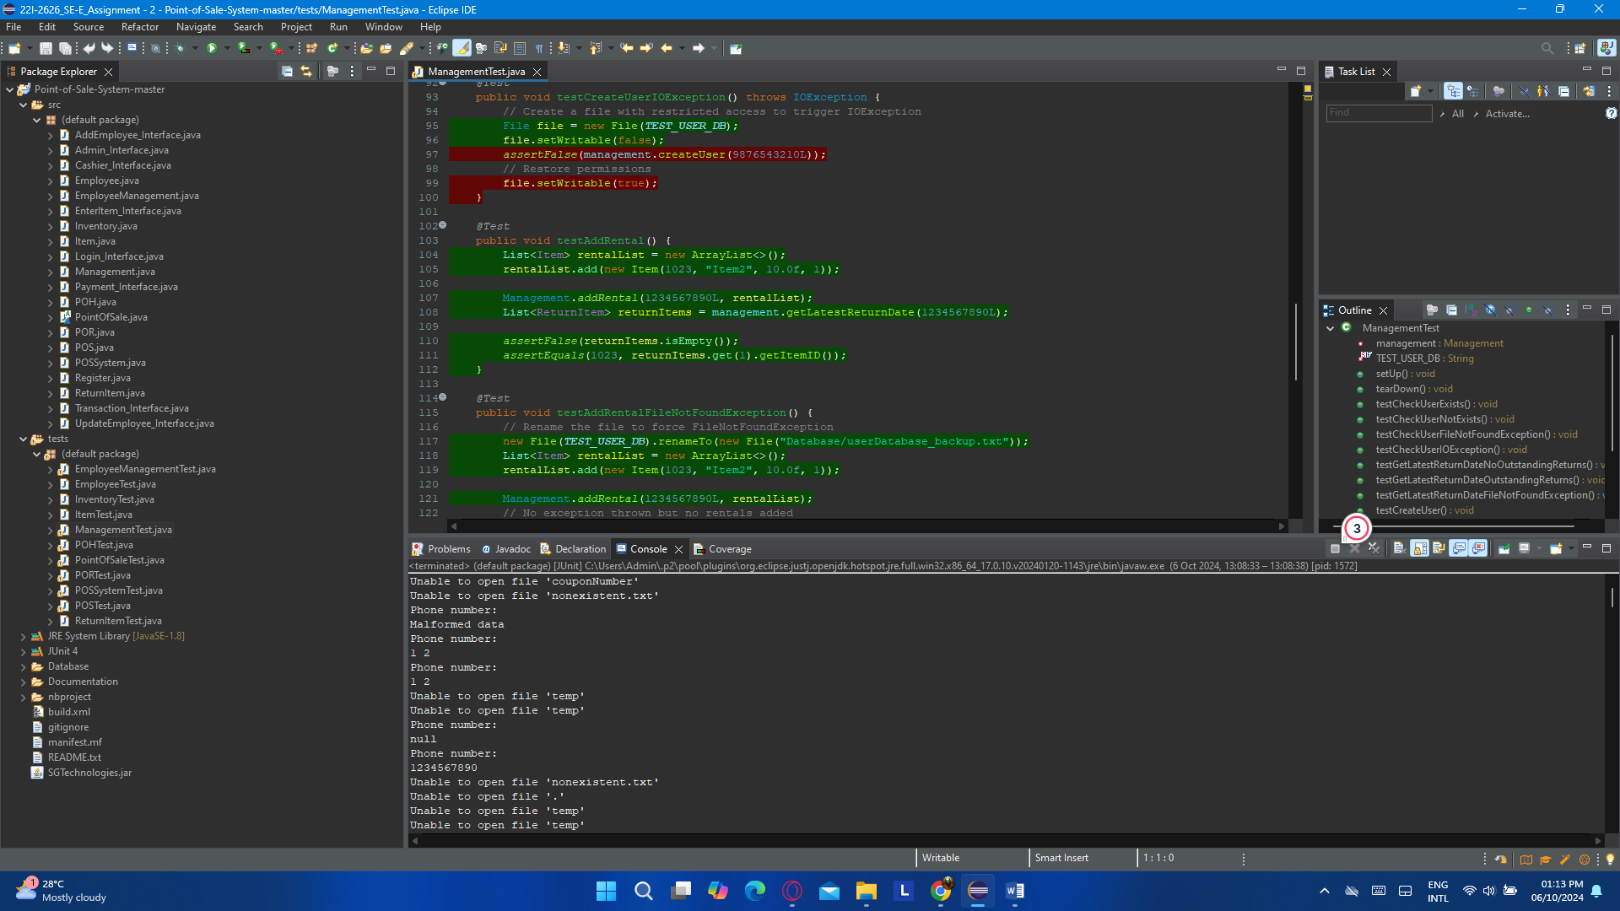

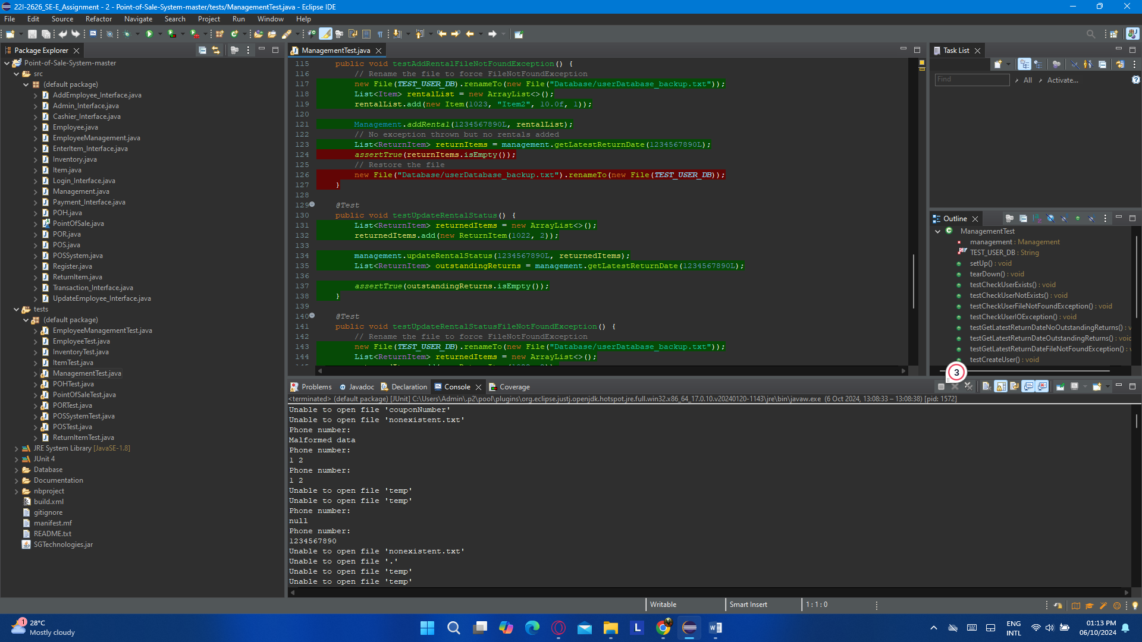

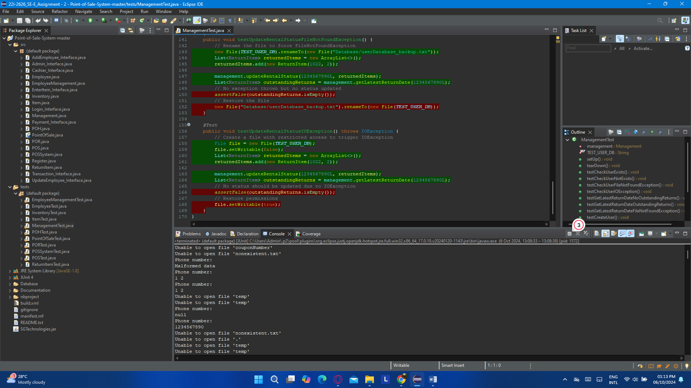

### (f). POHTest.java

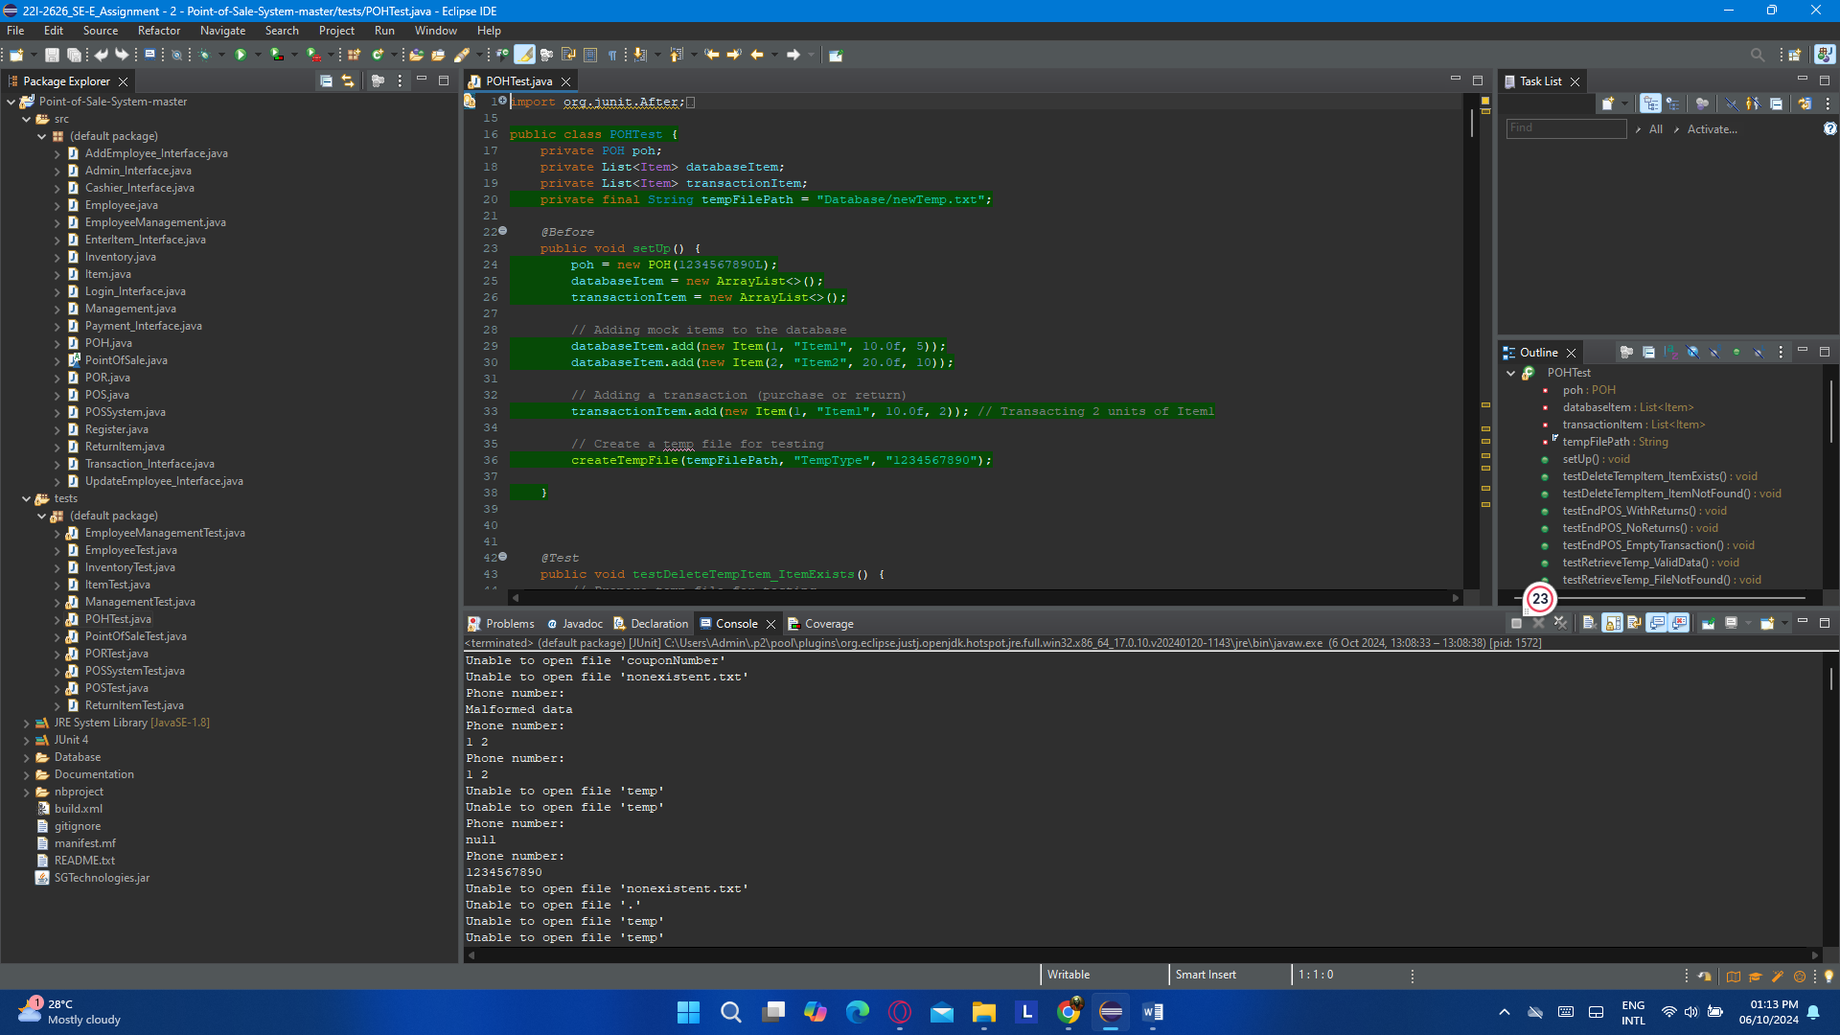

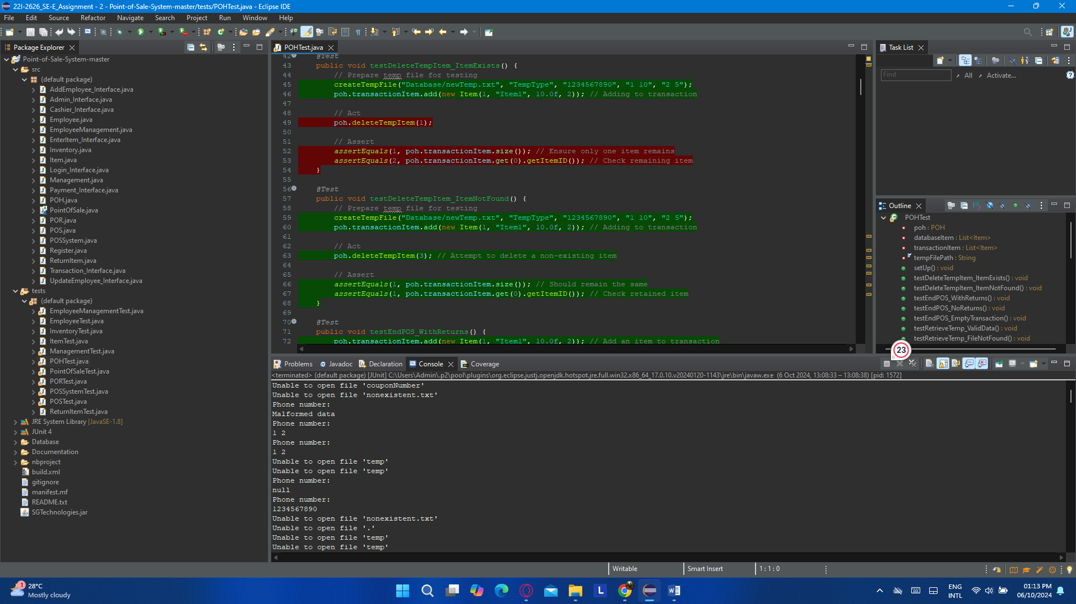

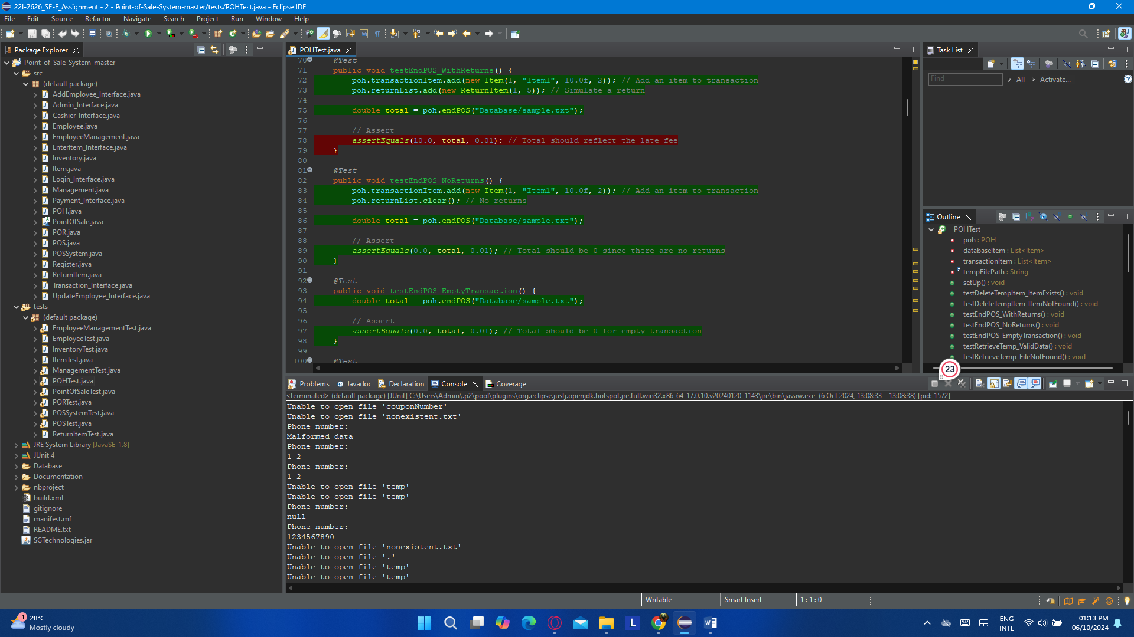

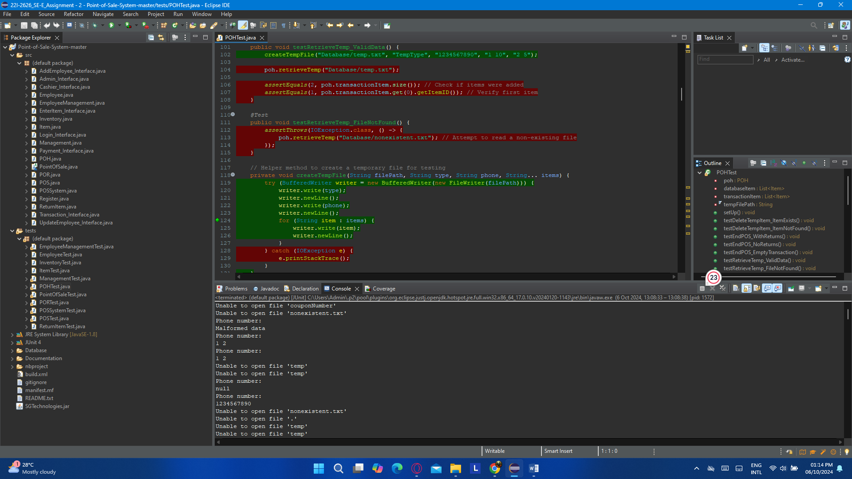

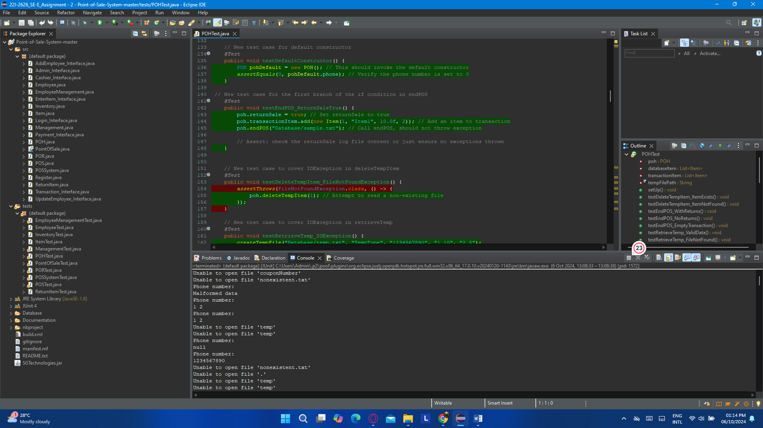

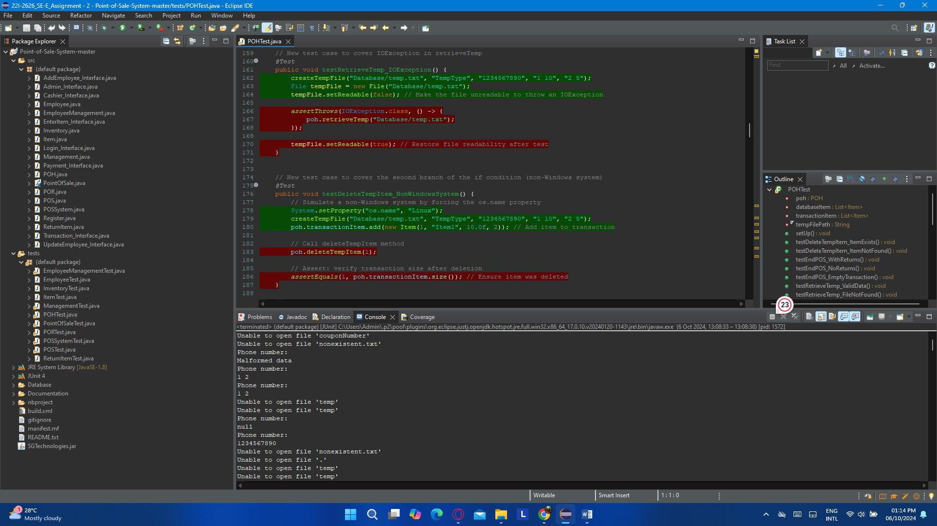

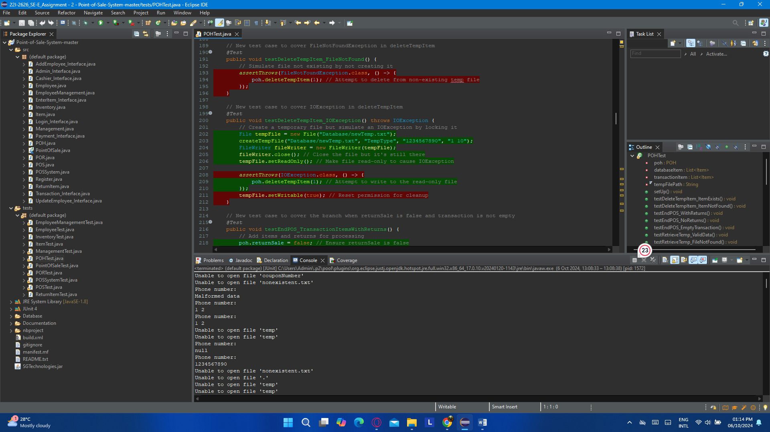

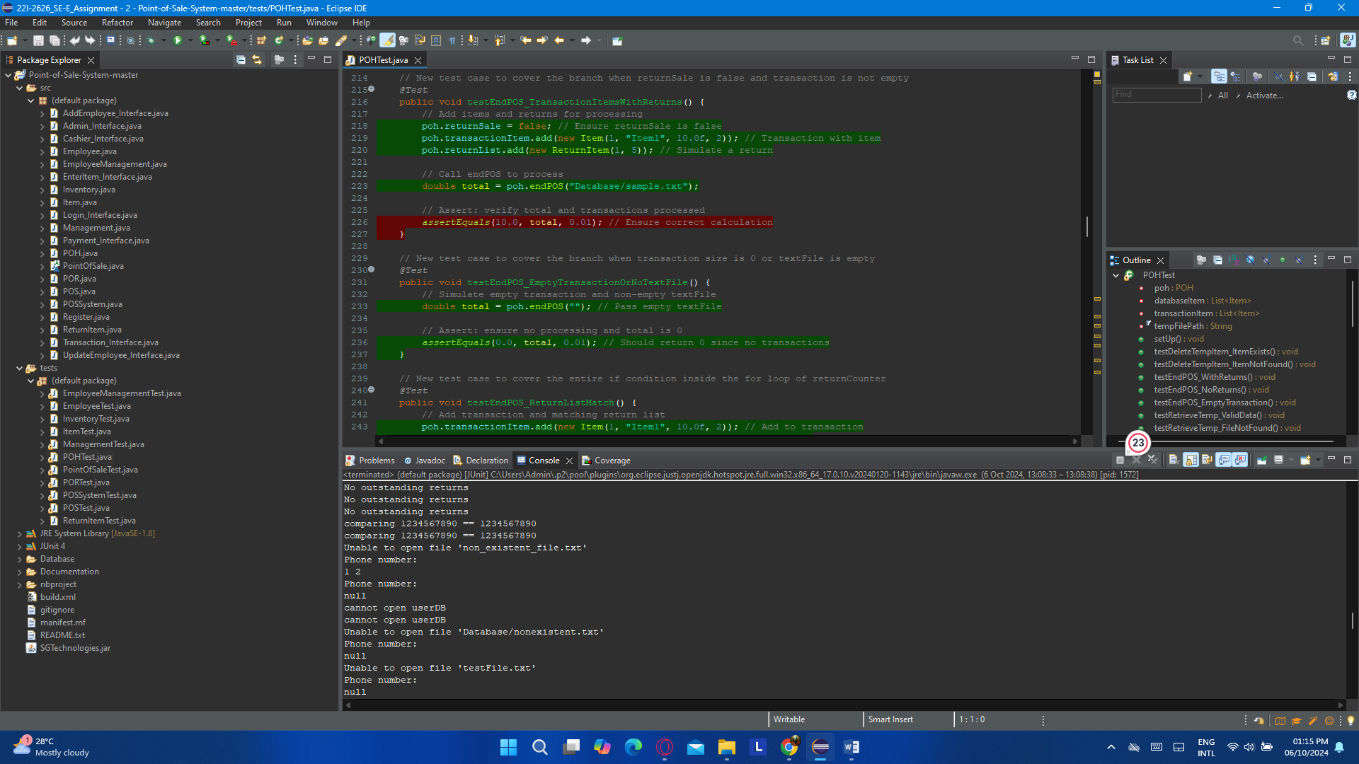

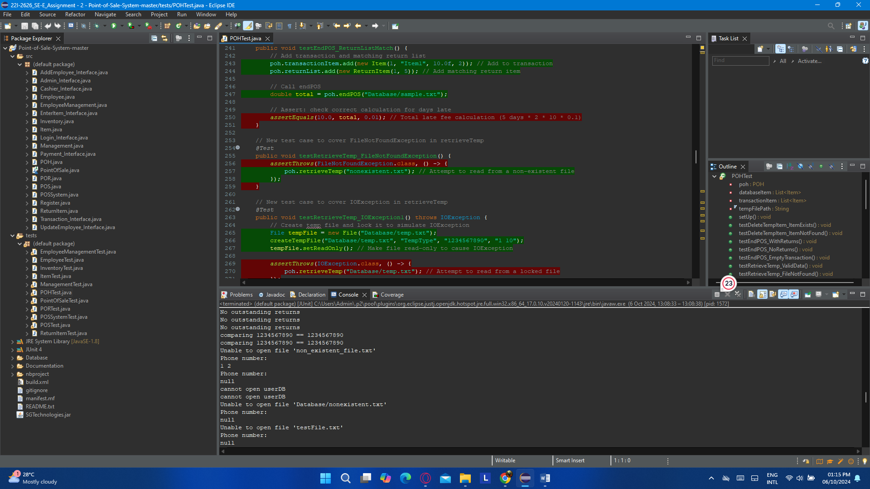

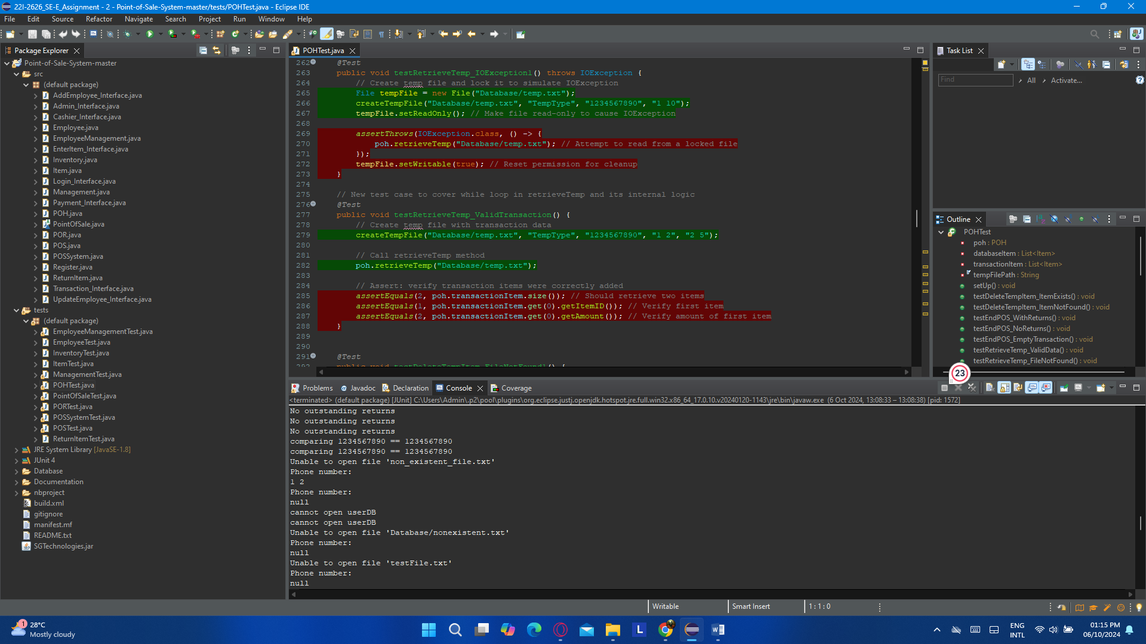

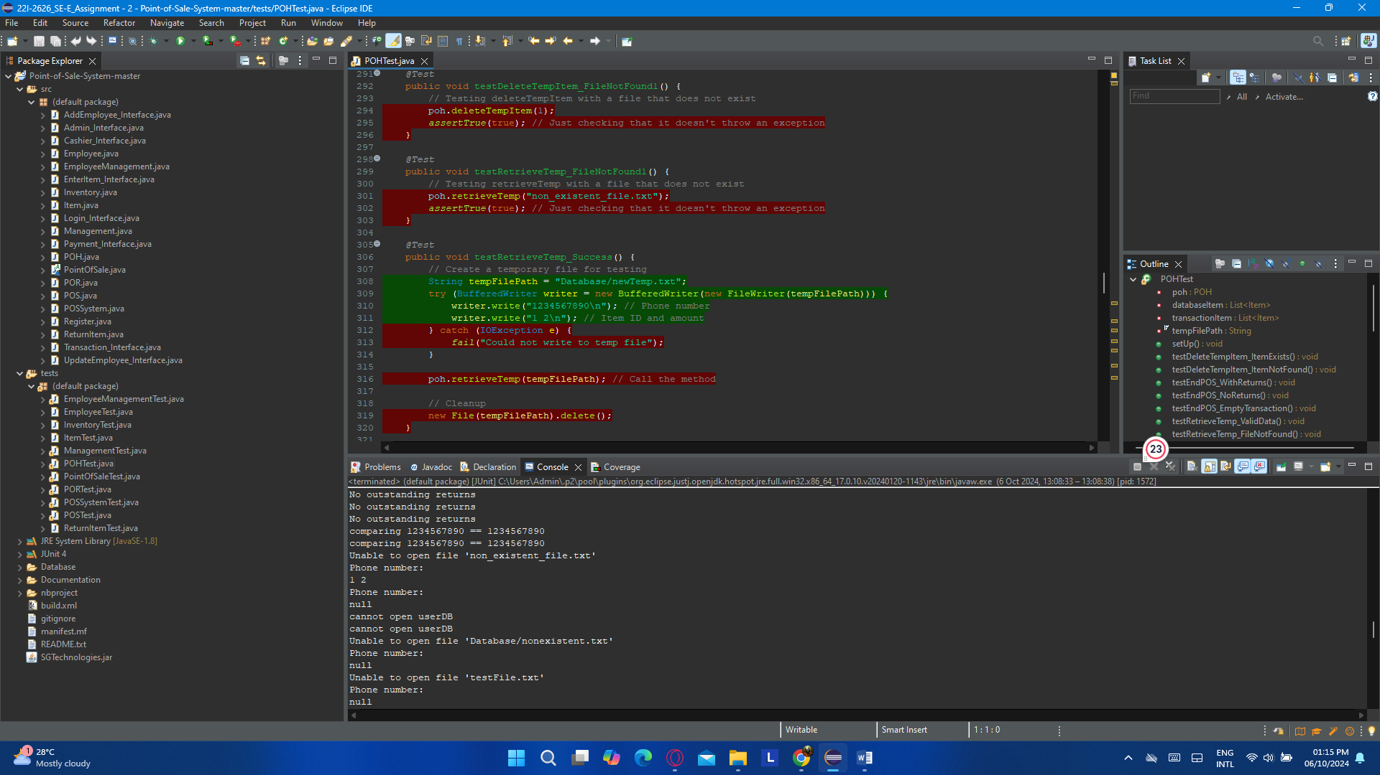

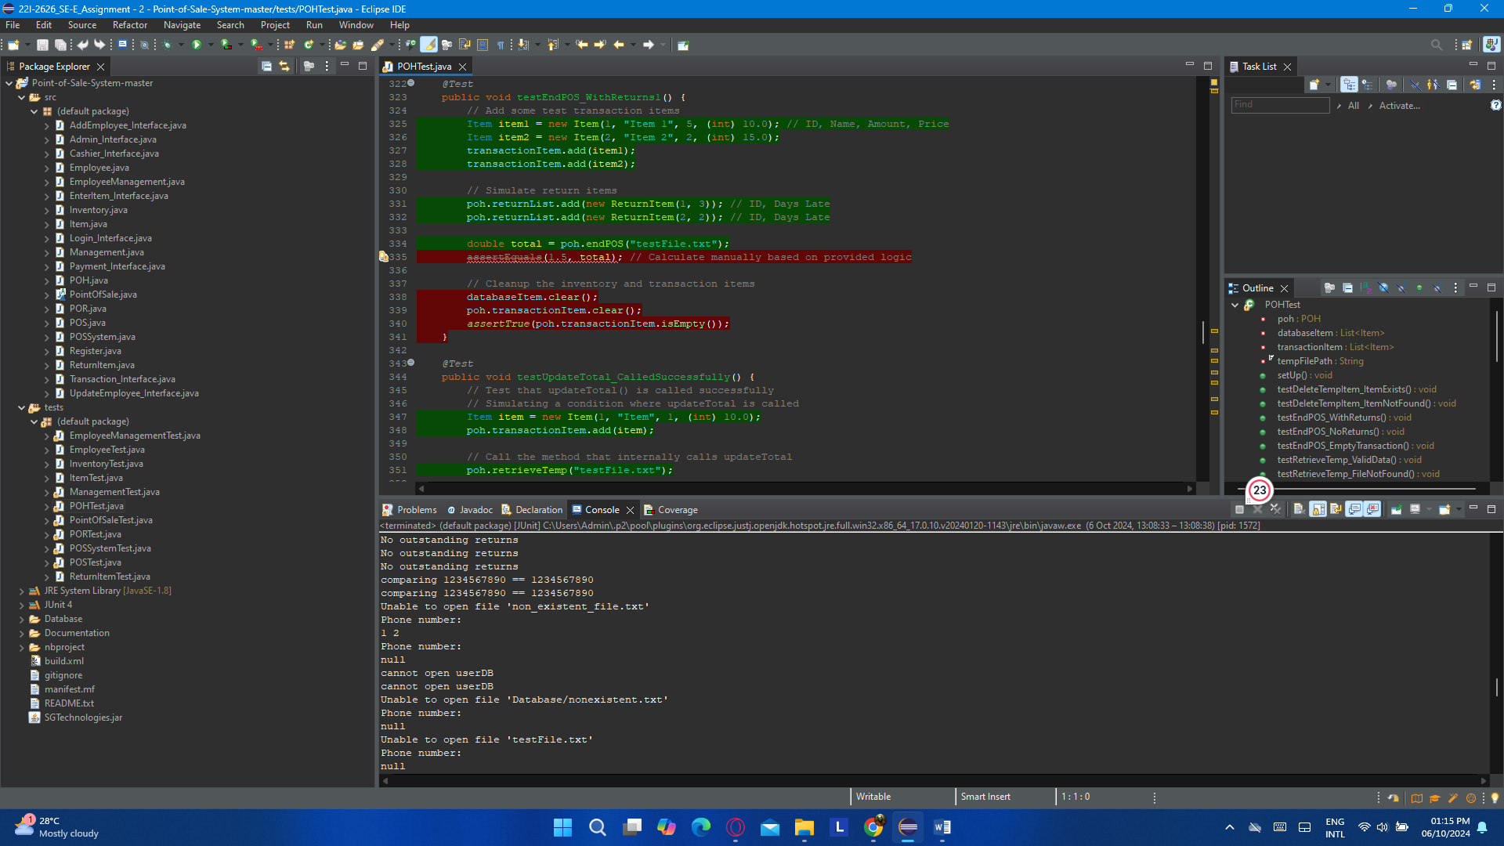

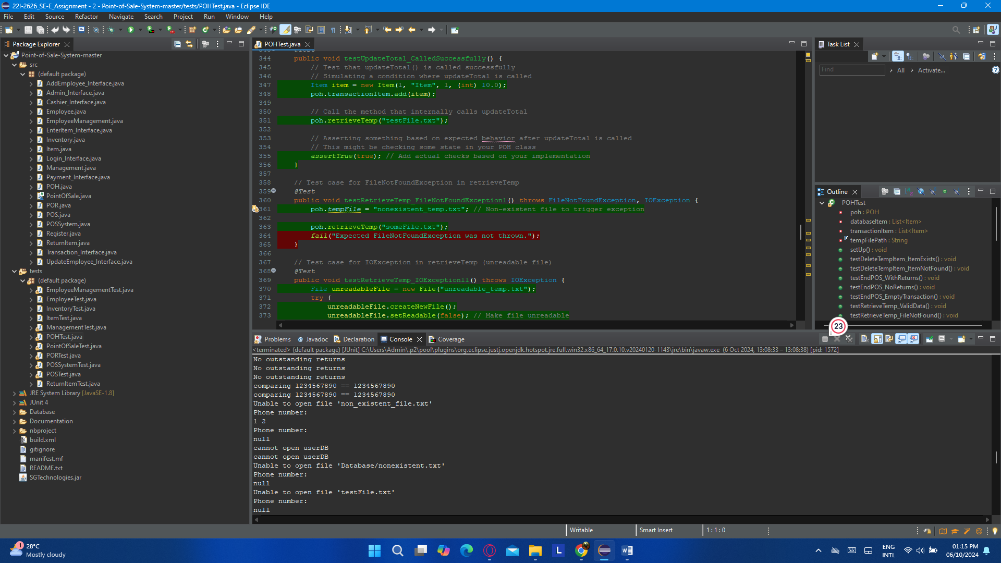

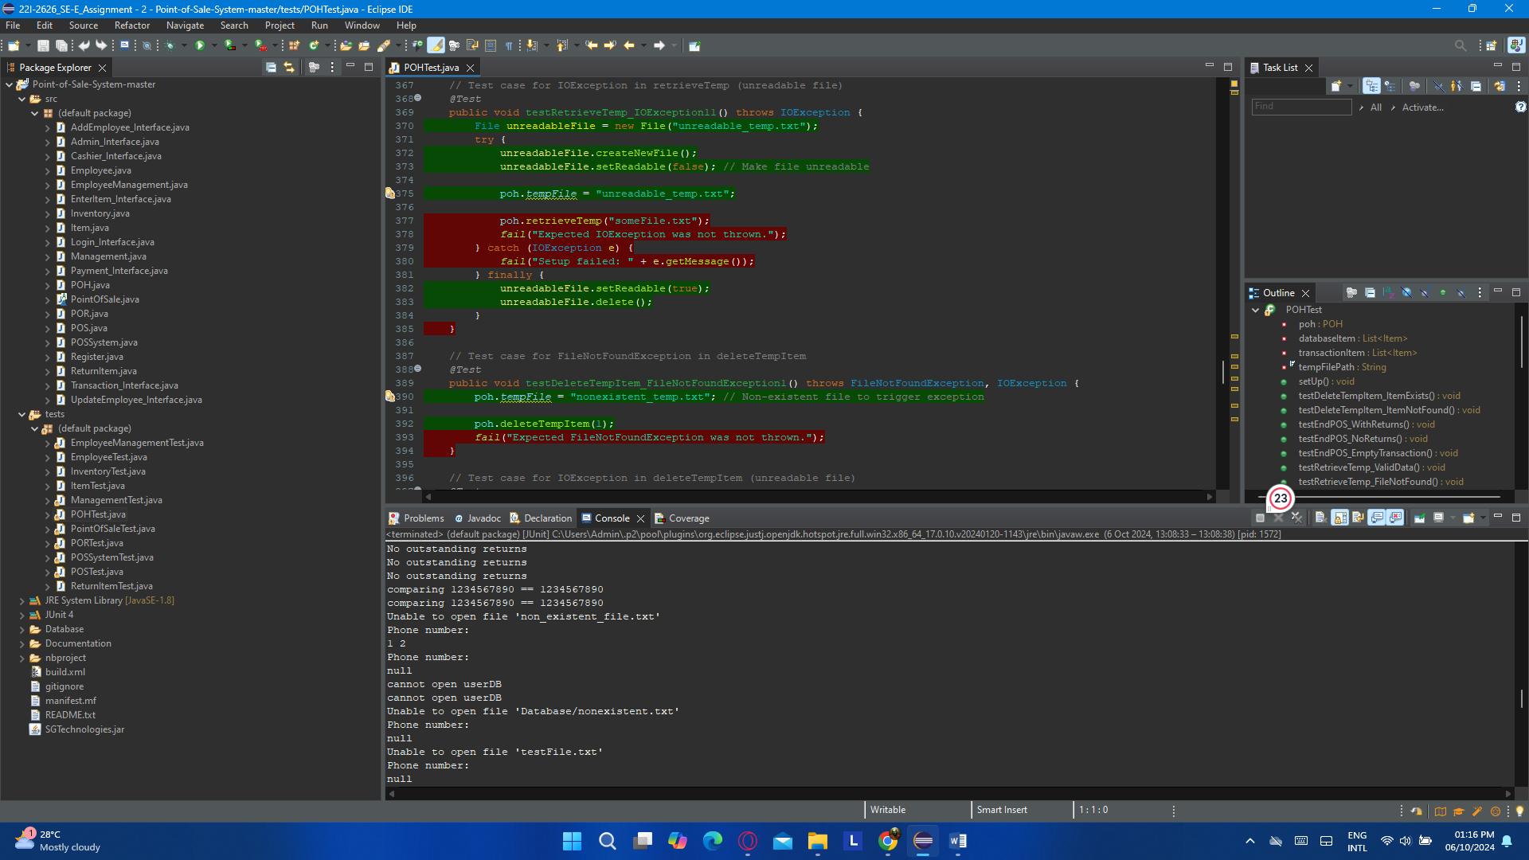

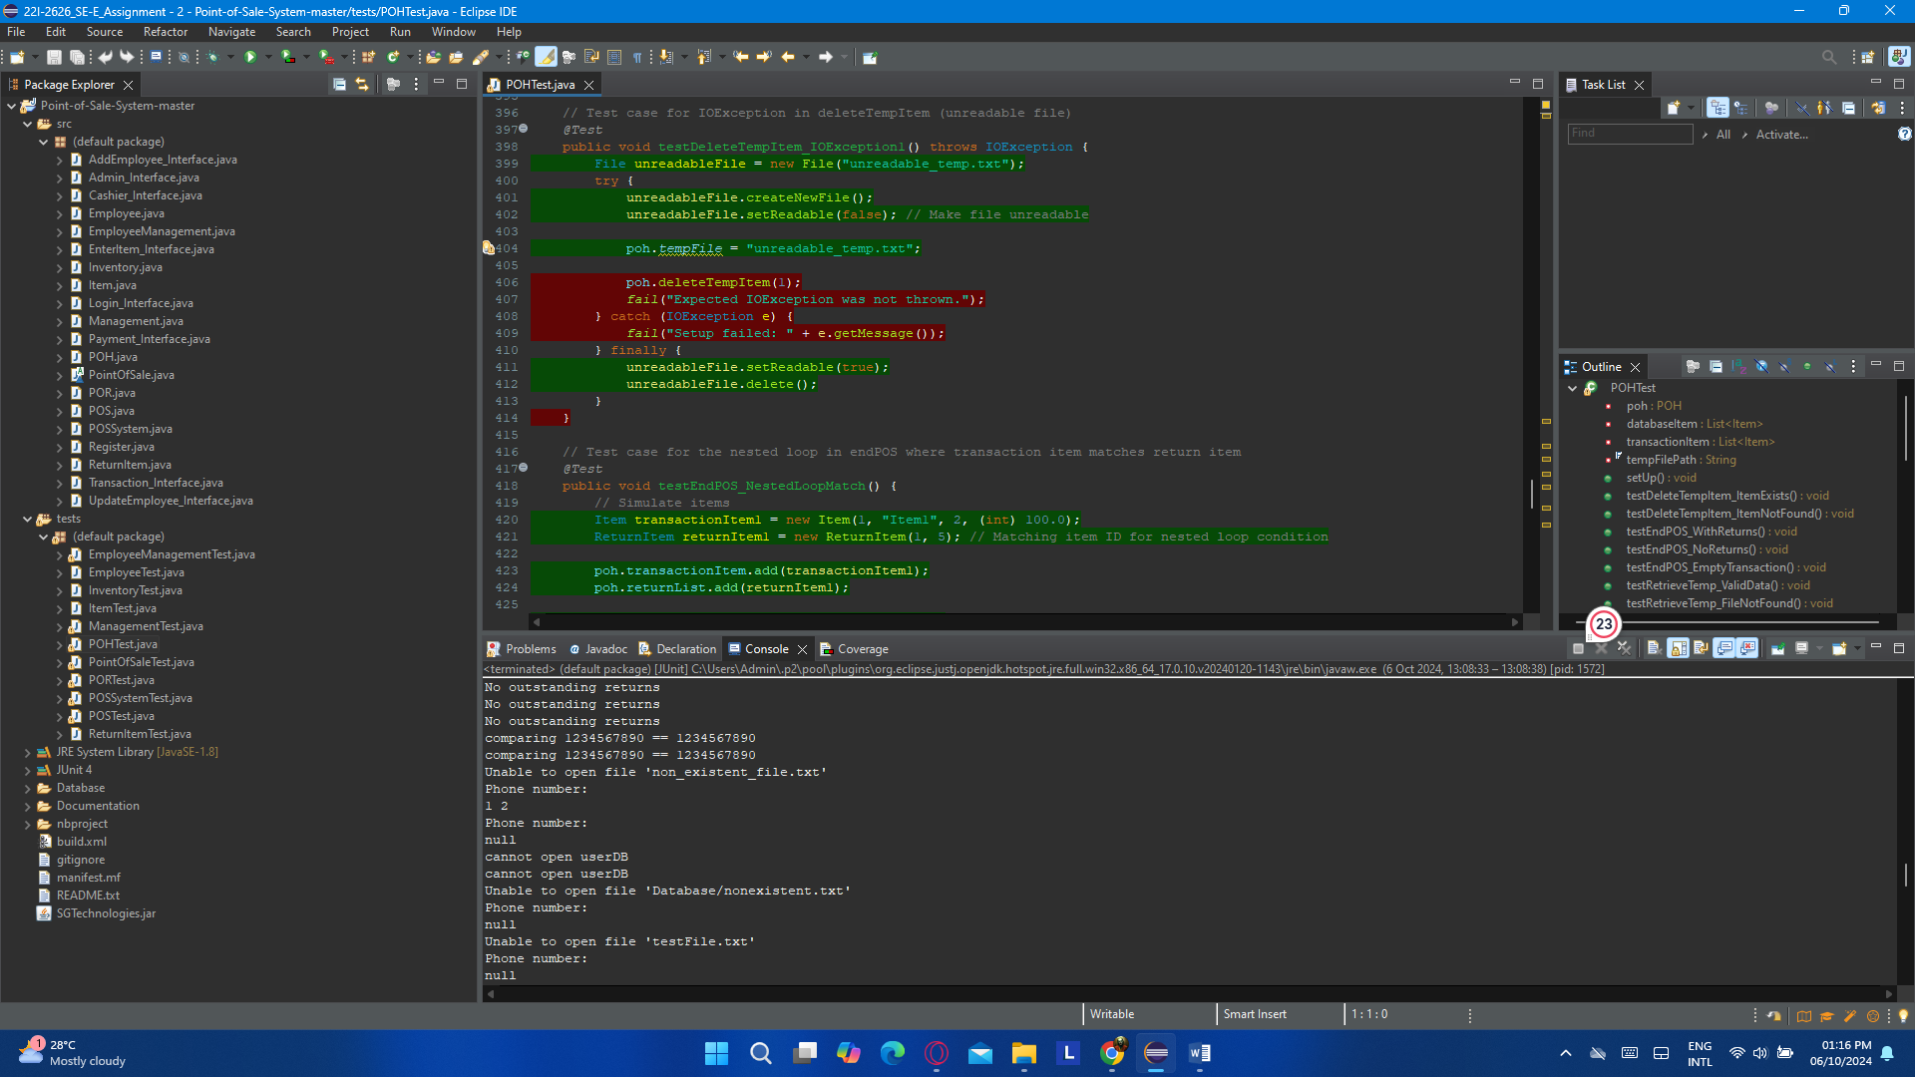

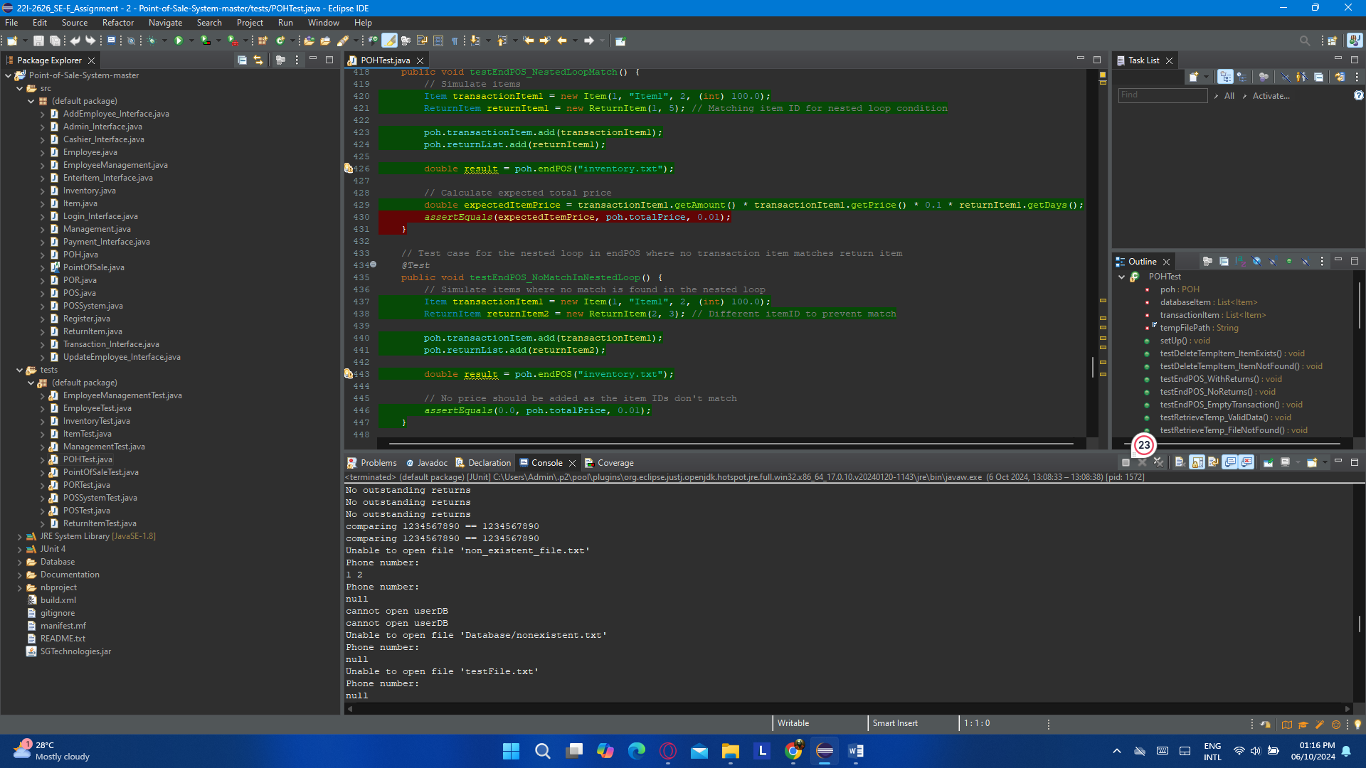

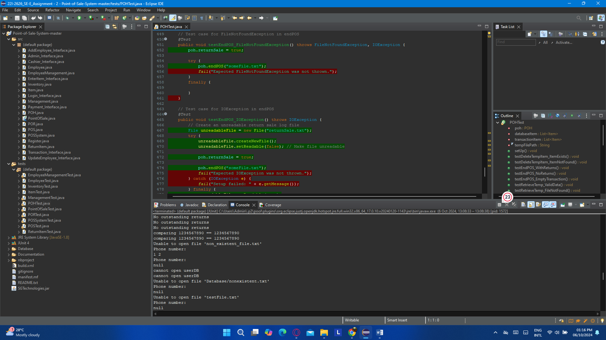

### (g). PointOfSaleTest.java

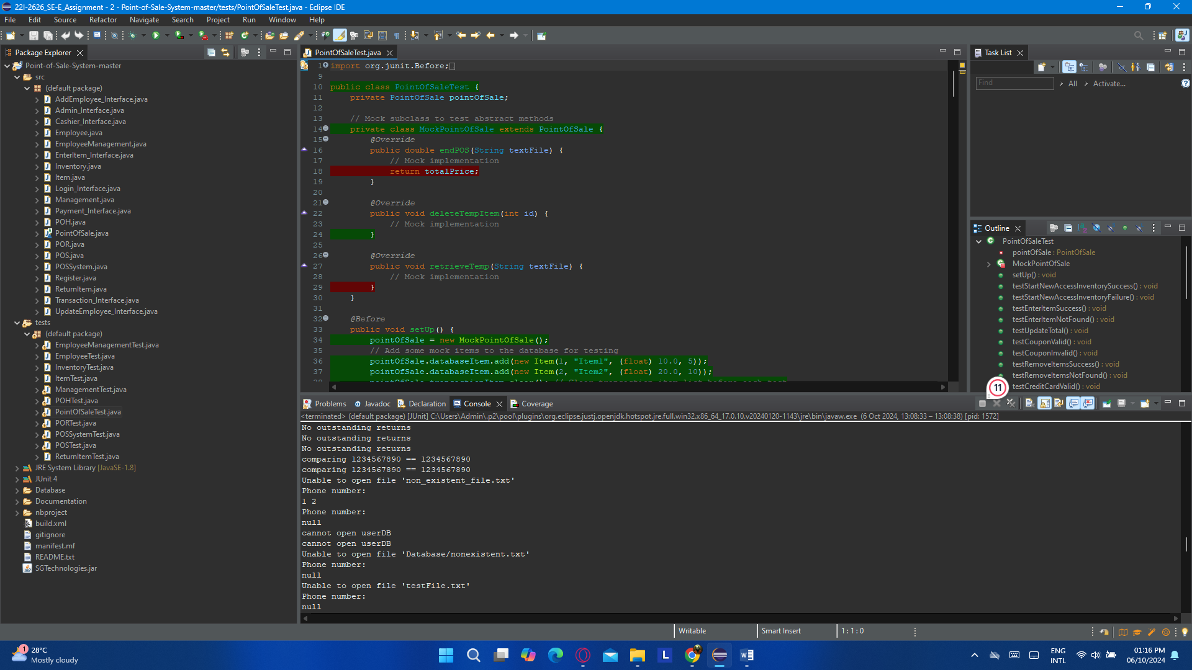

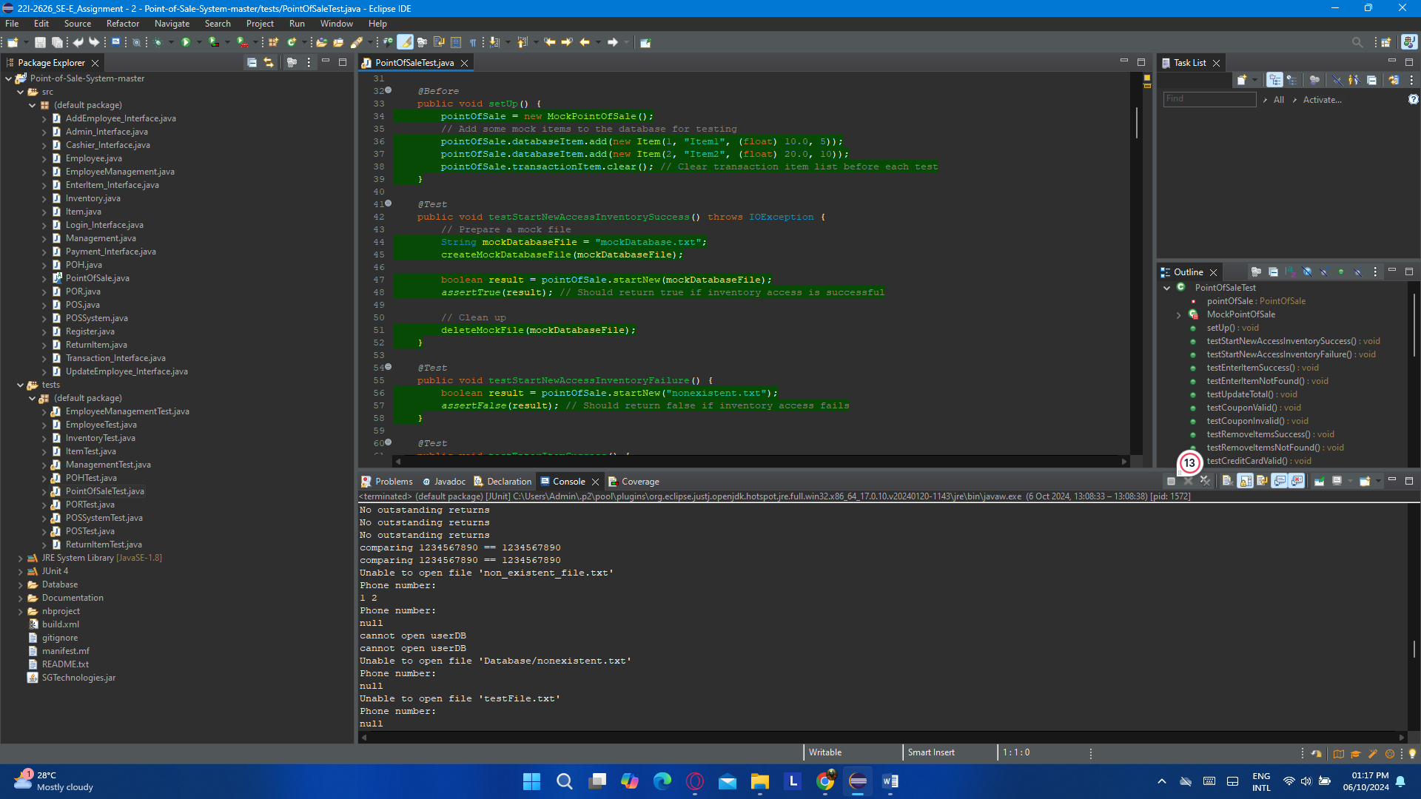

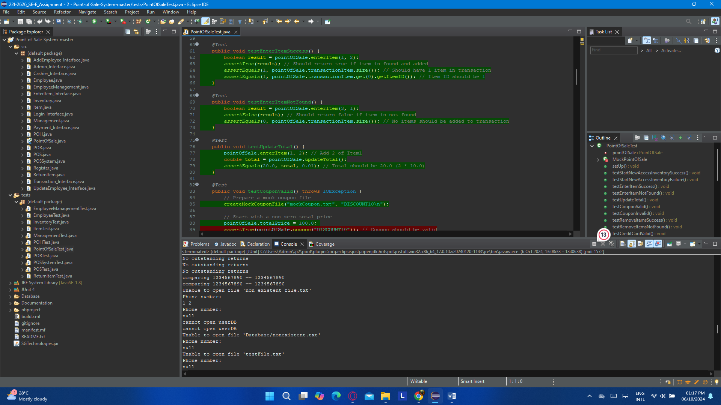

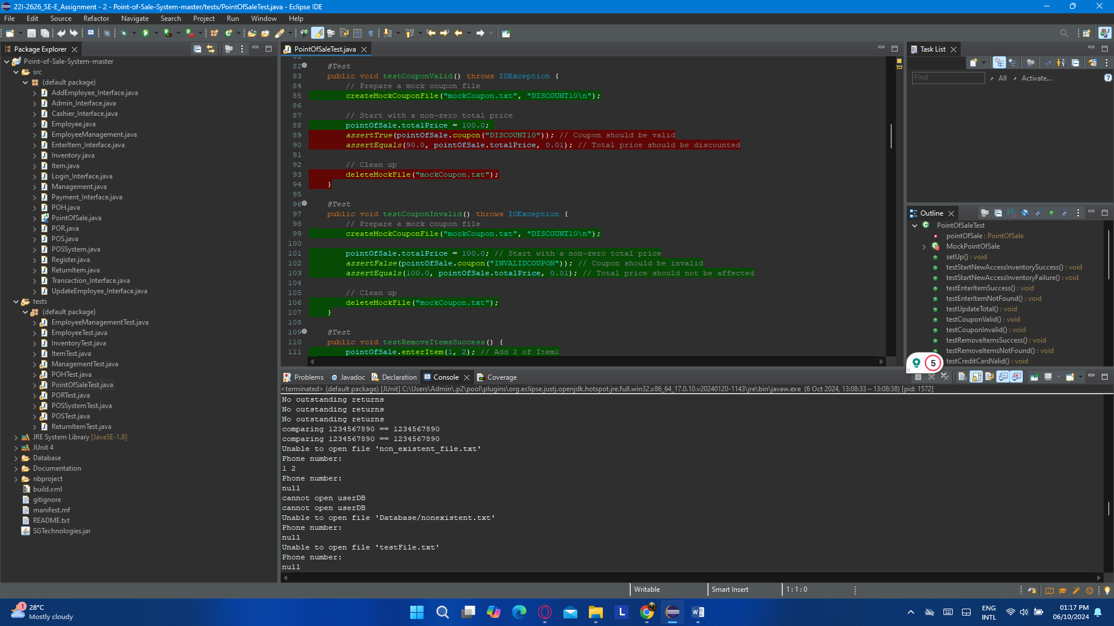

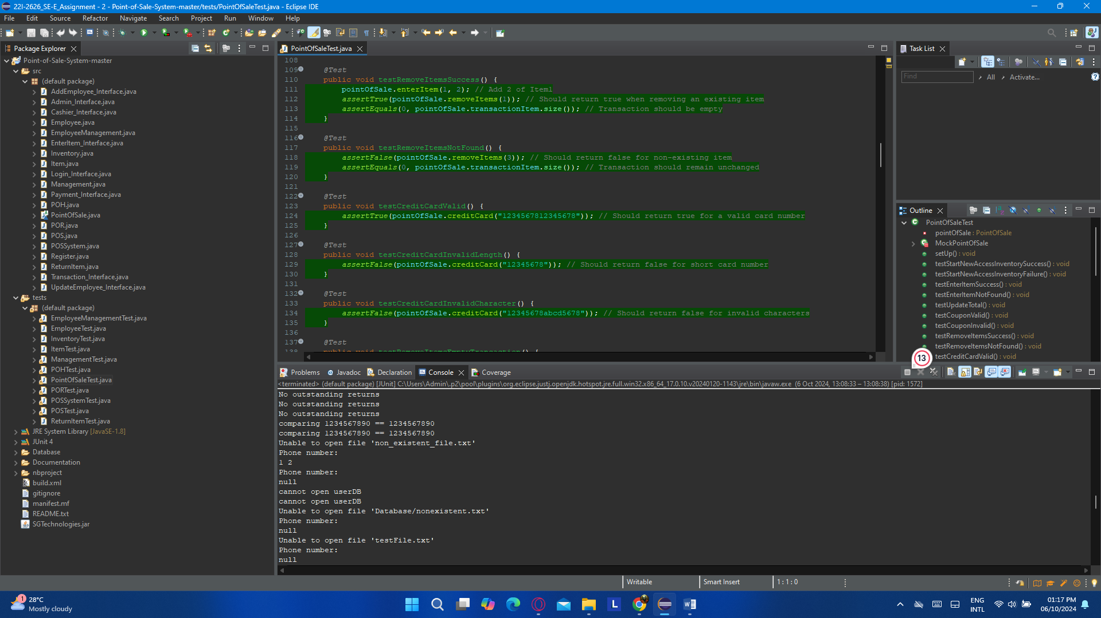

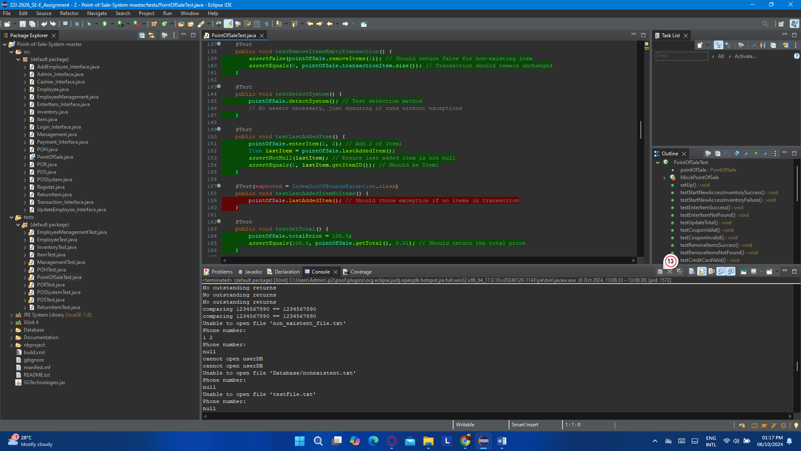

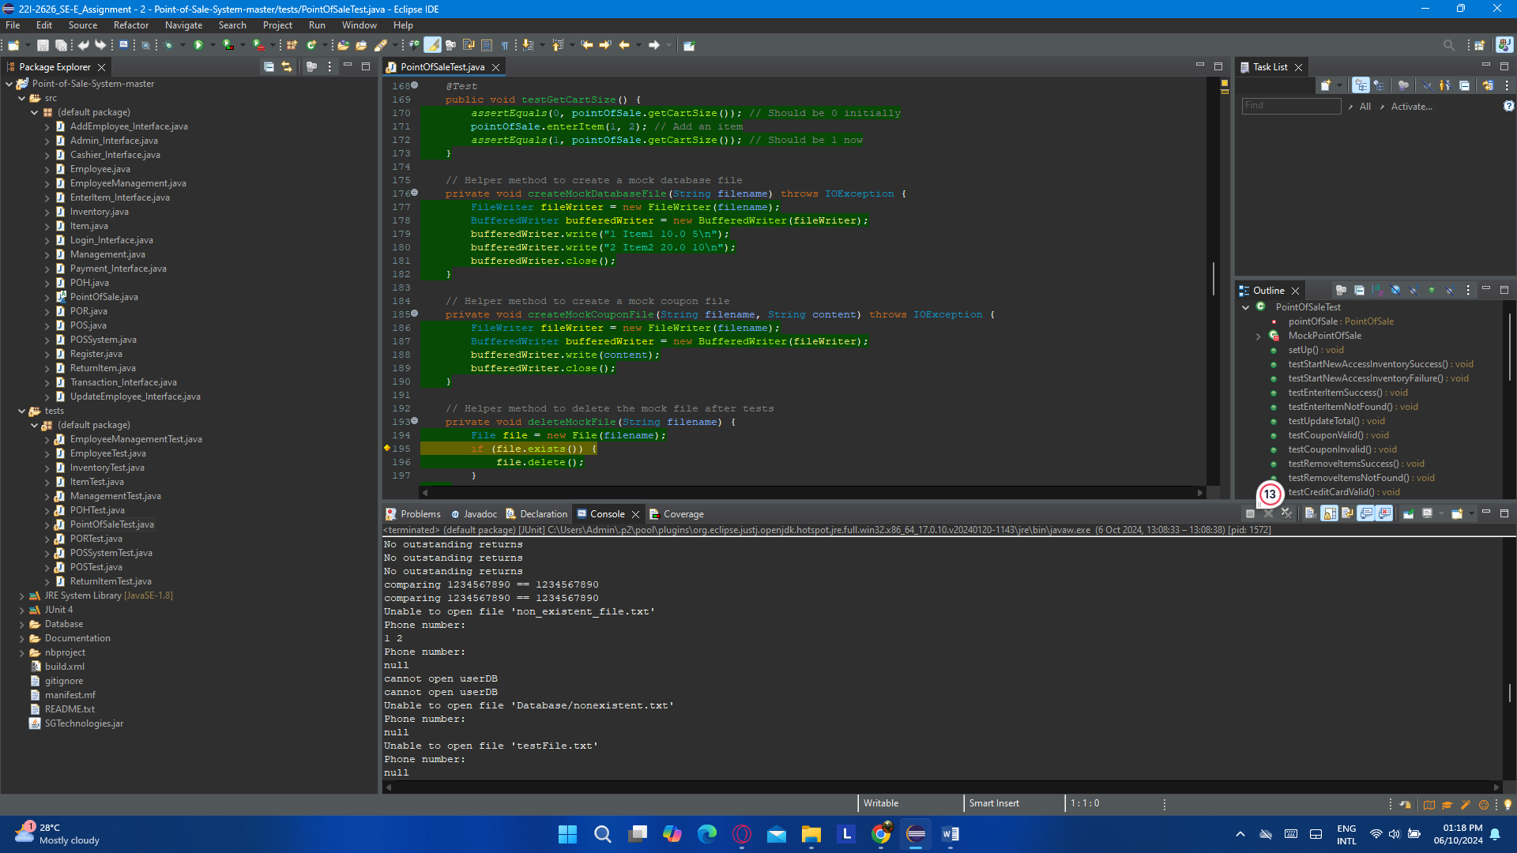

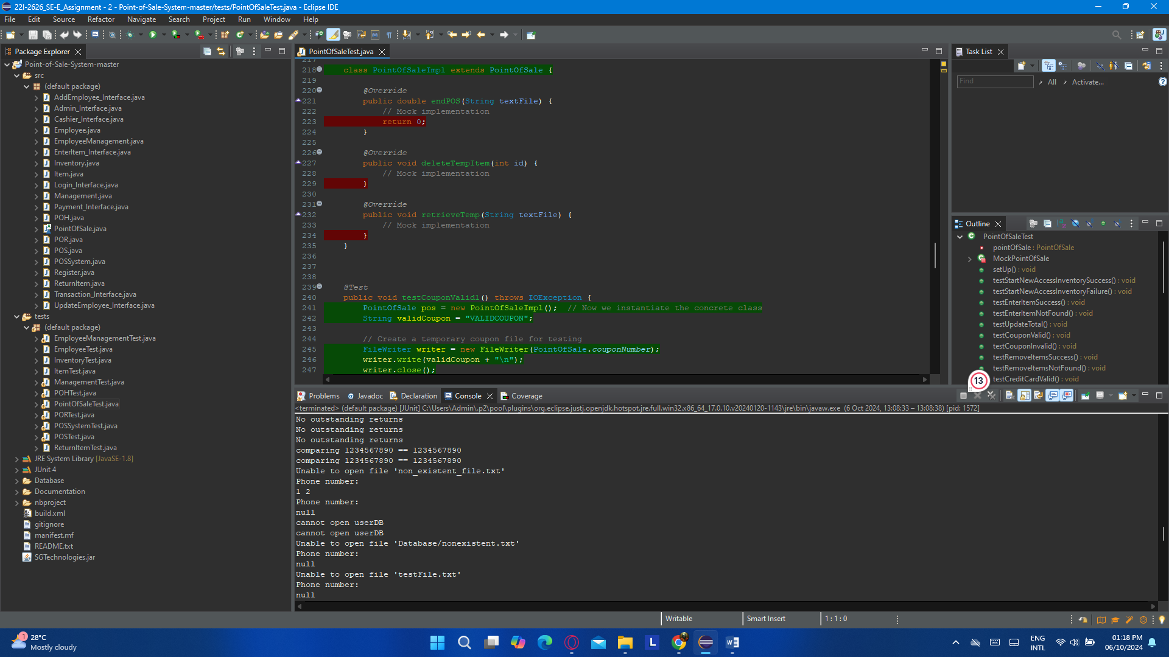

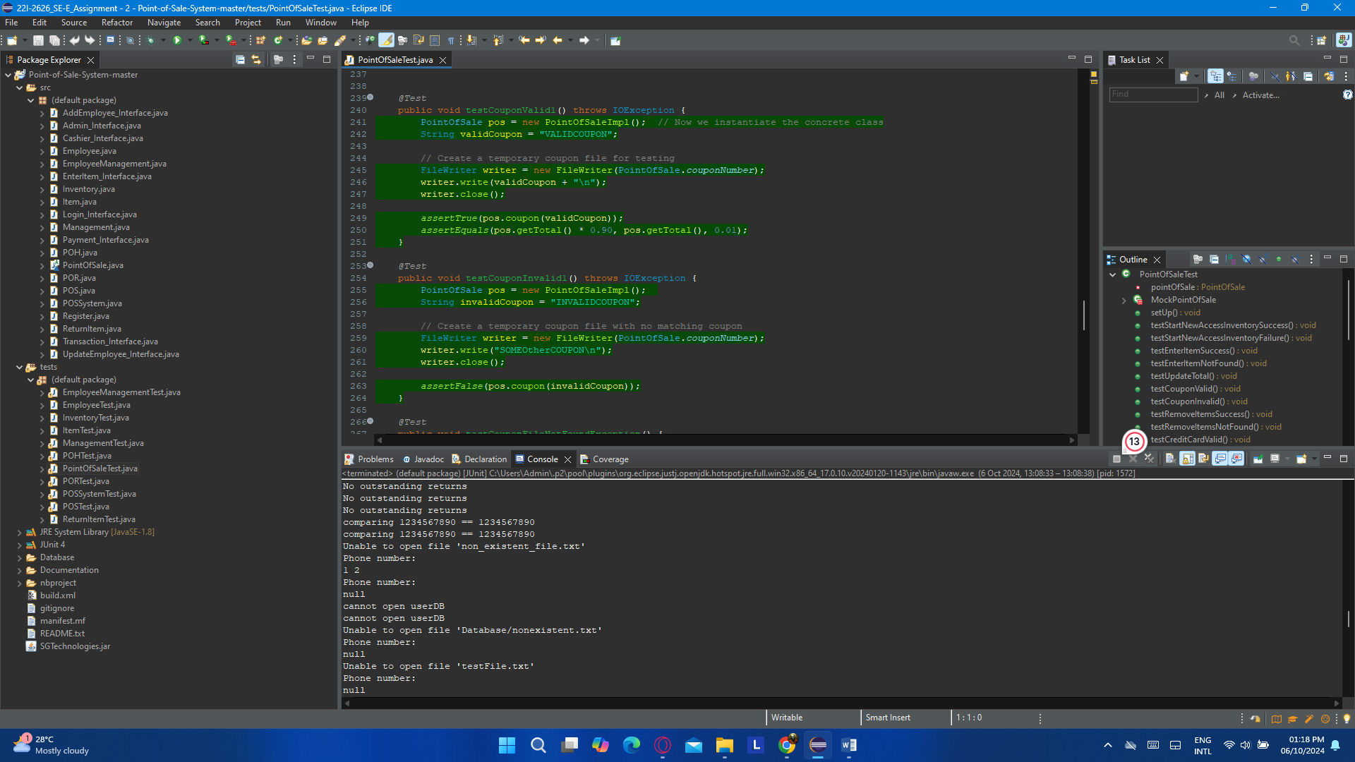

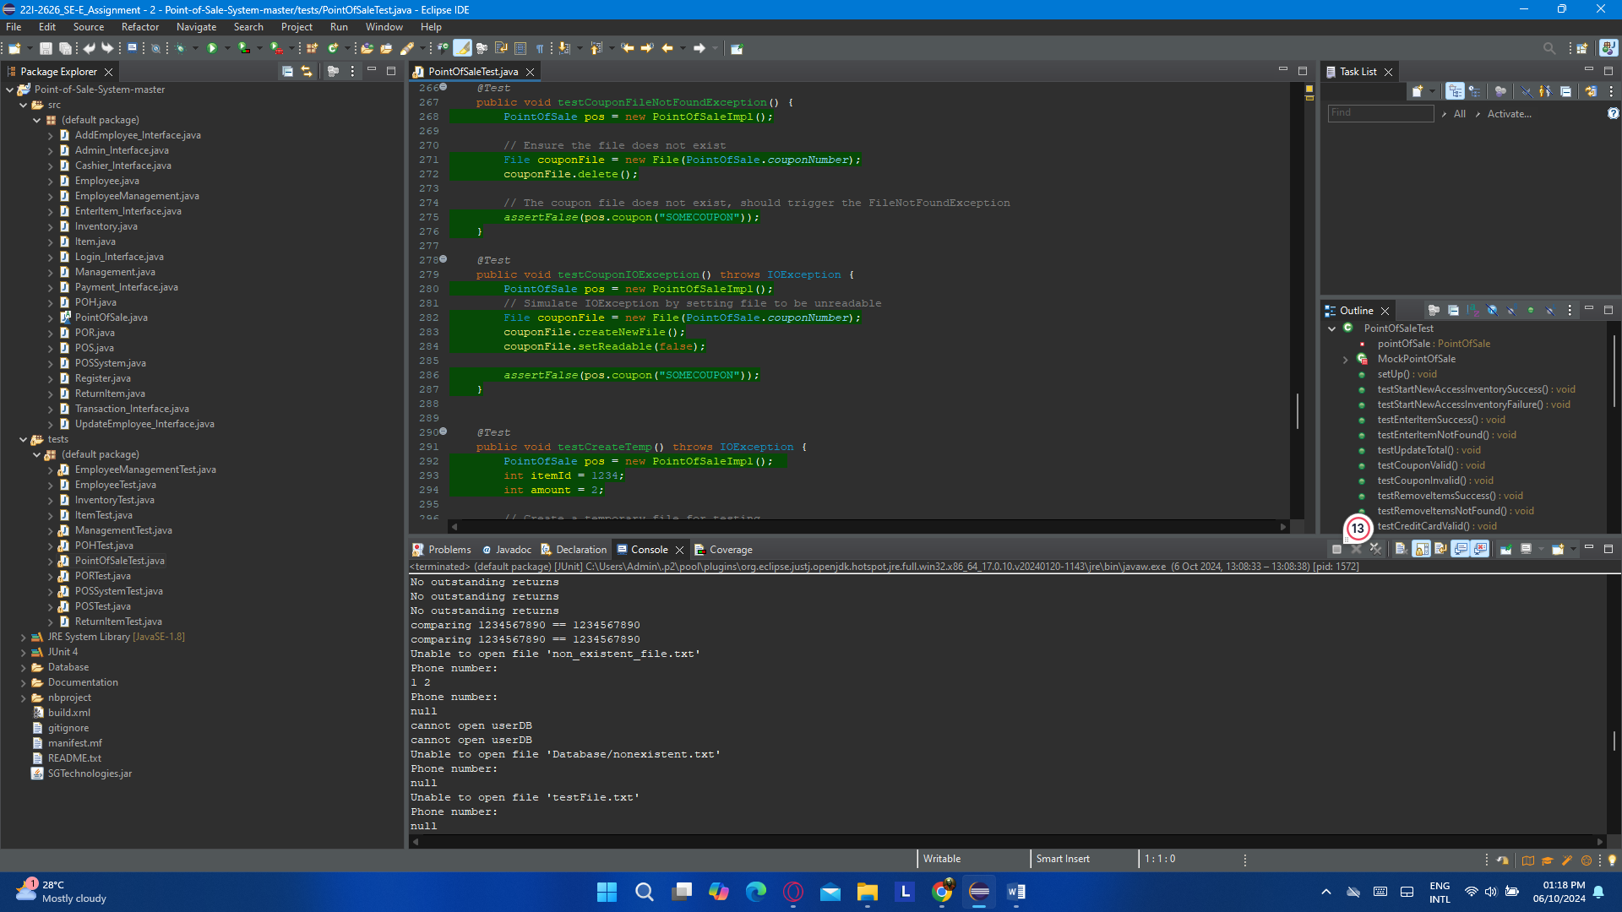

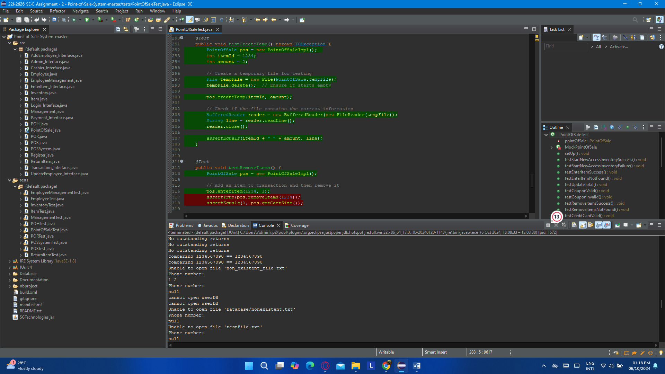

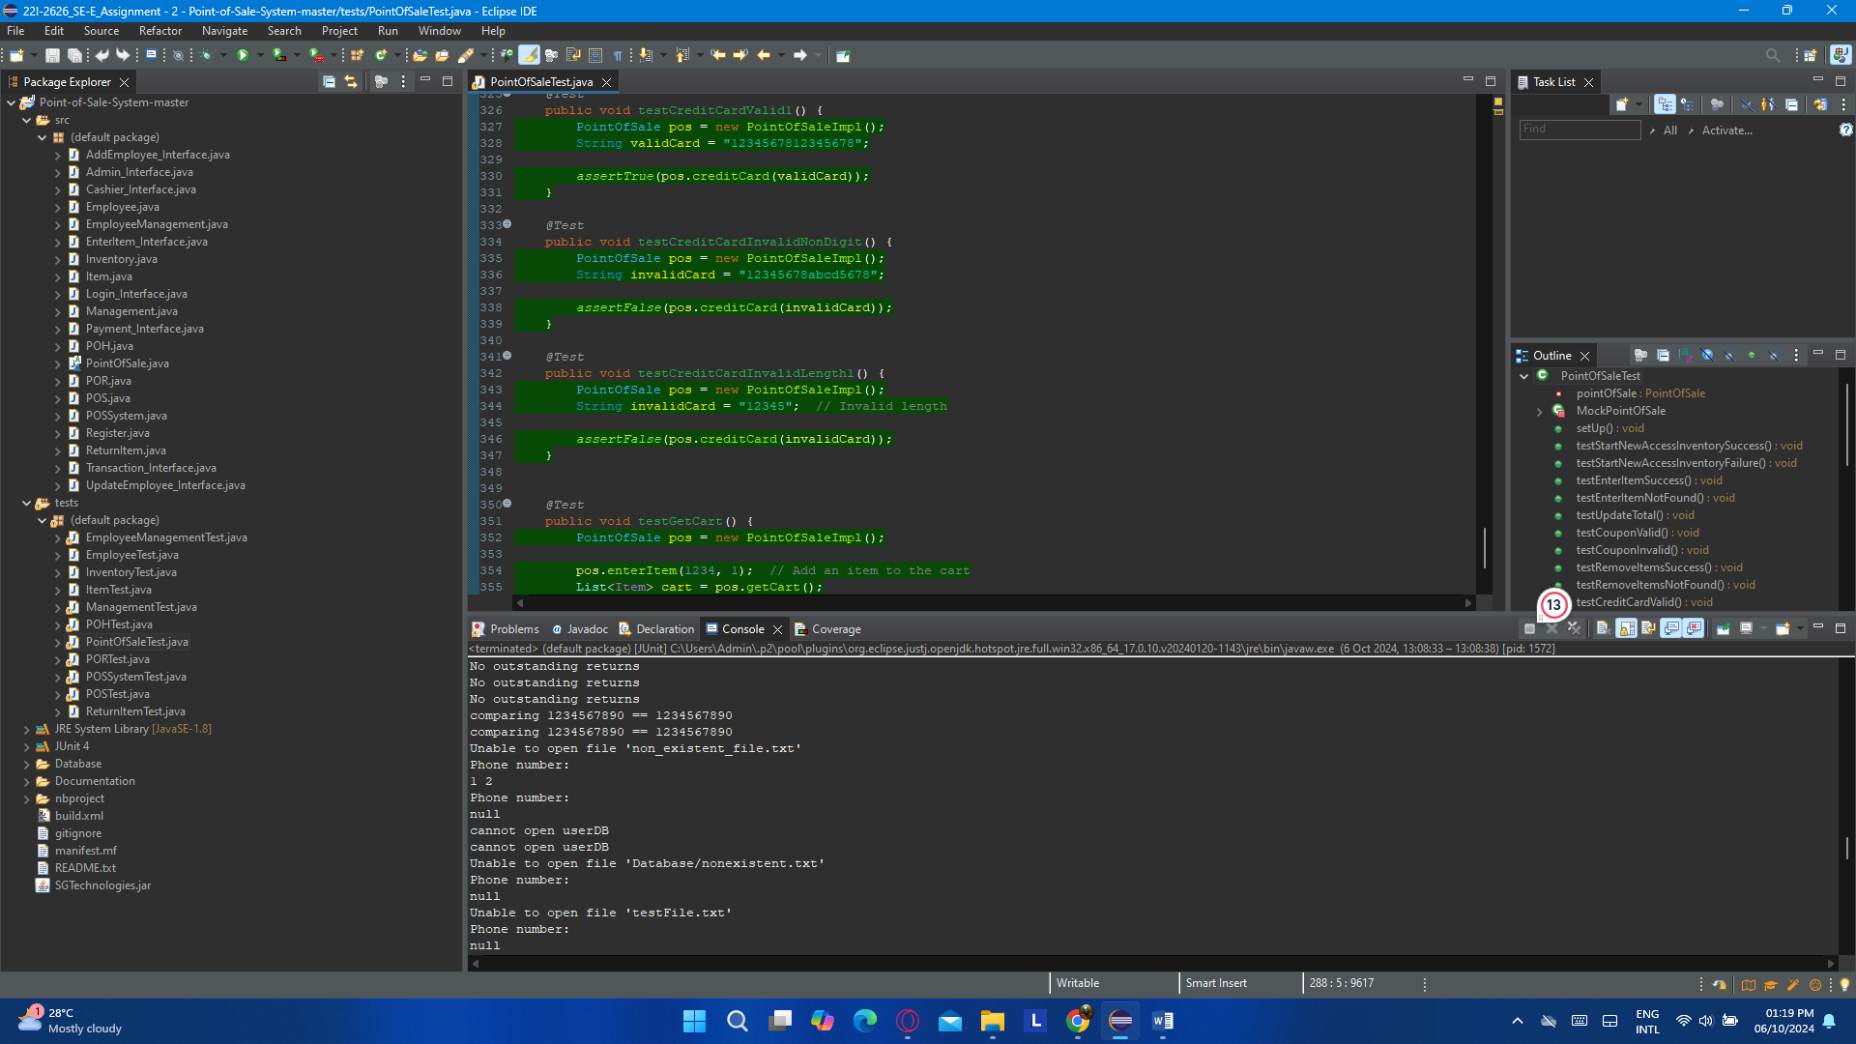

### (h). PORTest.java

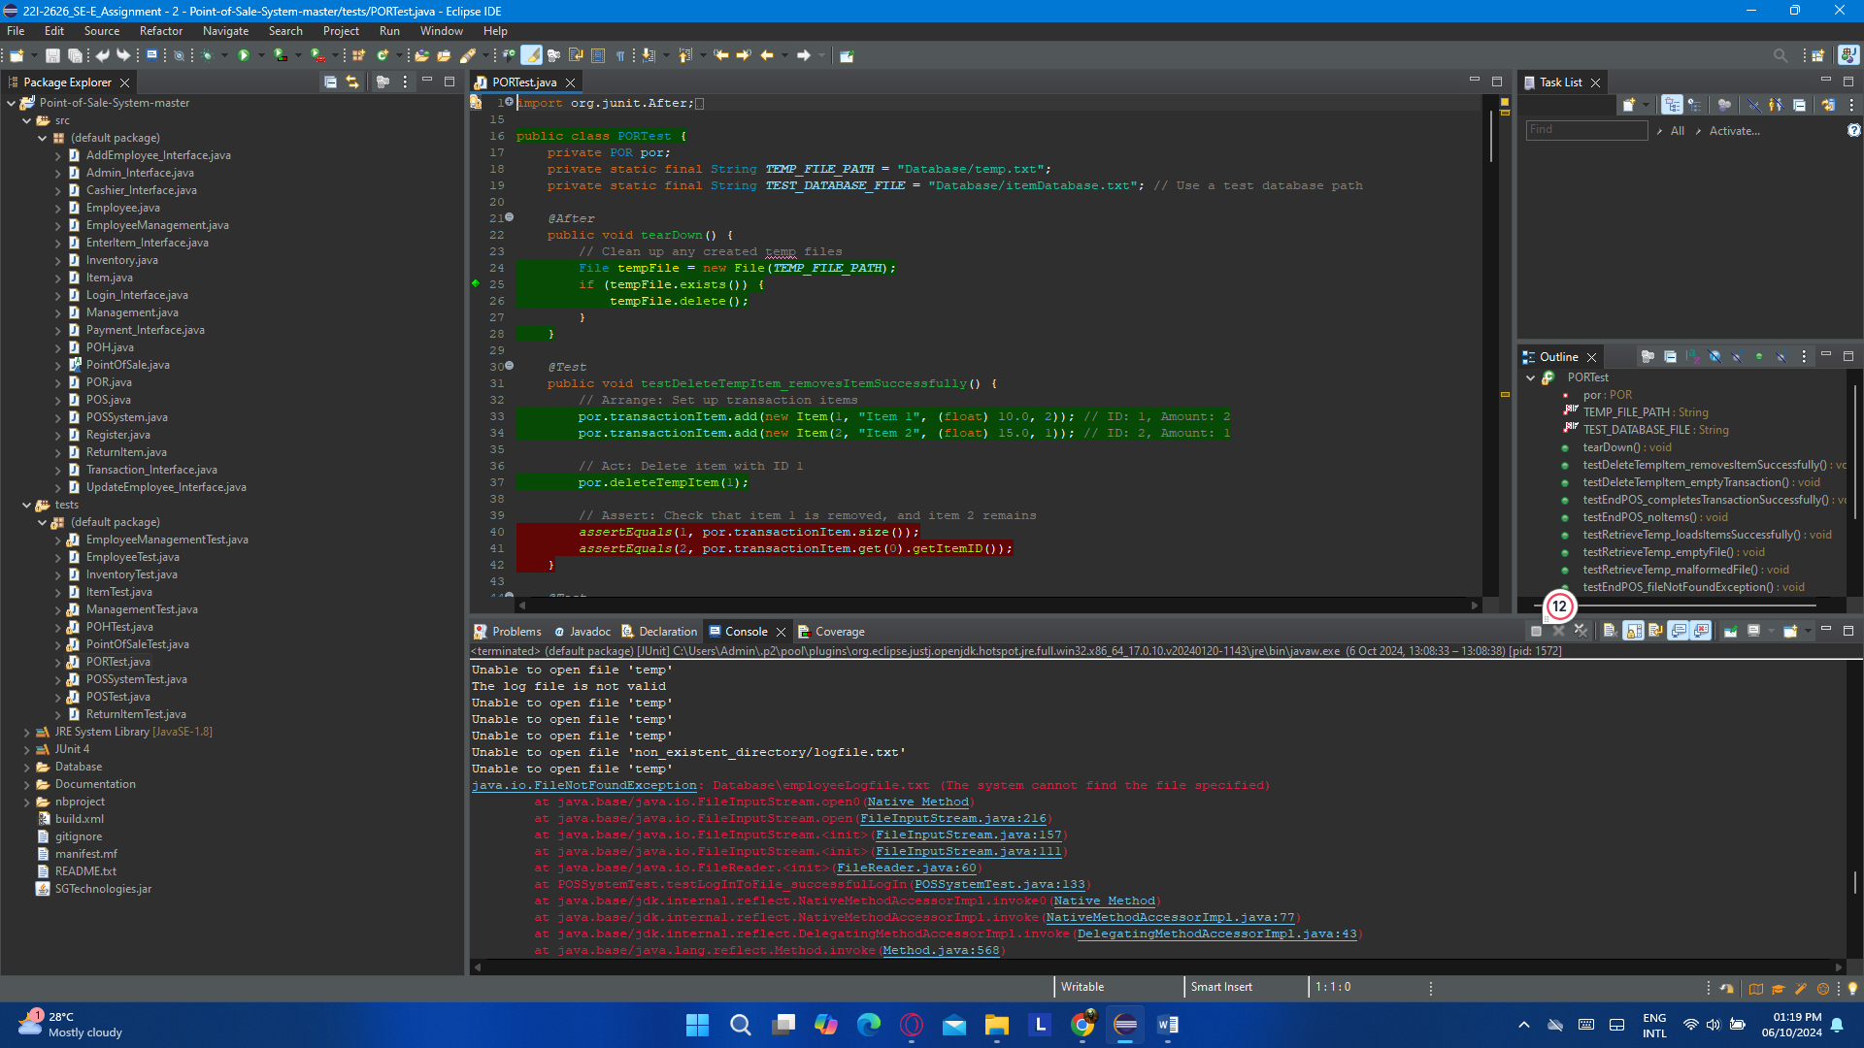

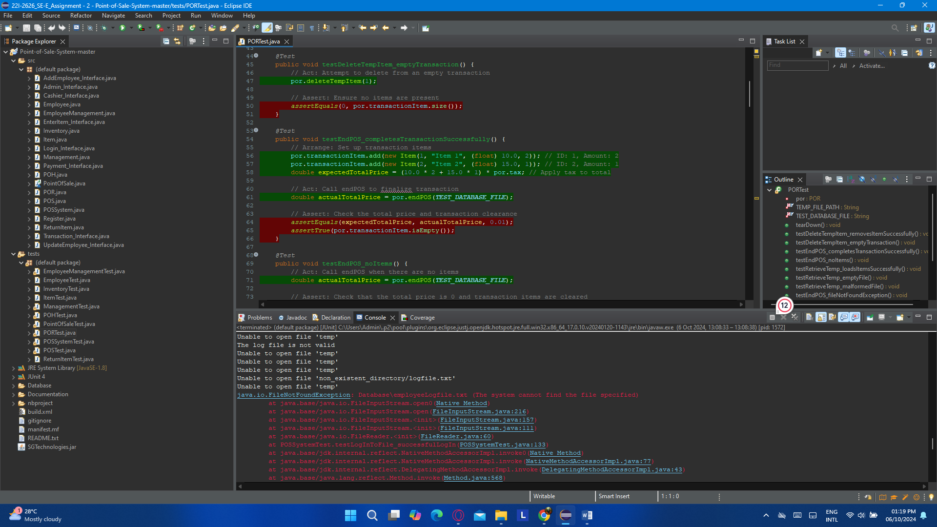

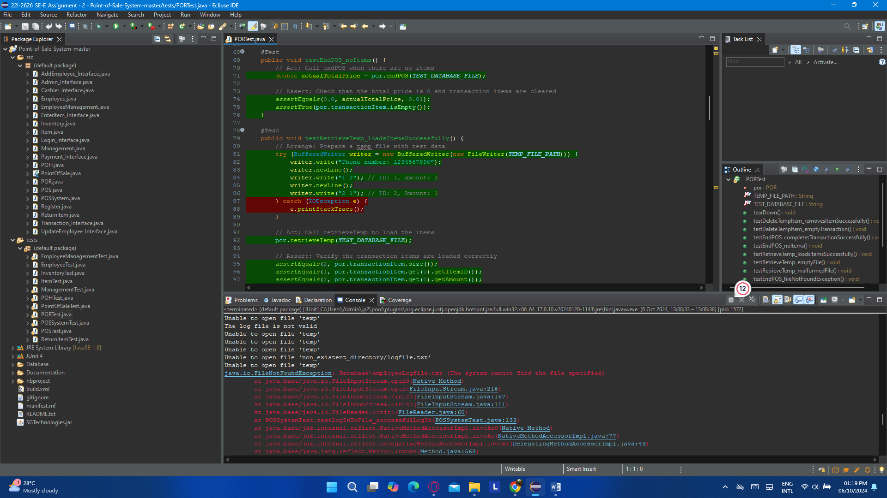

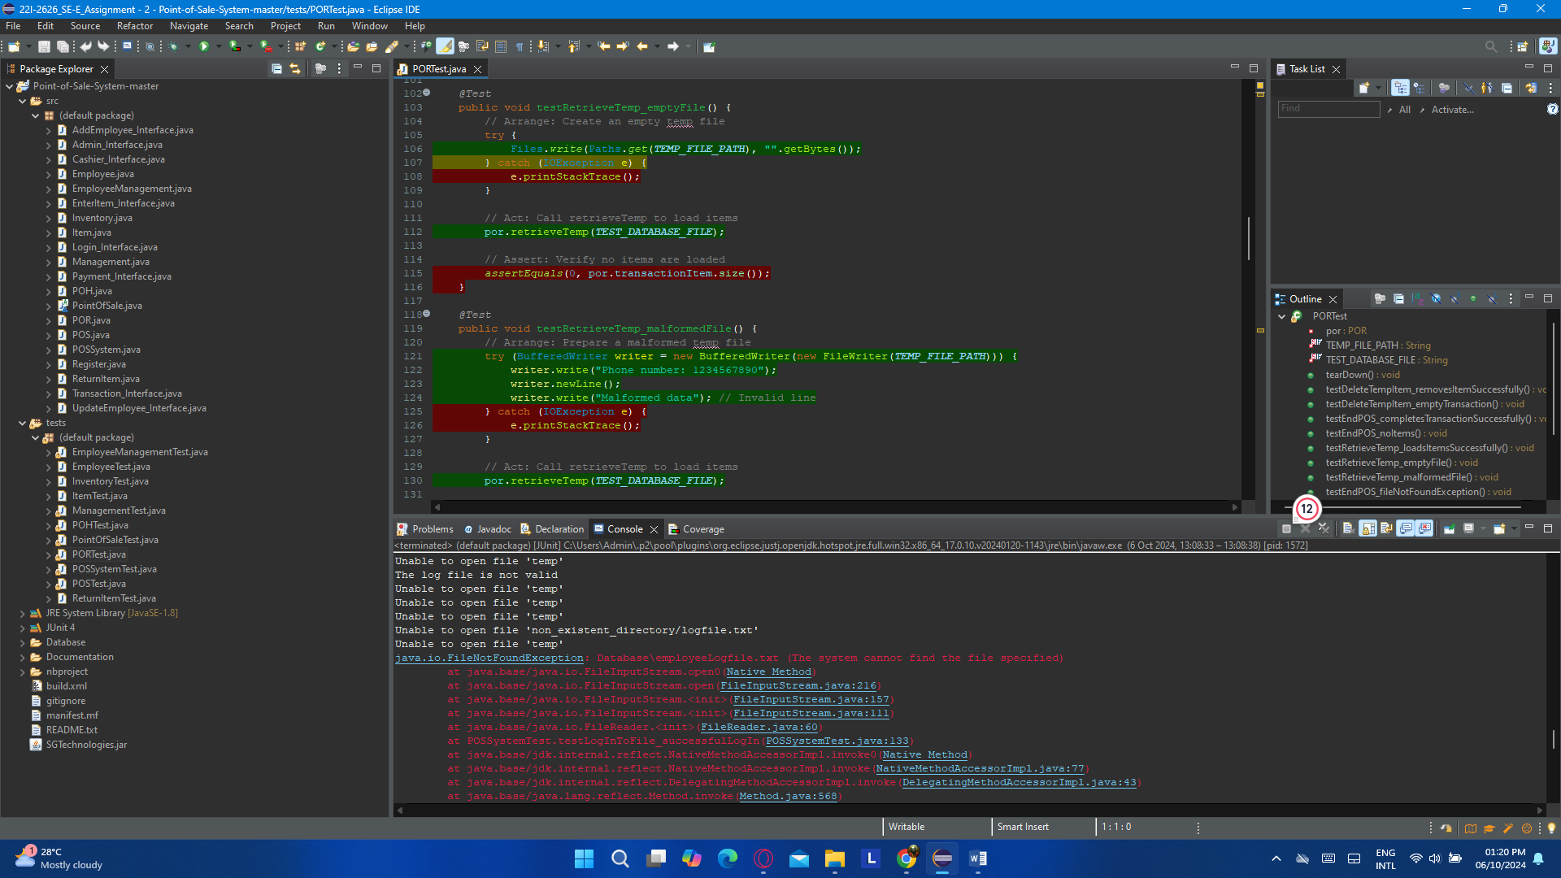

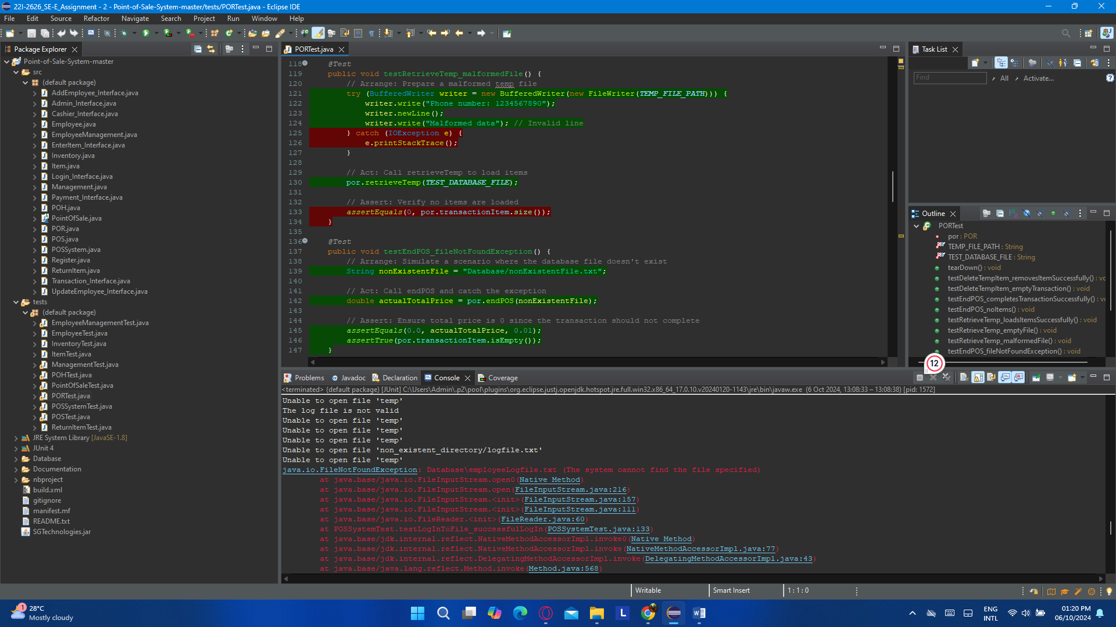

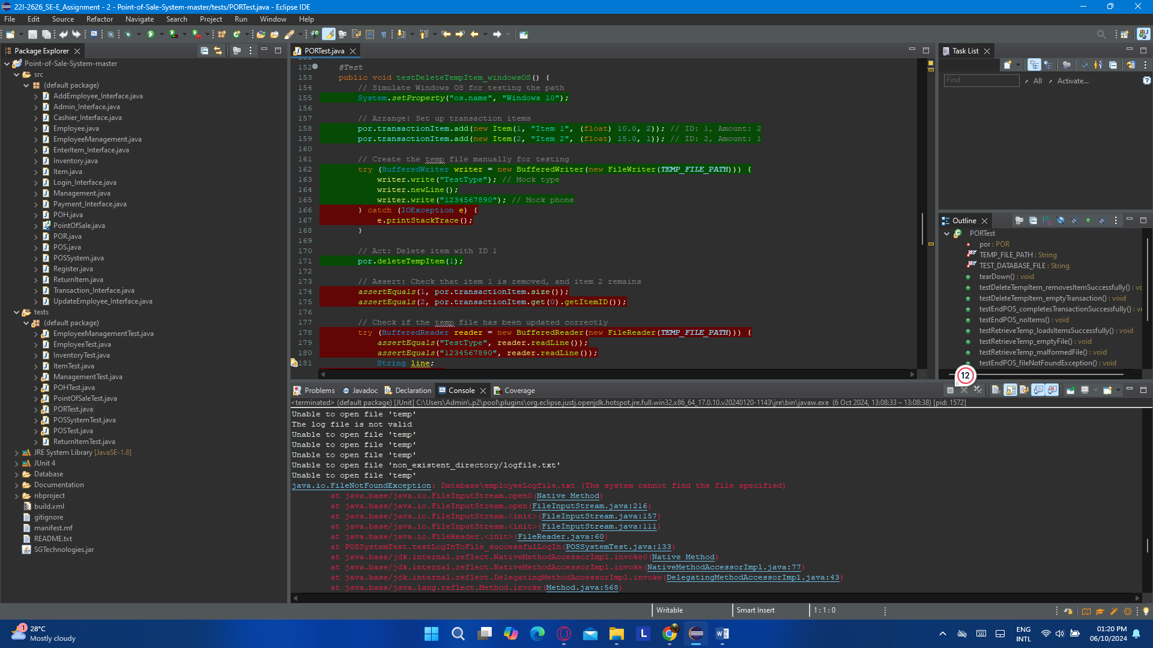

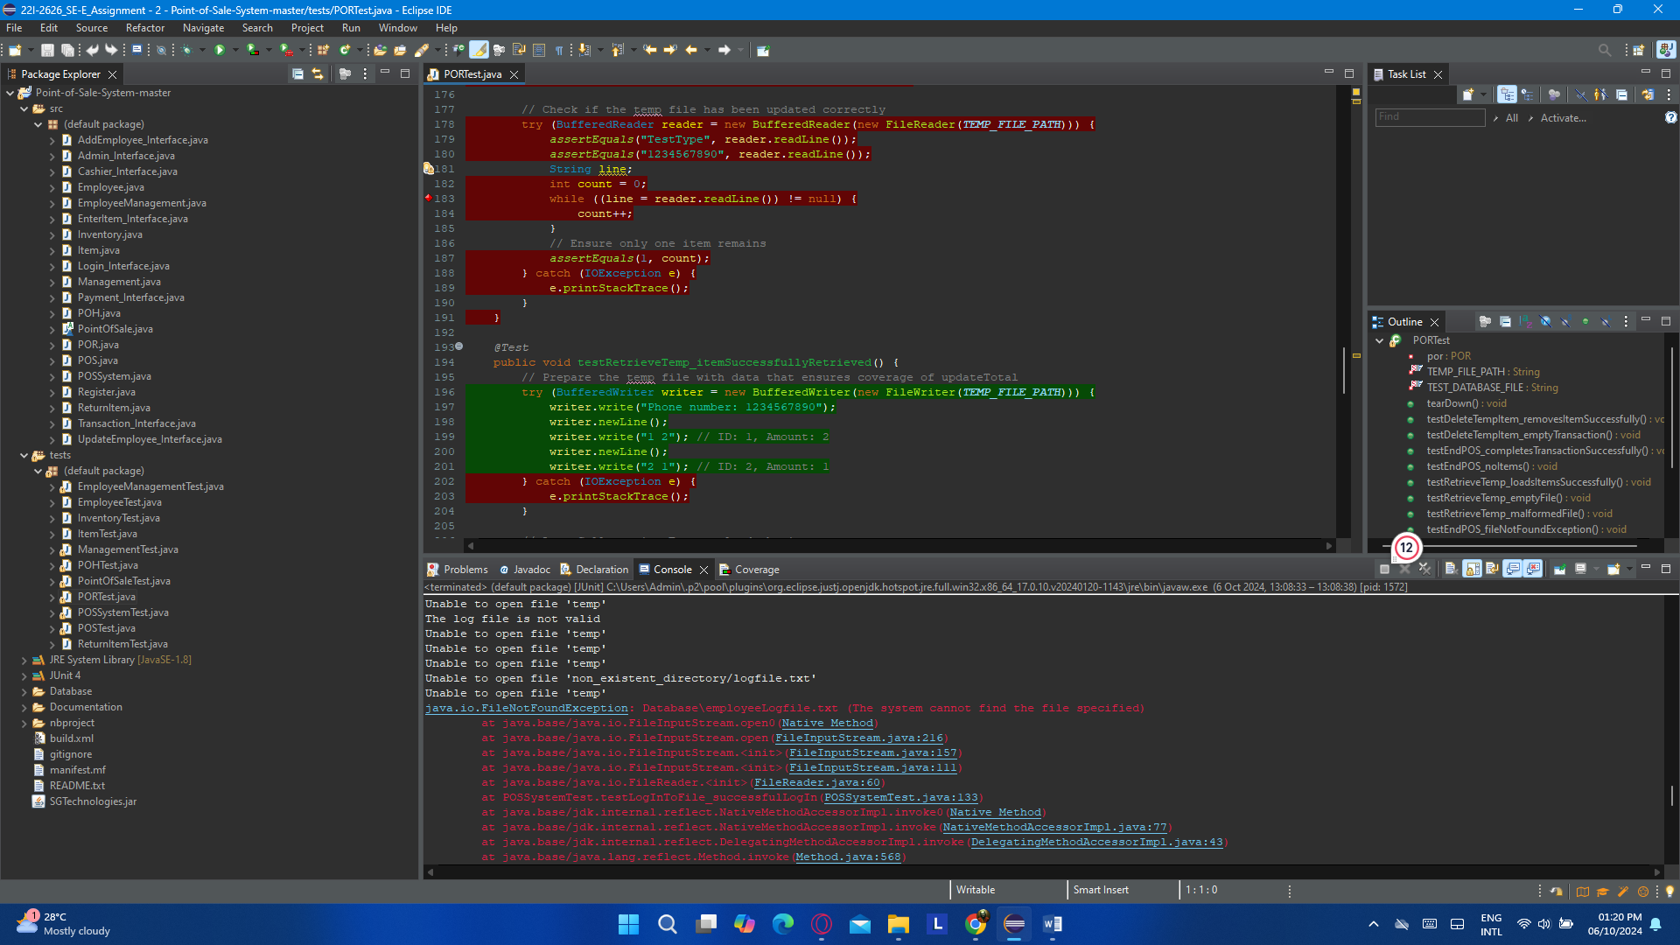

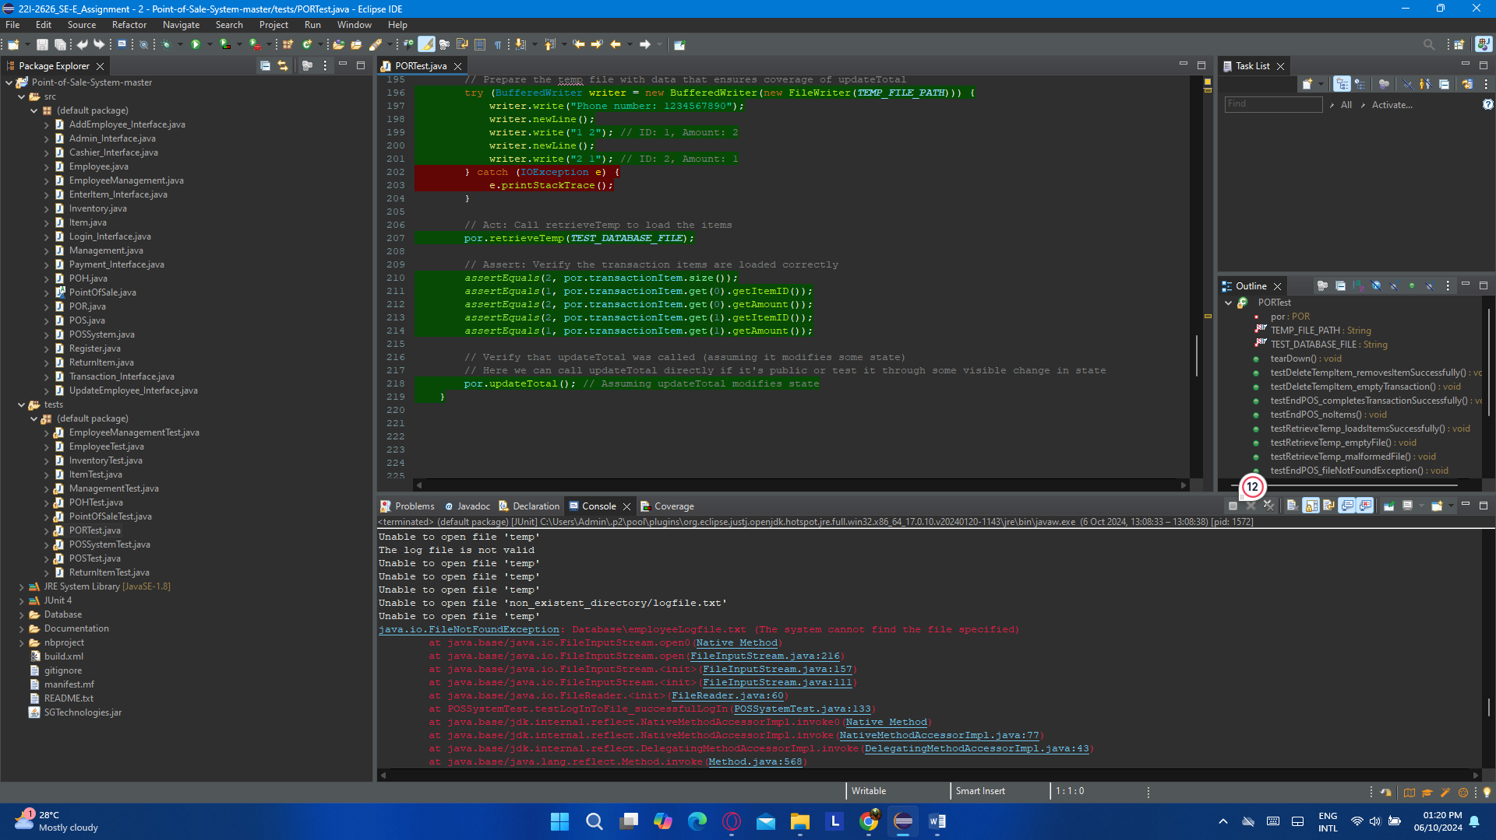

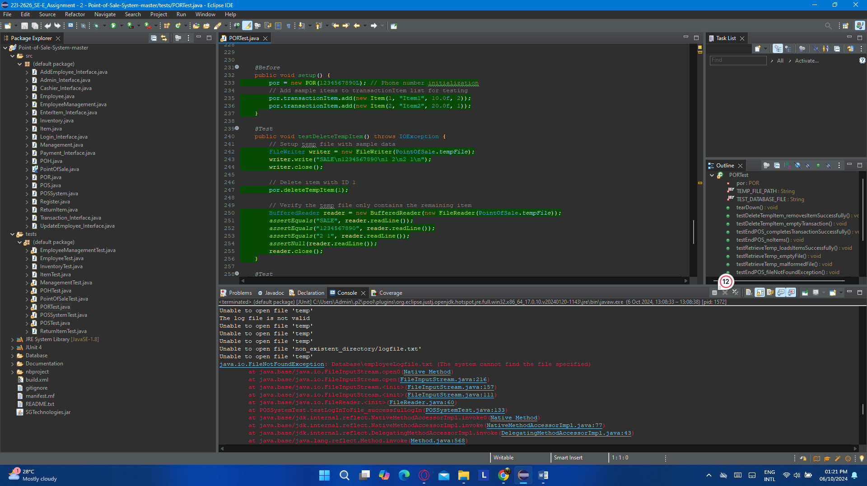

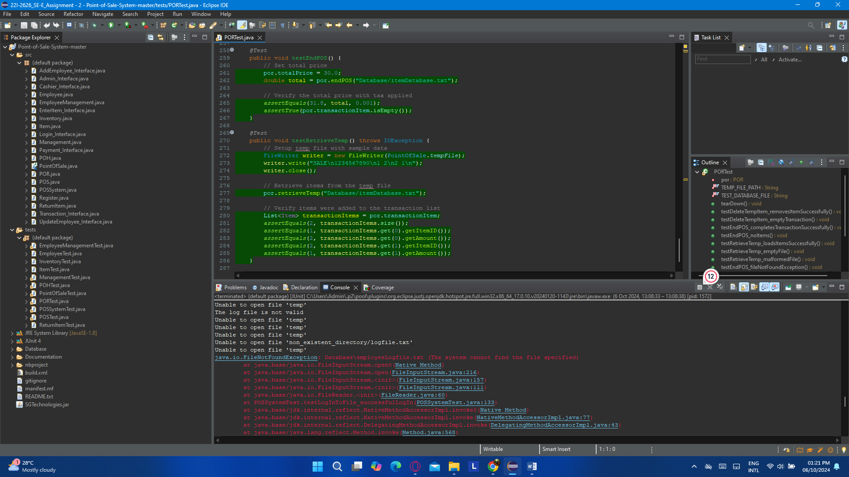

### (i). POSSystemTest.java

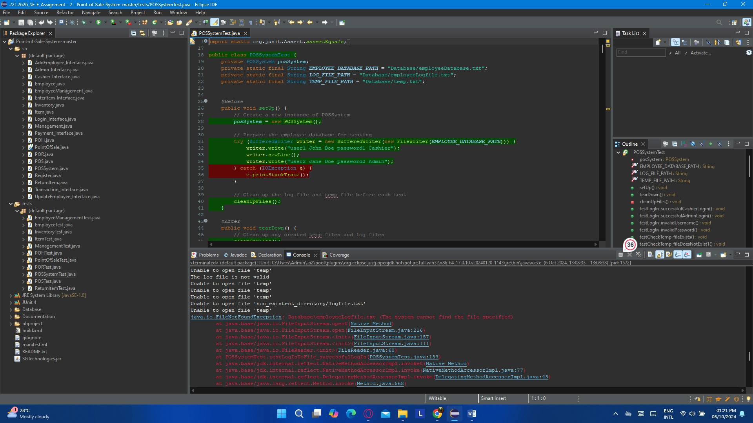

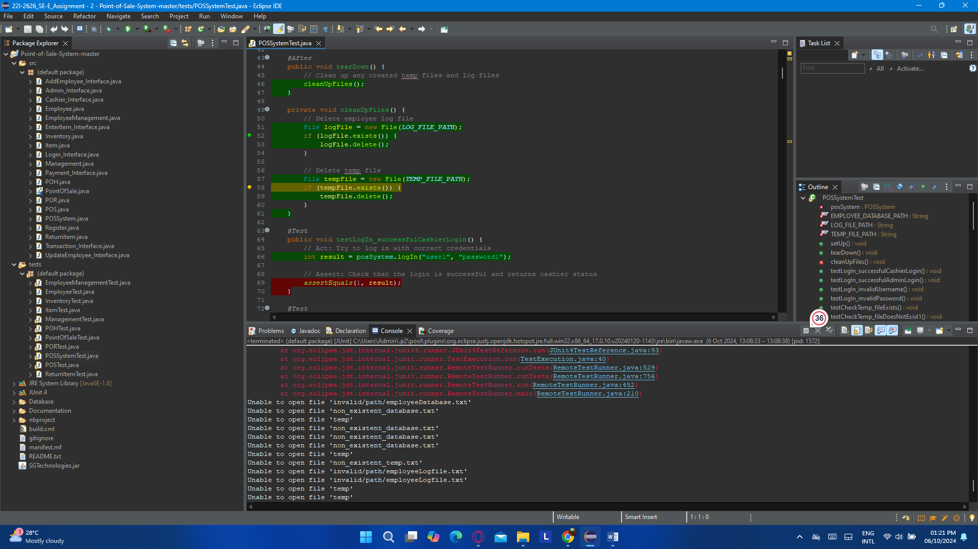

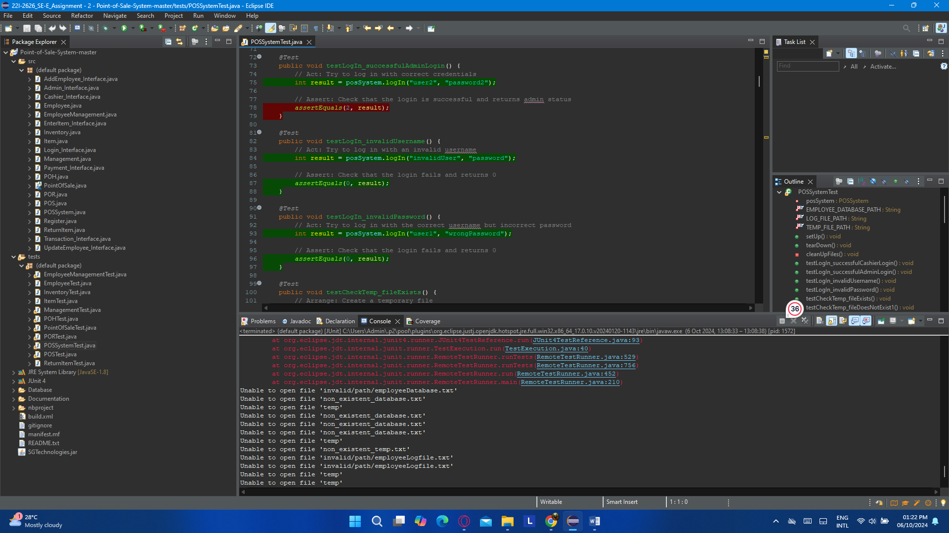

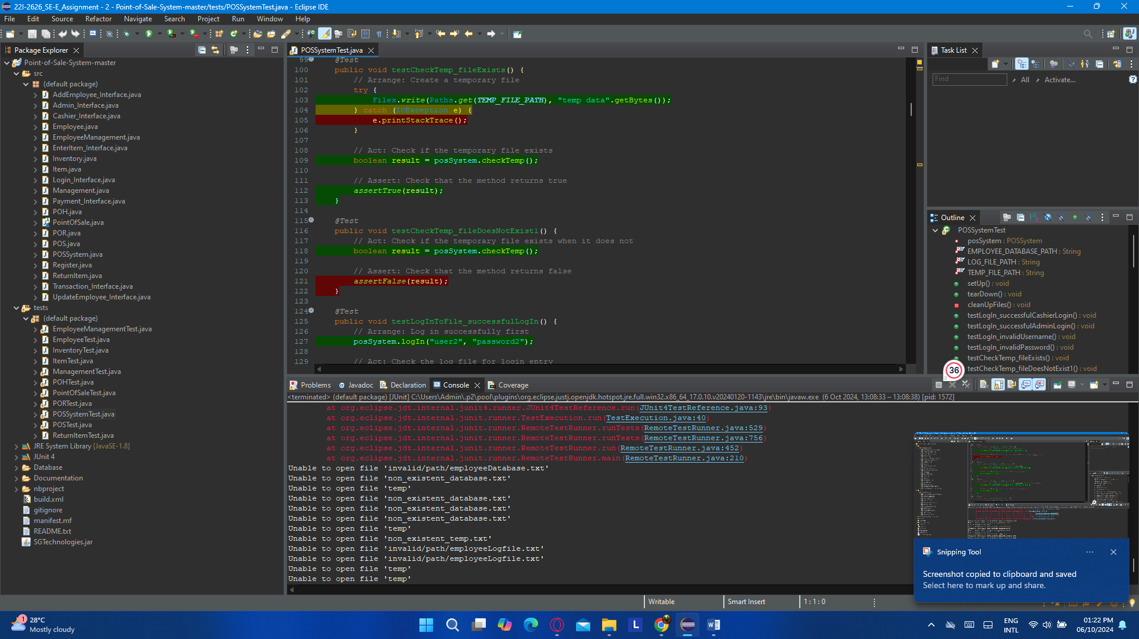

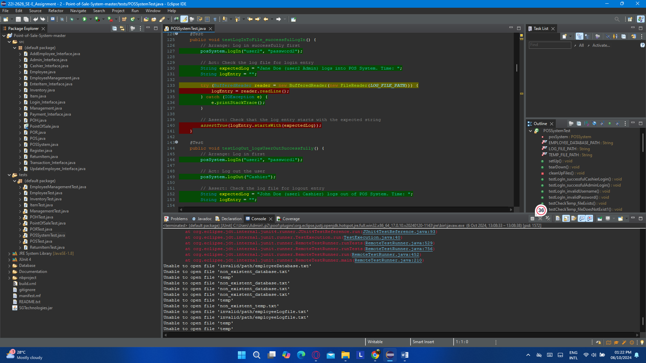

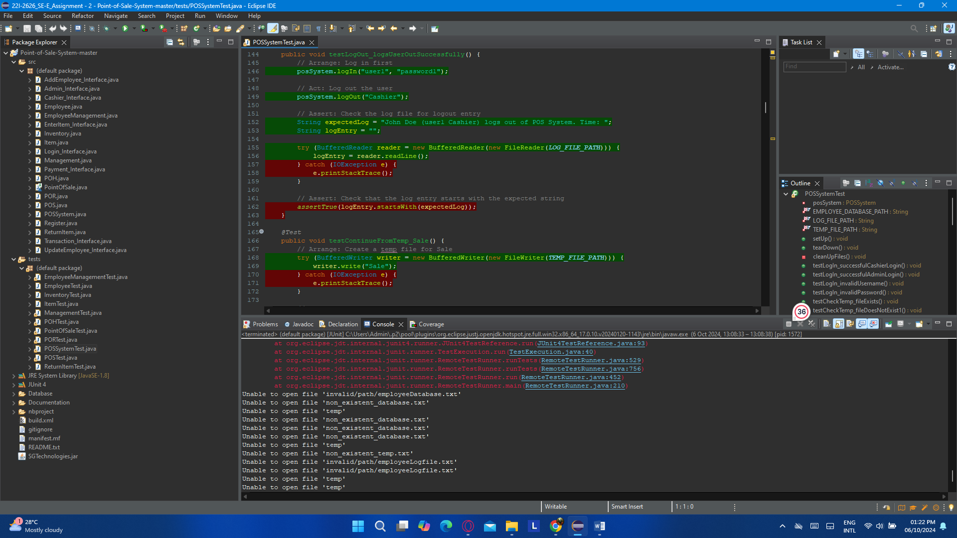

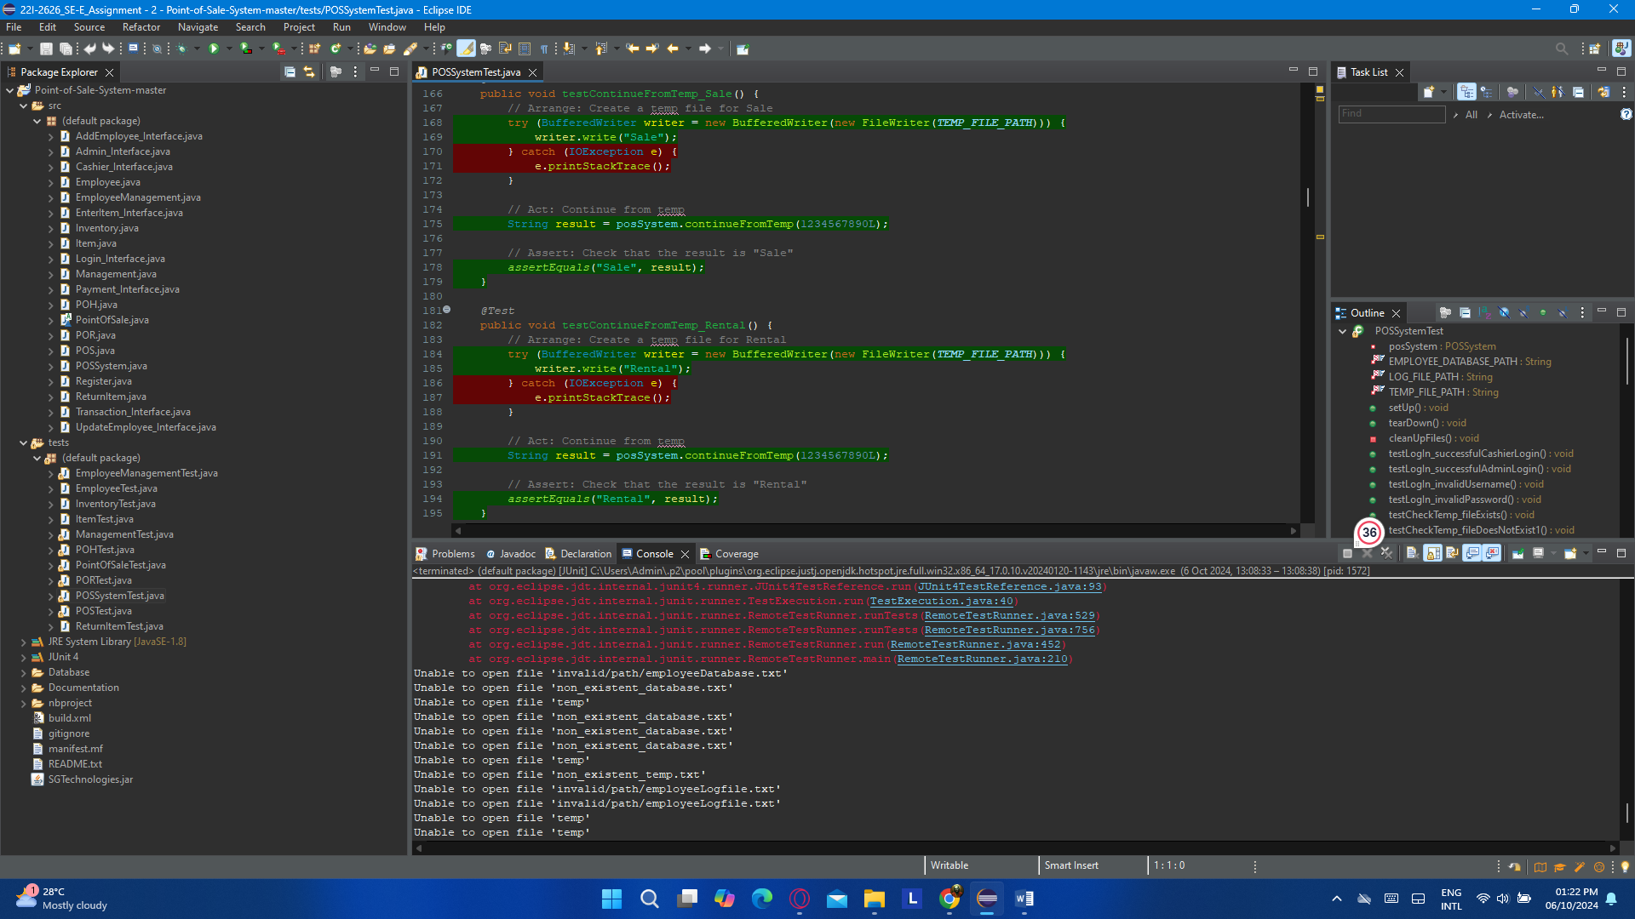

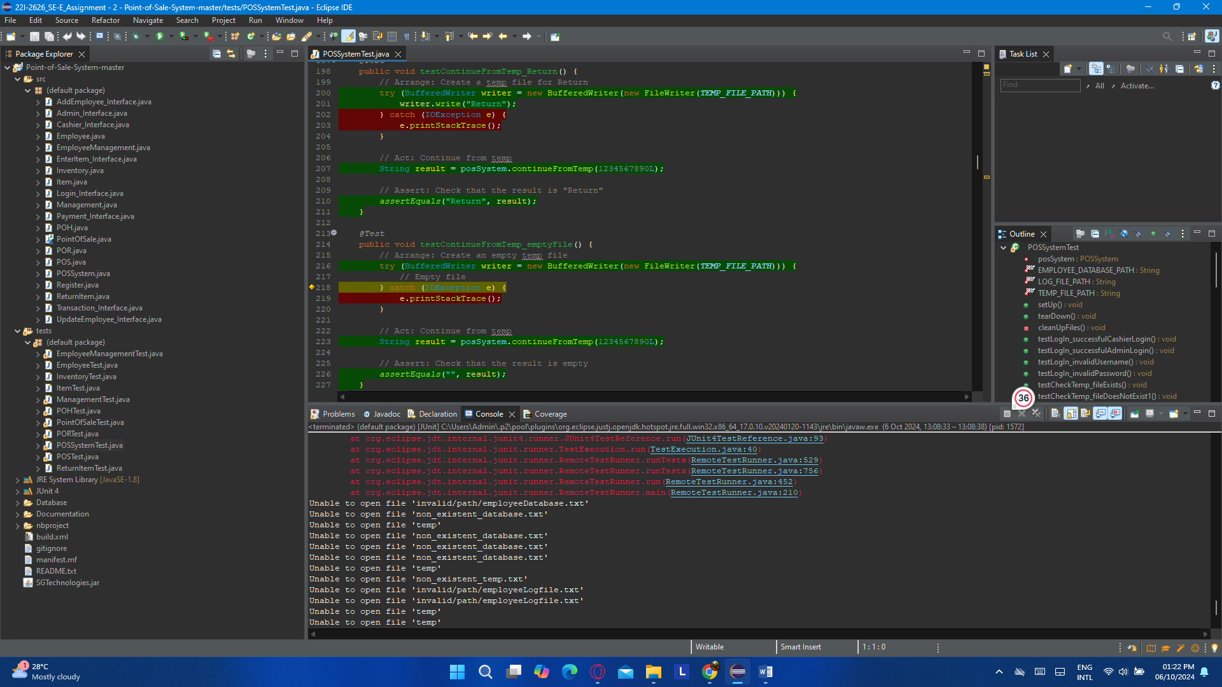

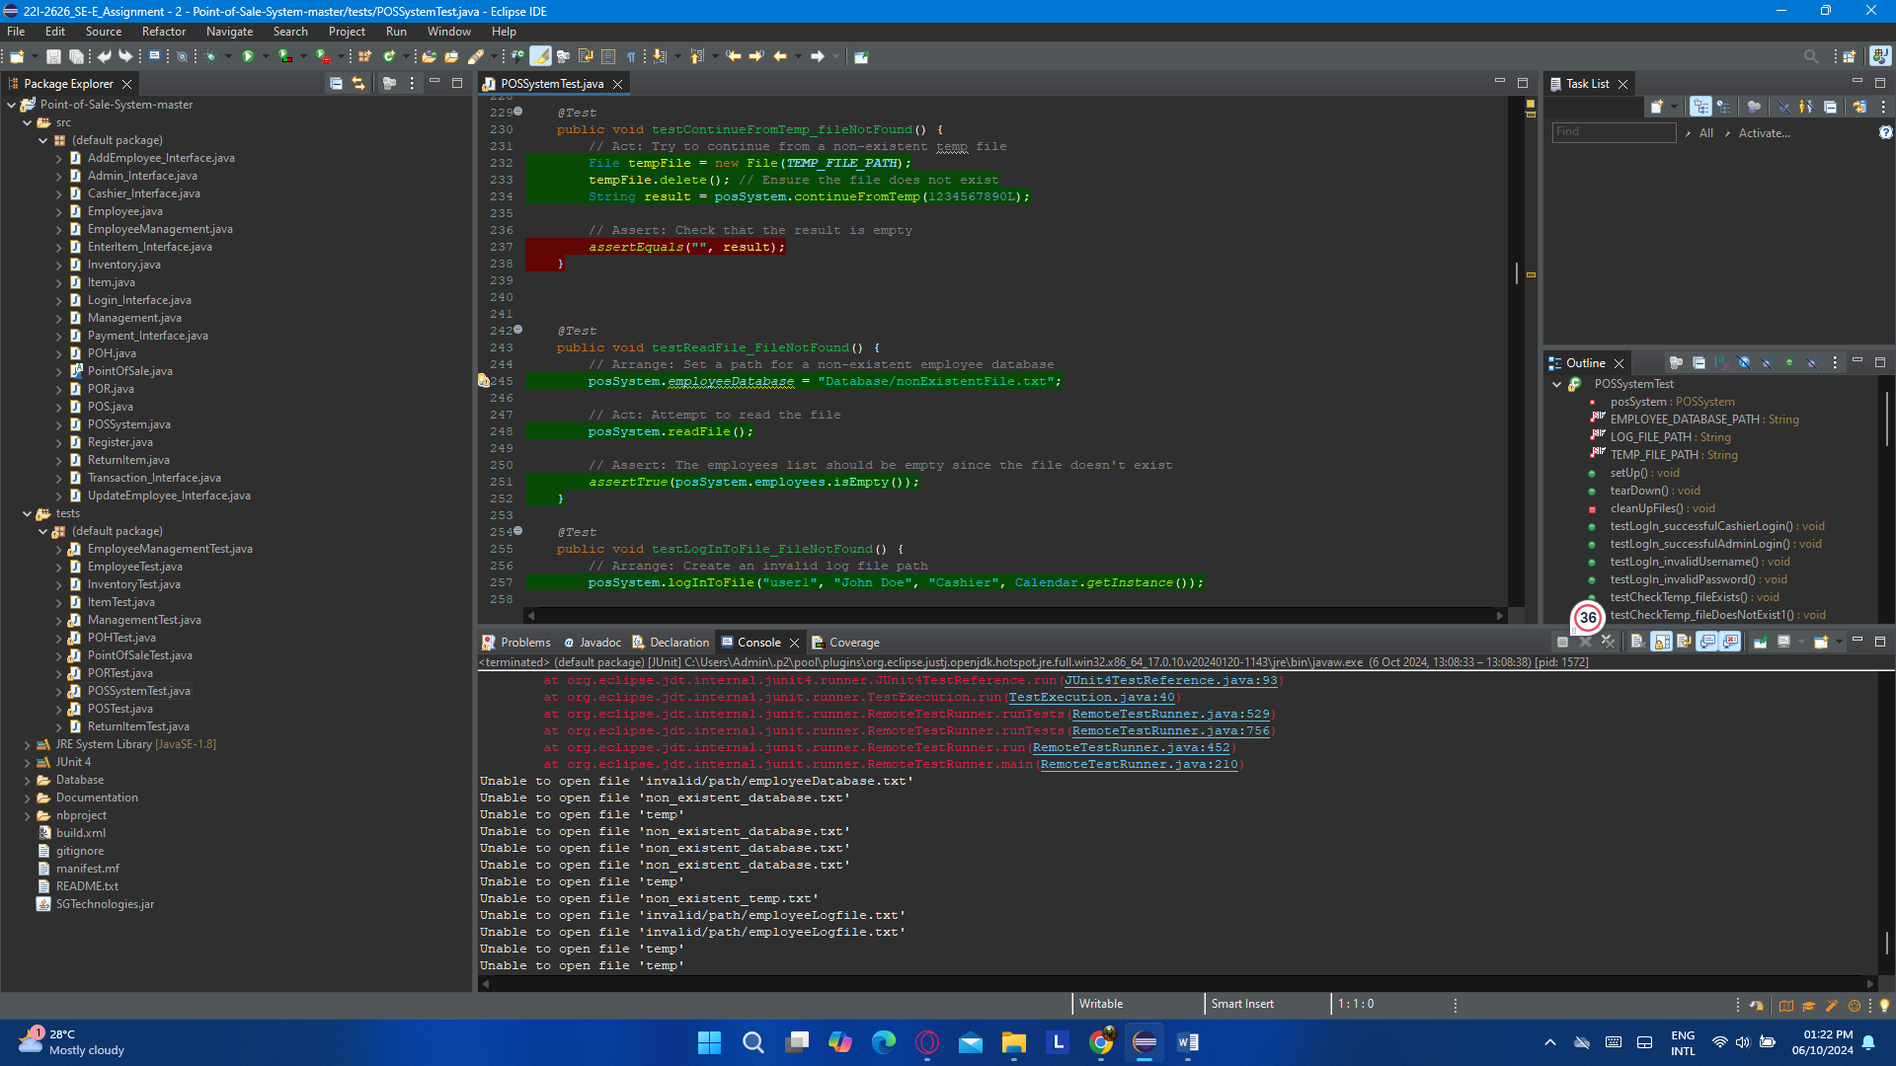

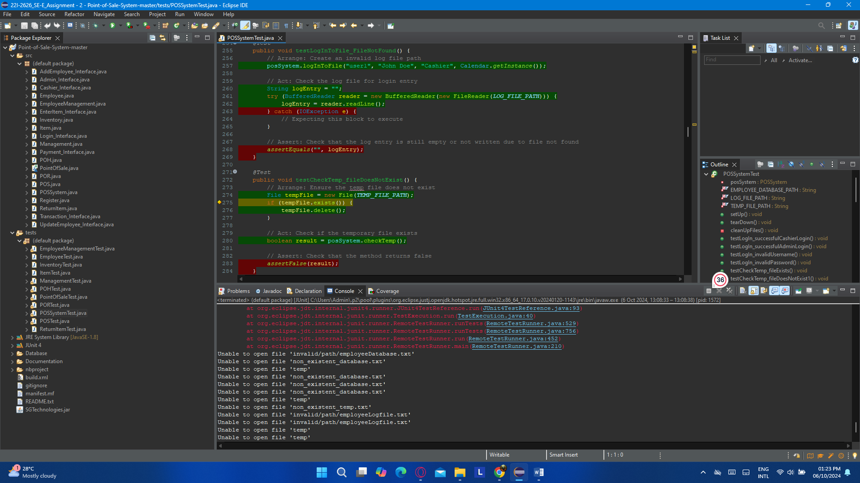

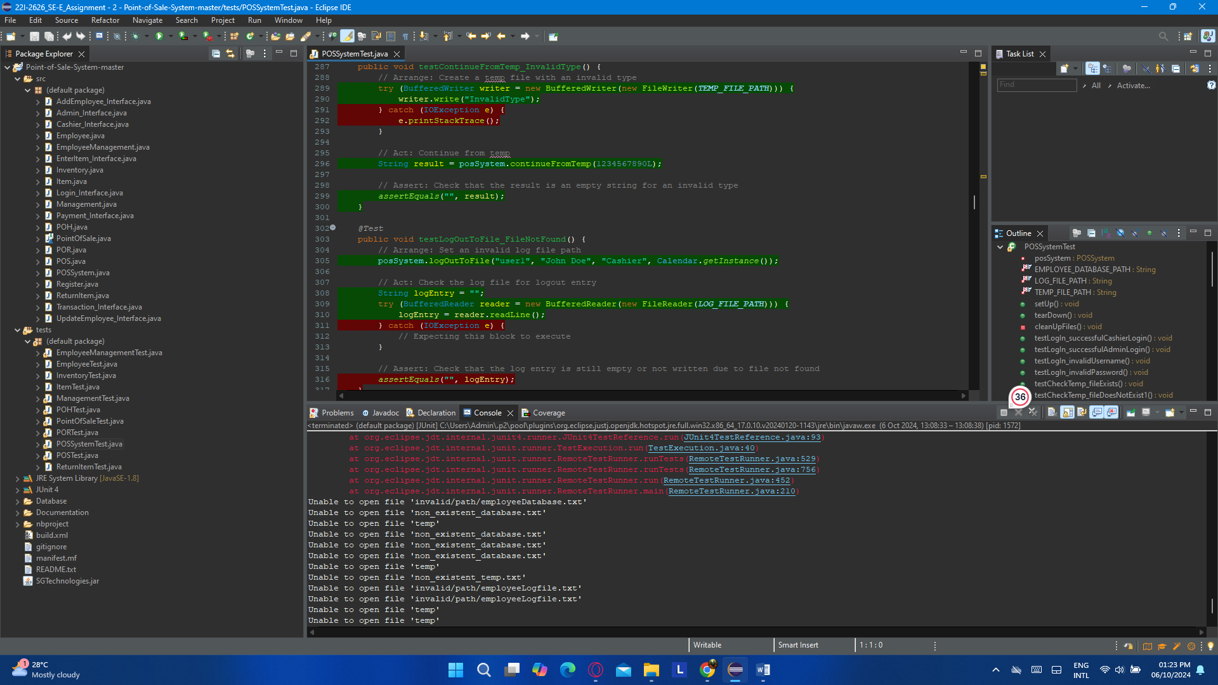

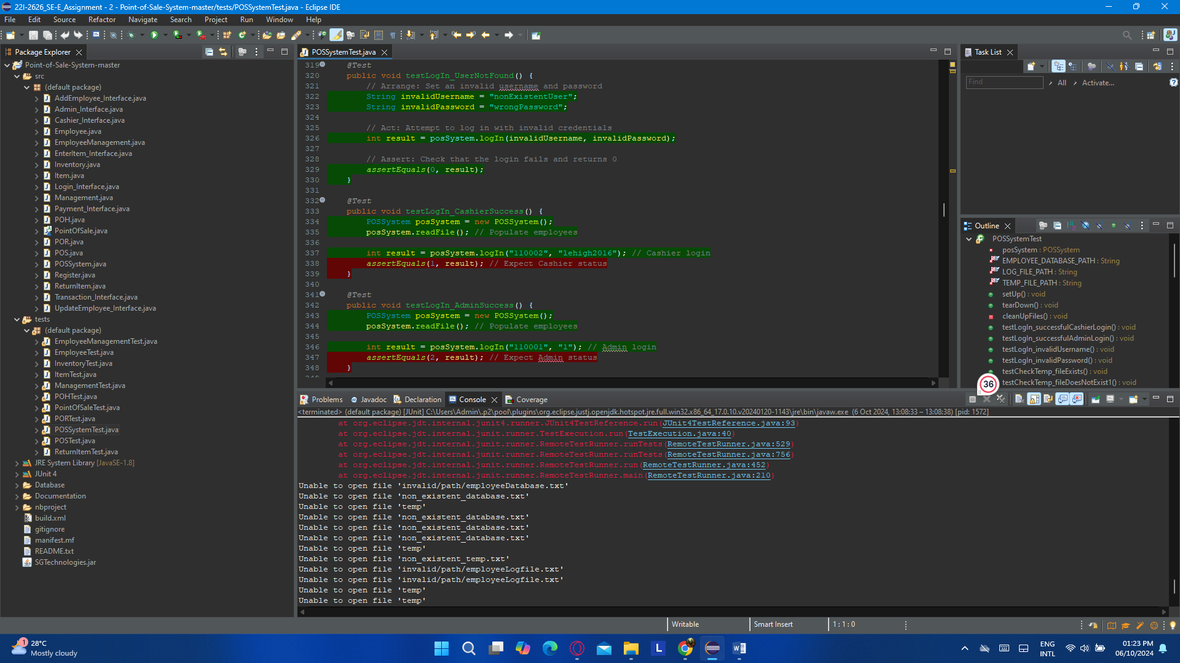

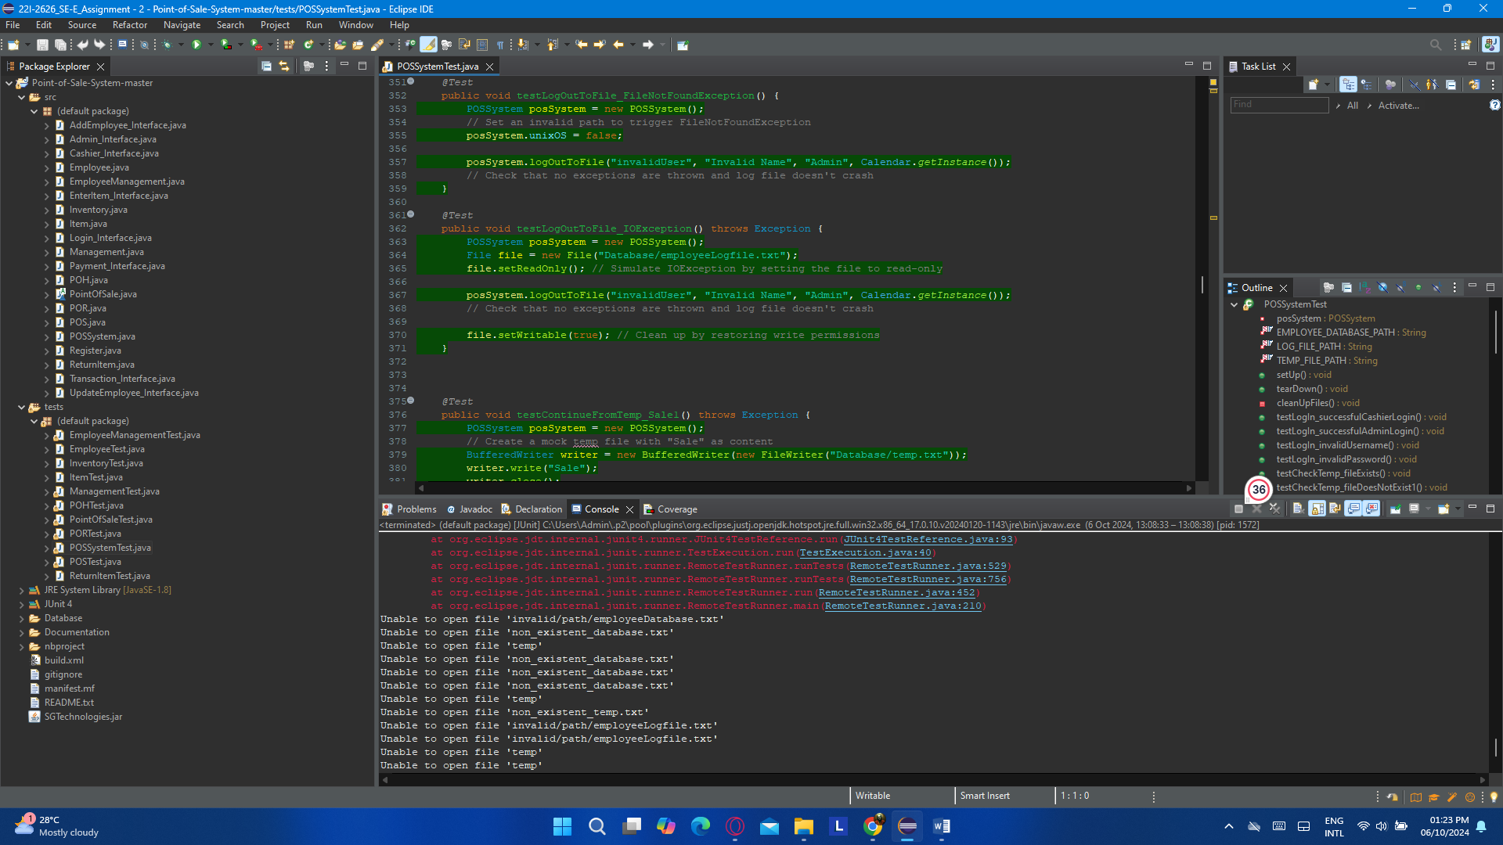

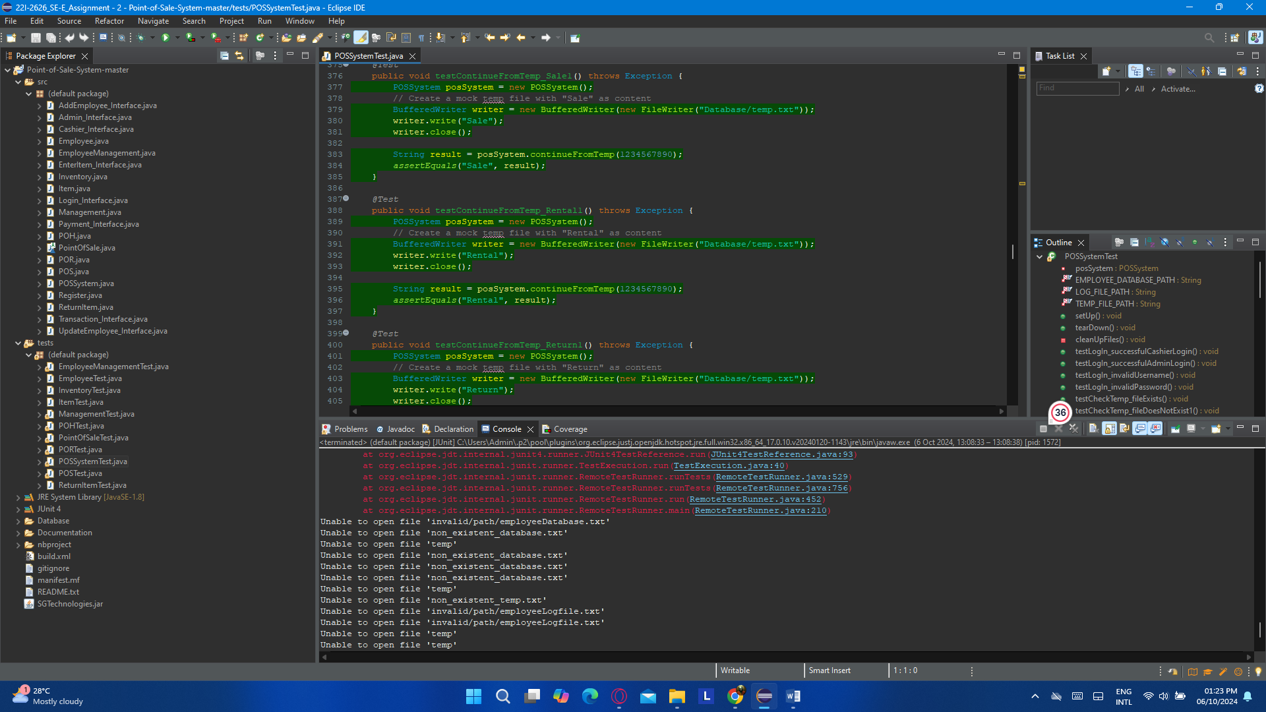

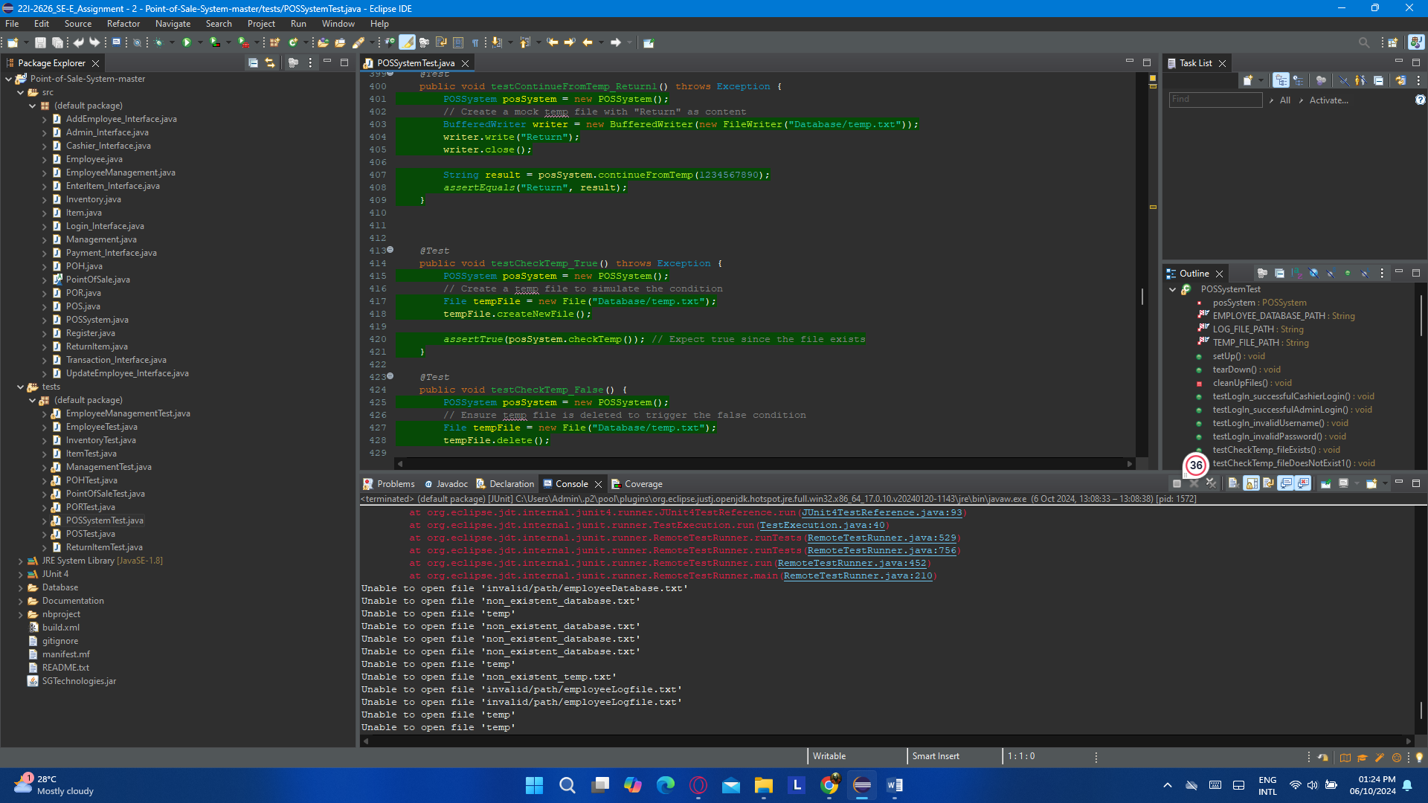

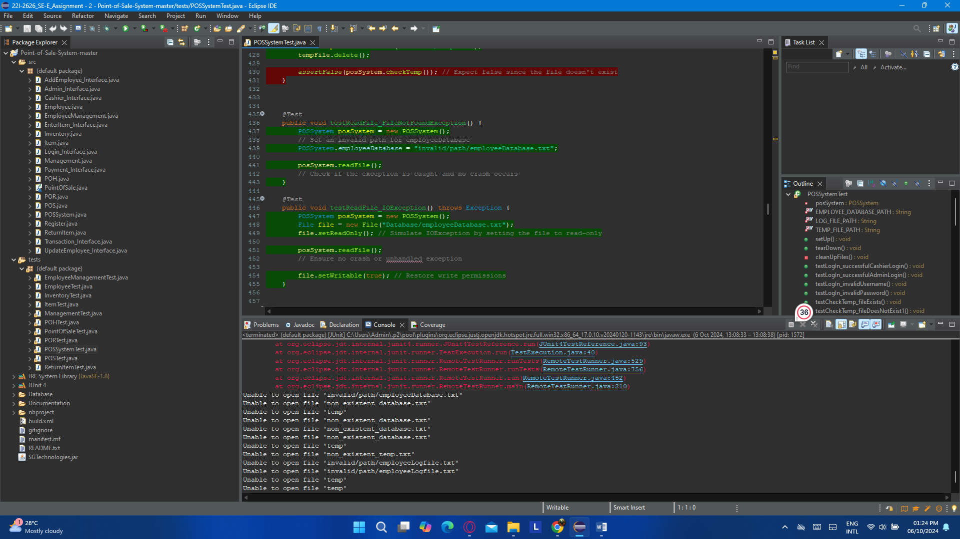

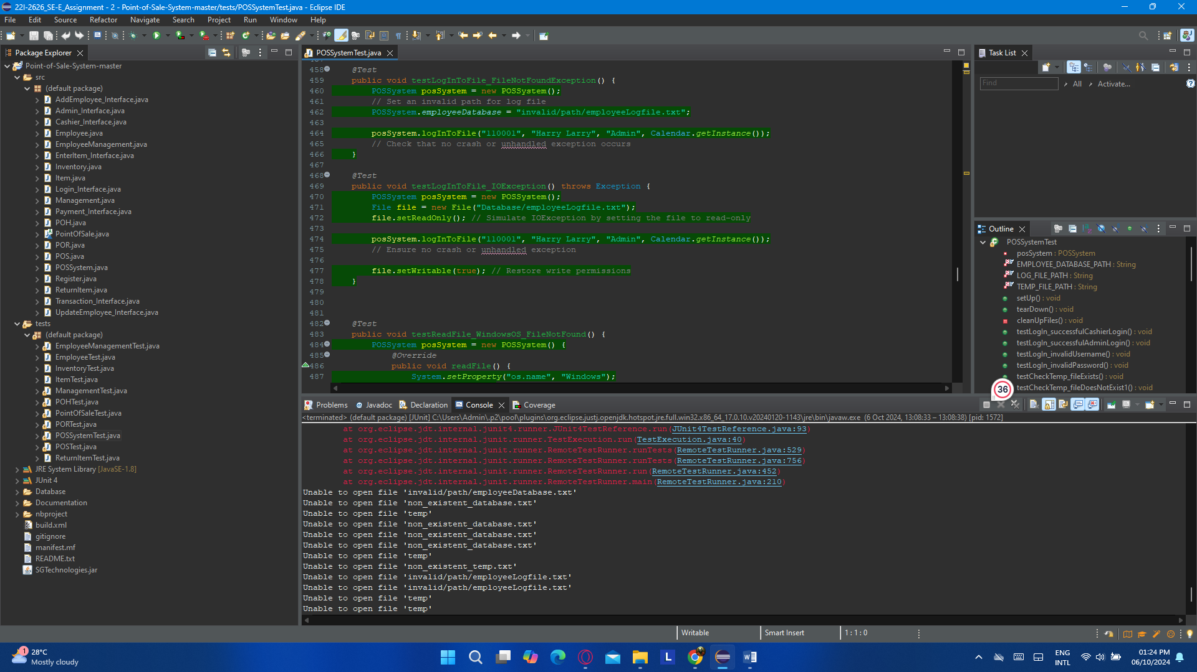

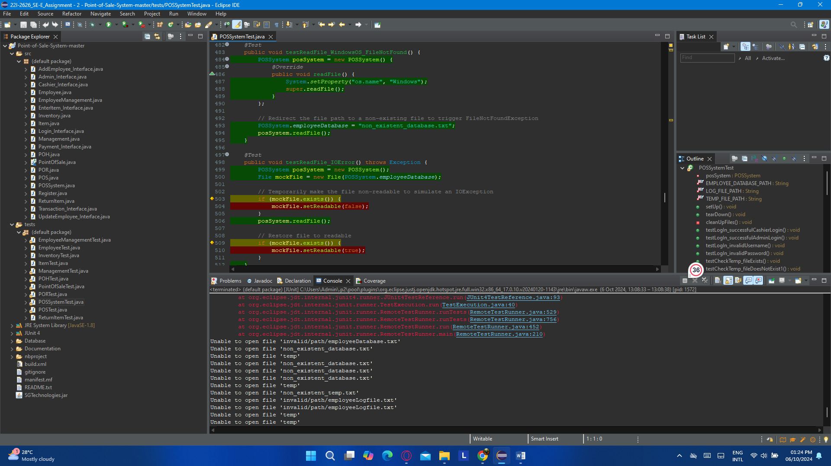

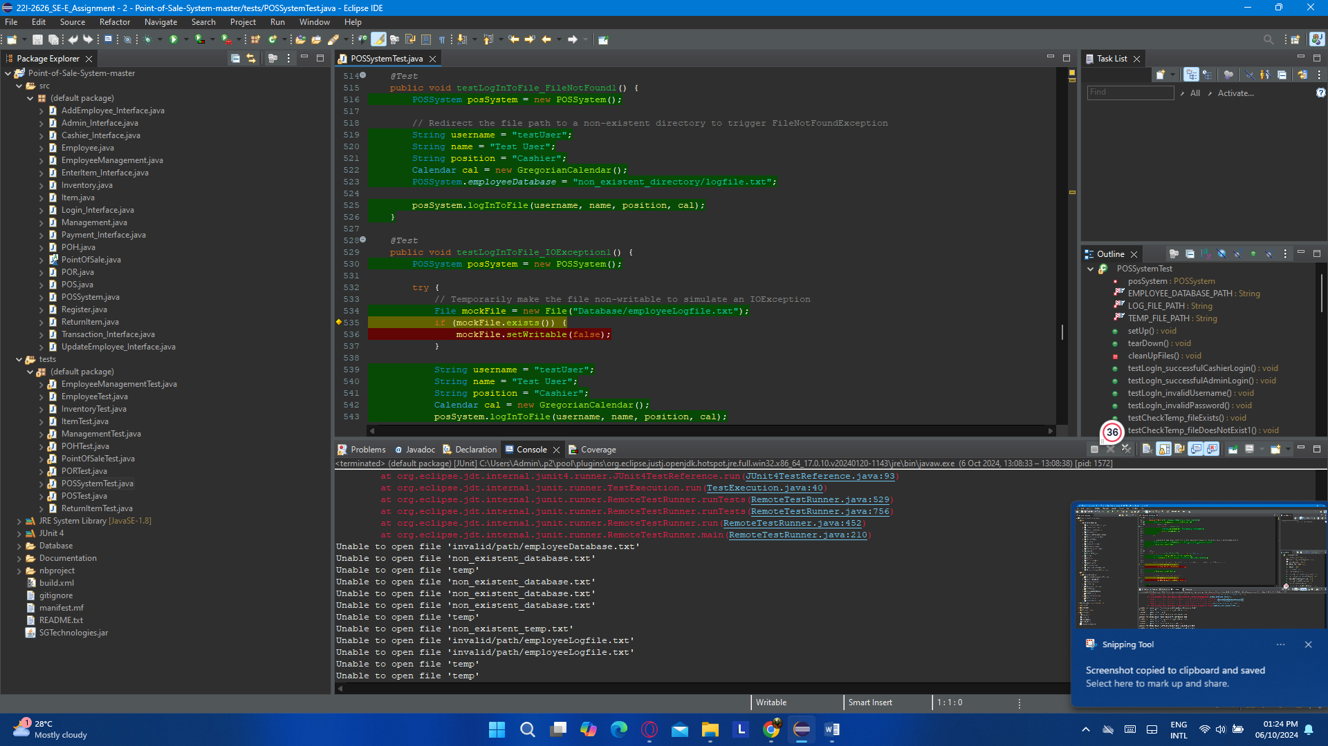

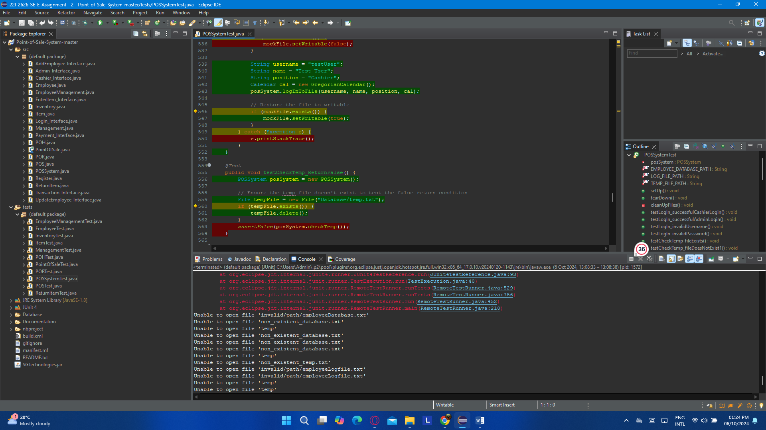

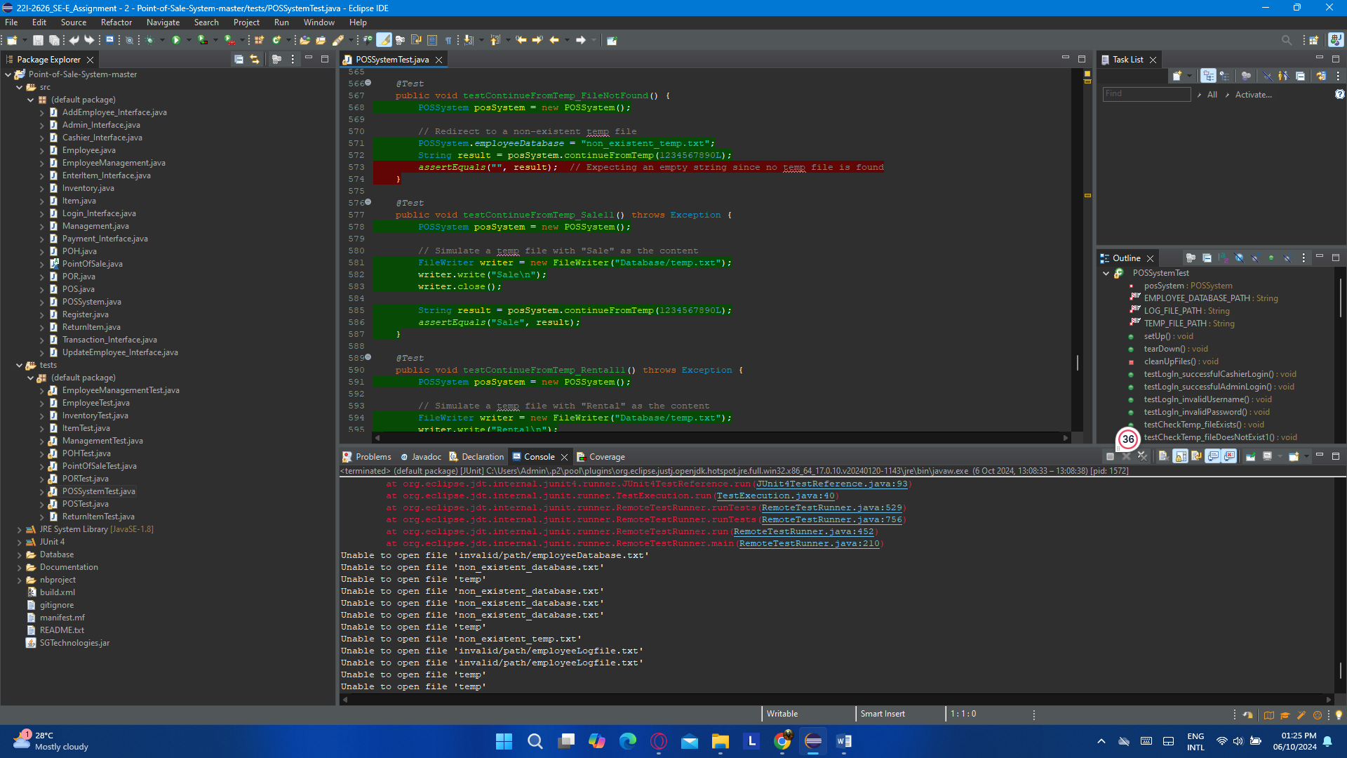

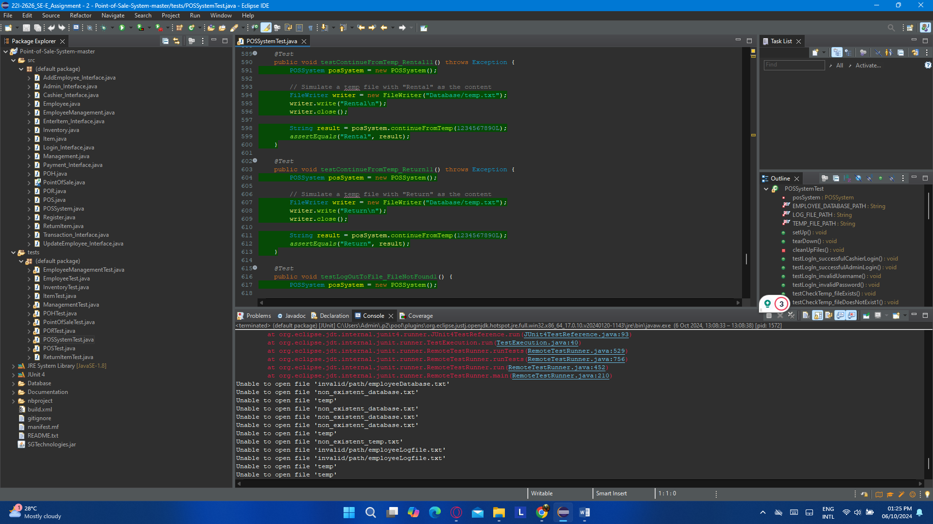

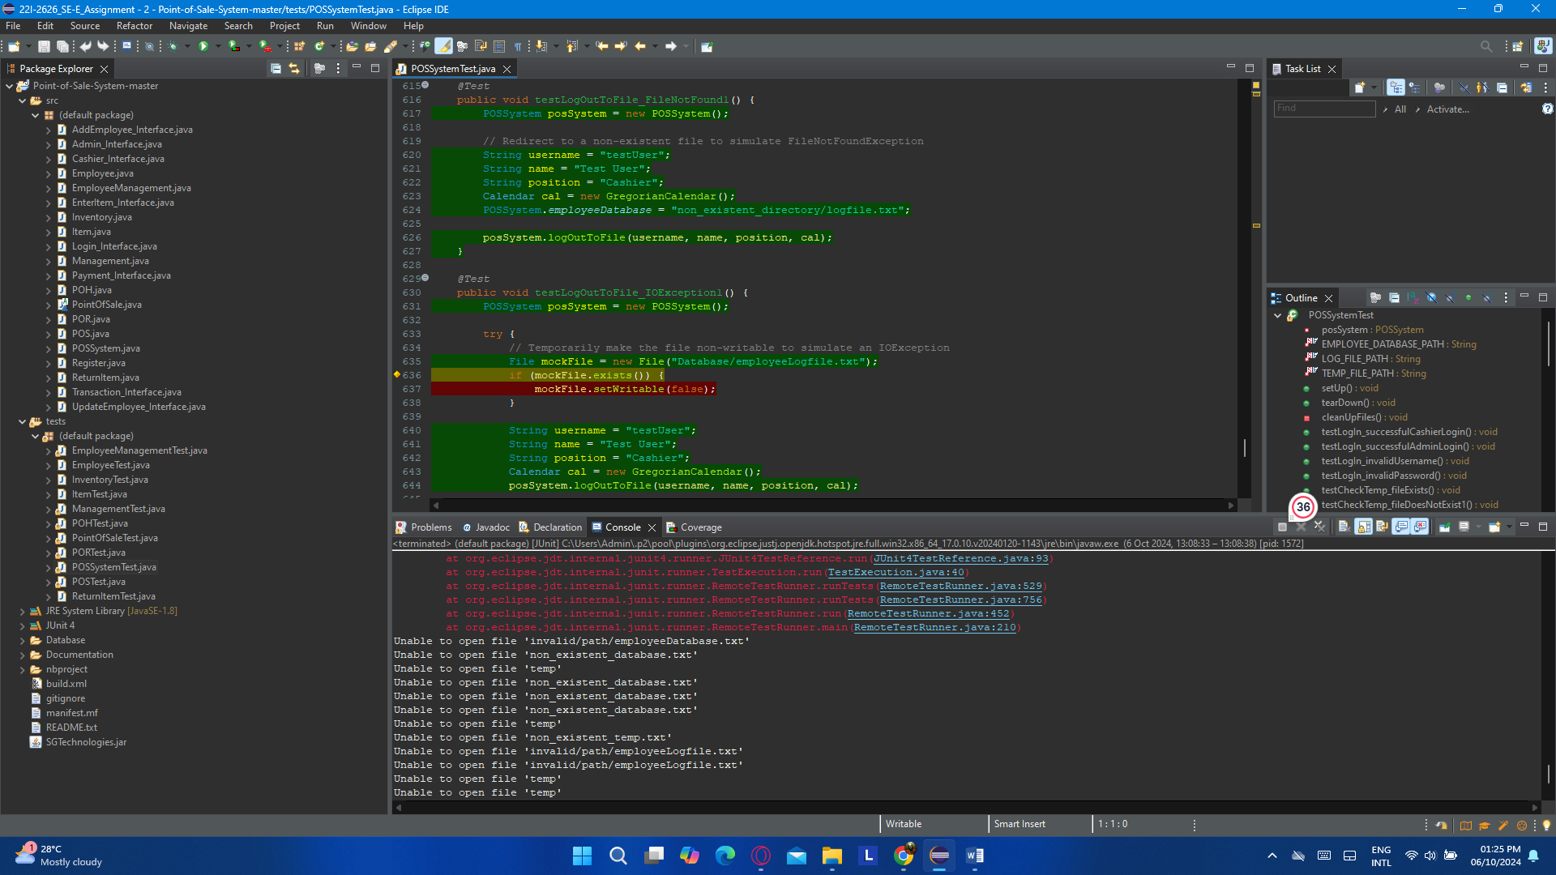

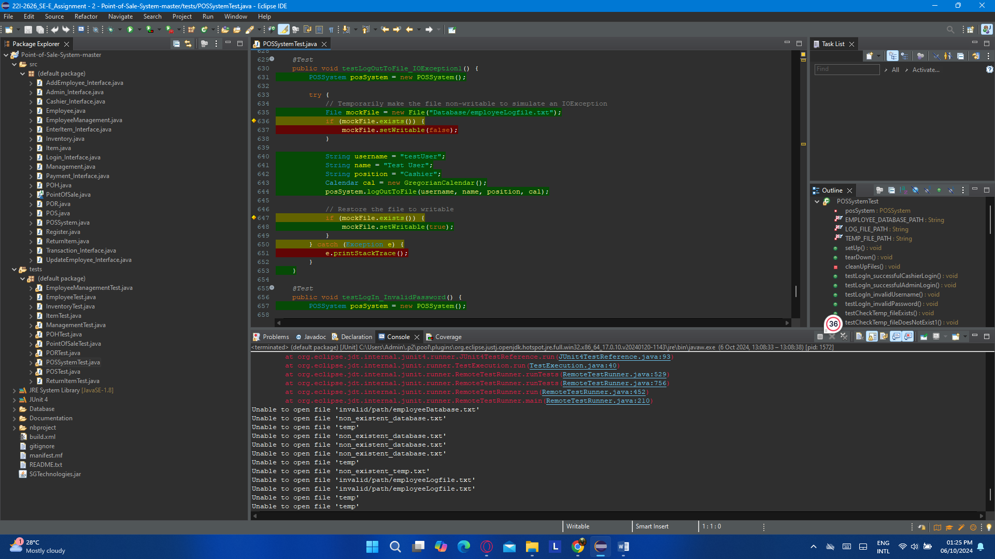

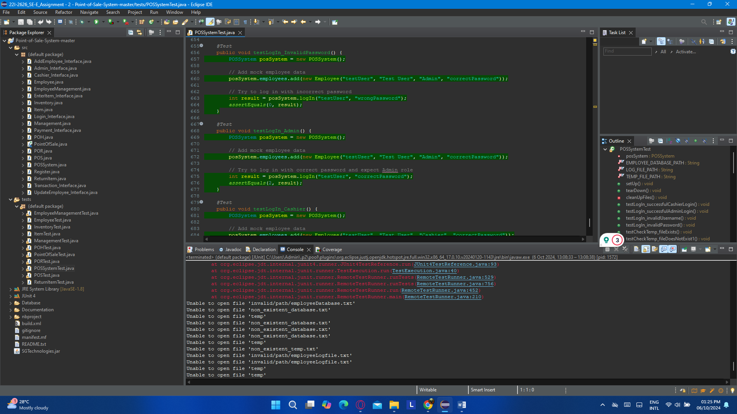

### (j). POSTest.java

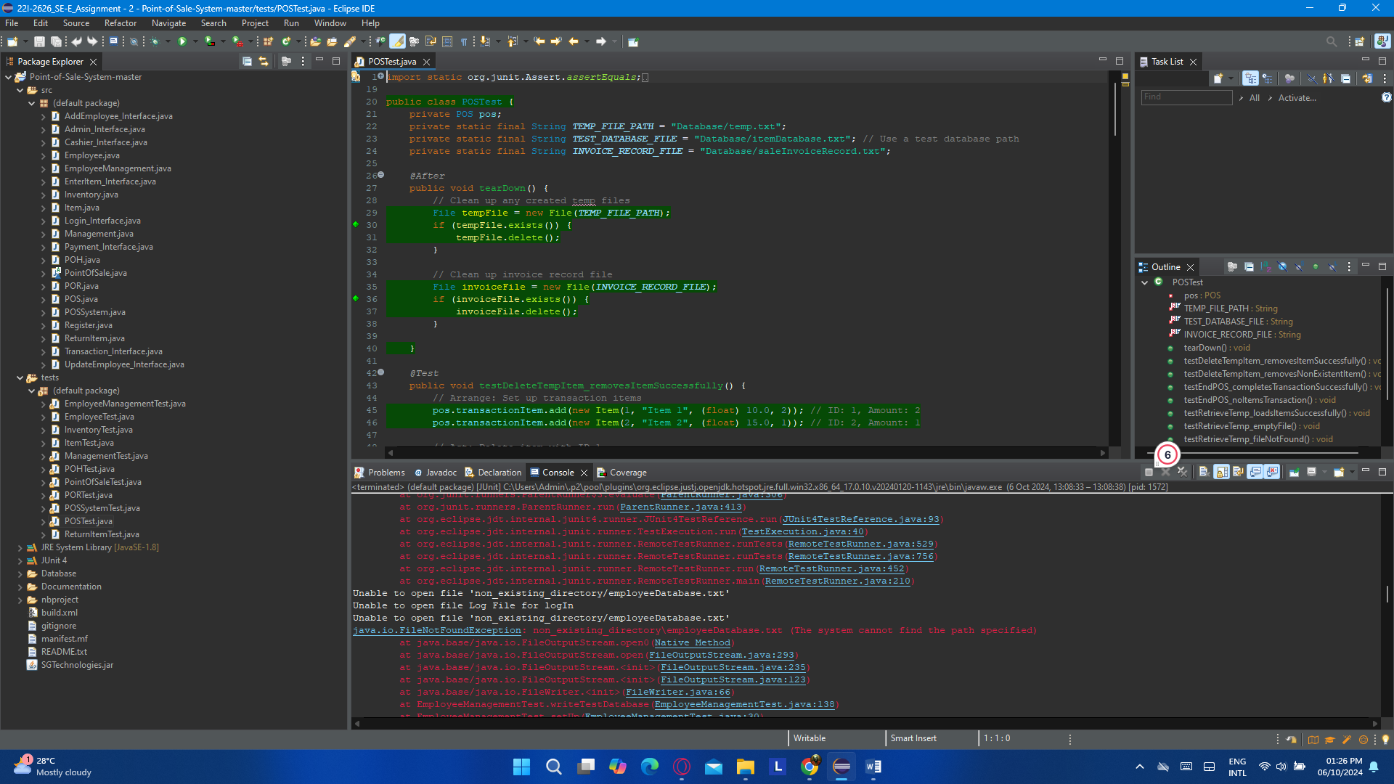

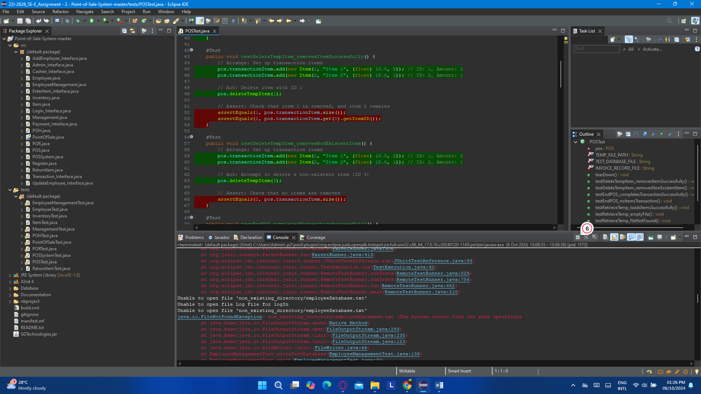

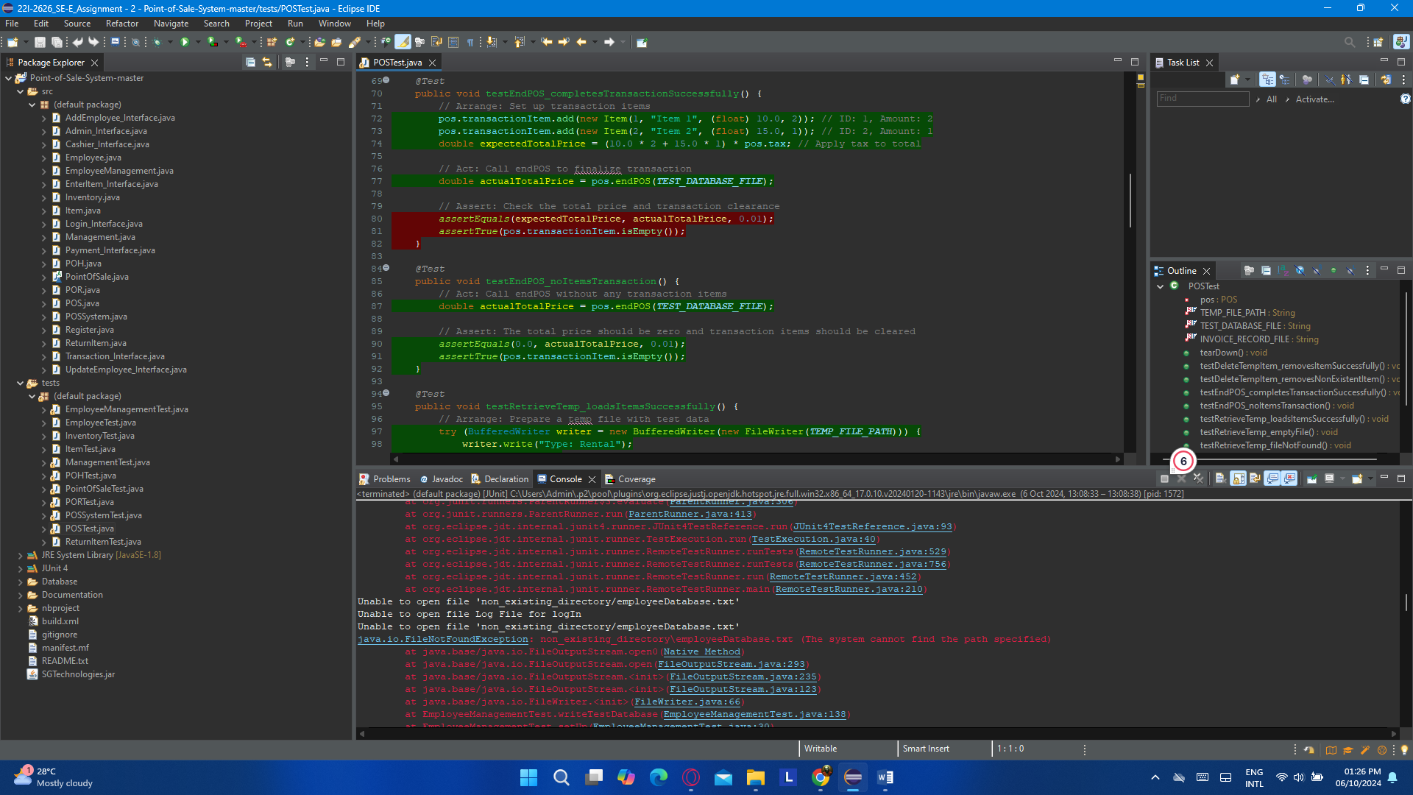

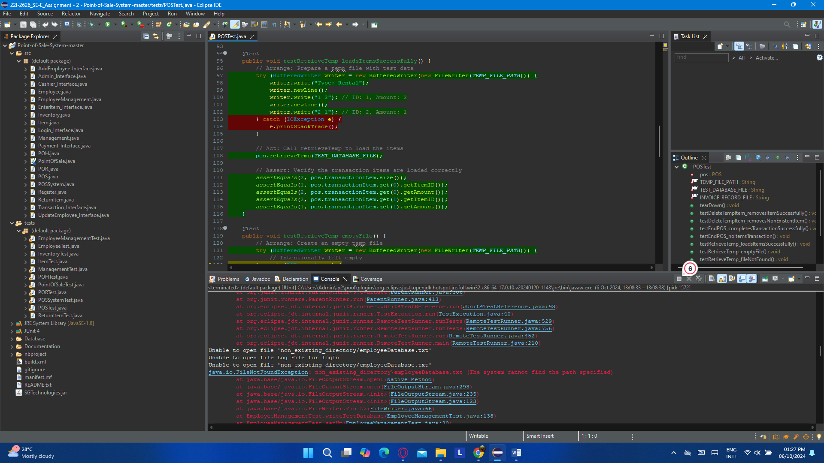

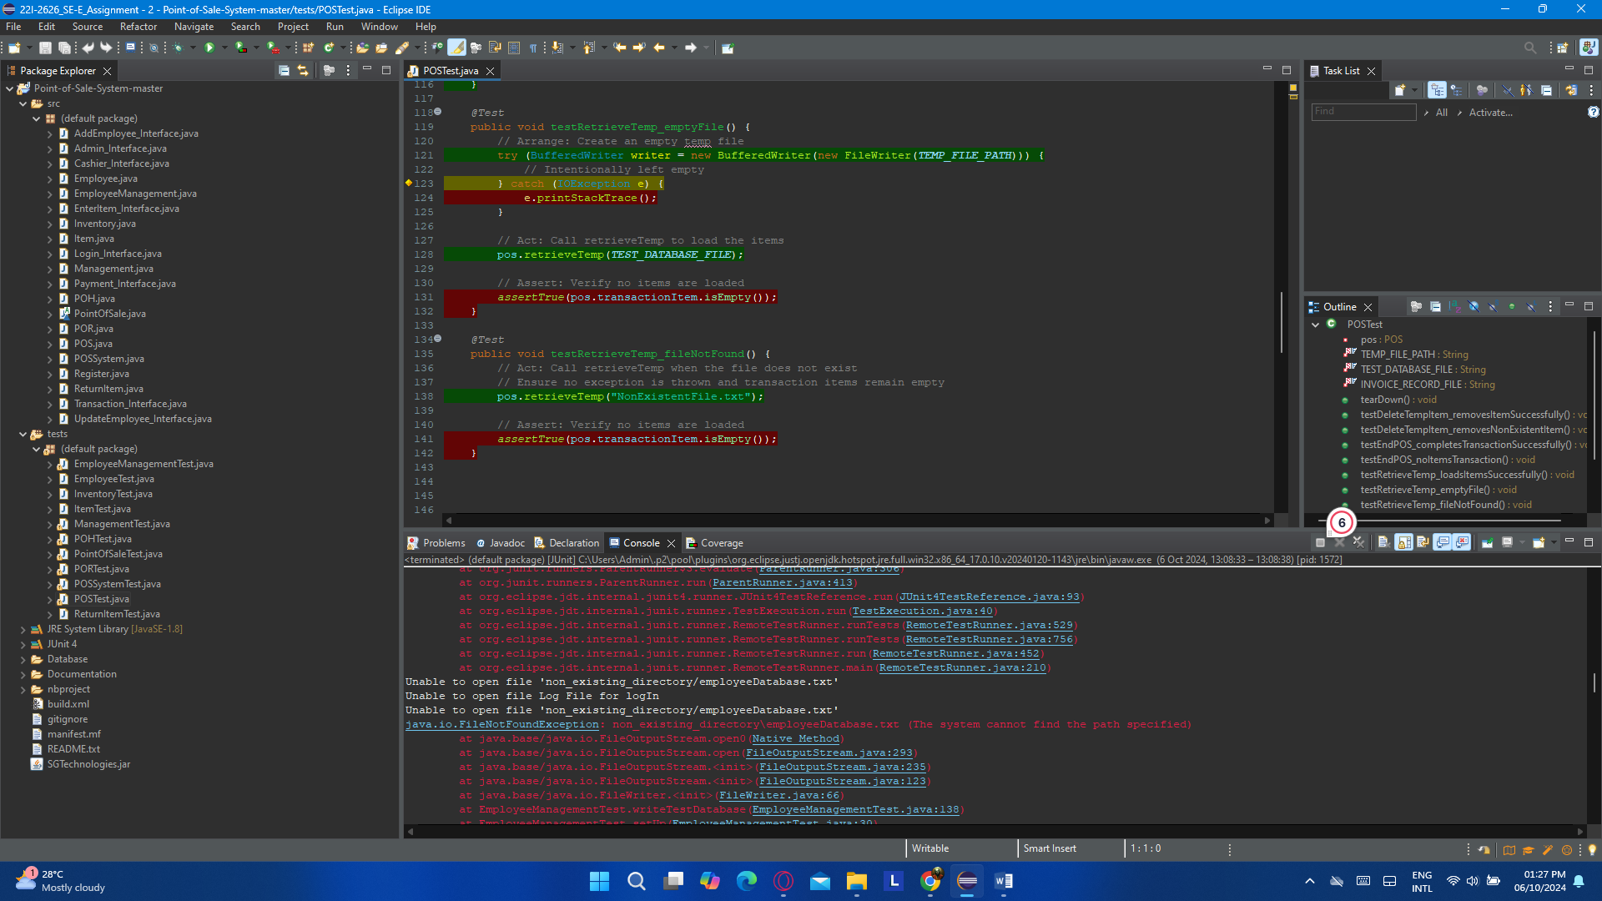

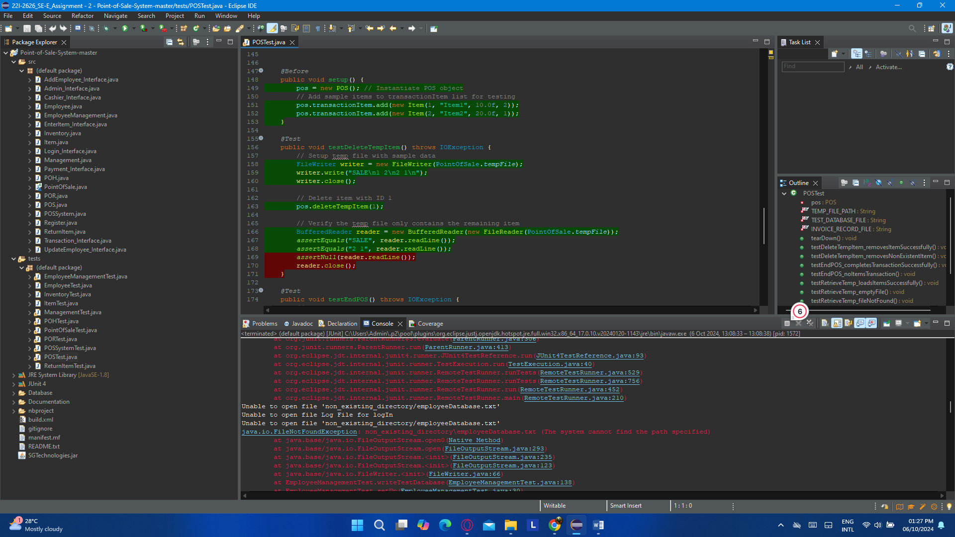

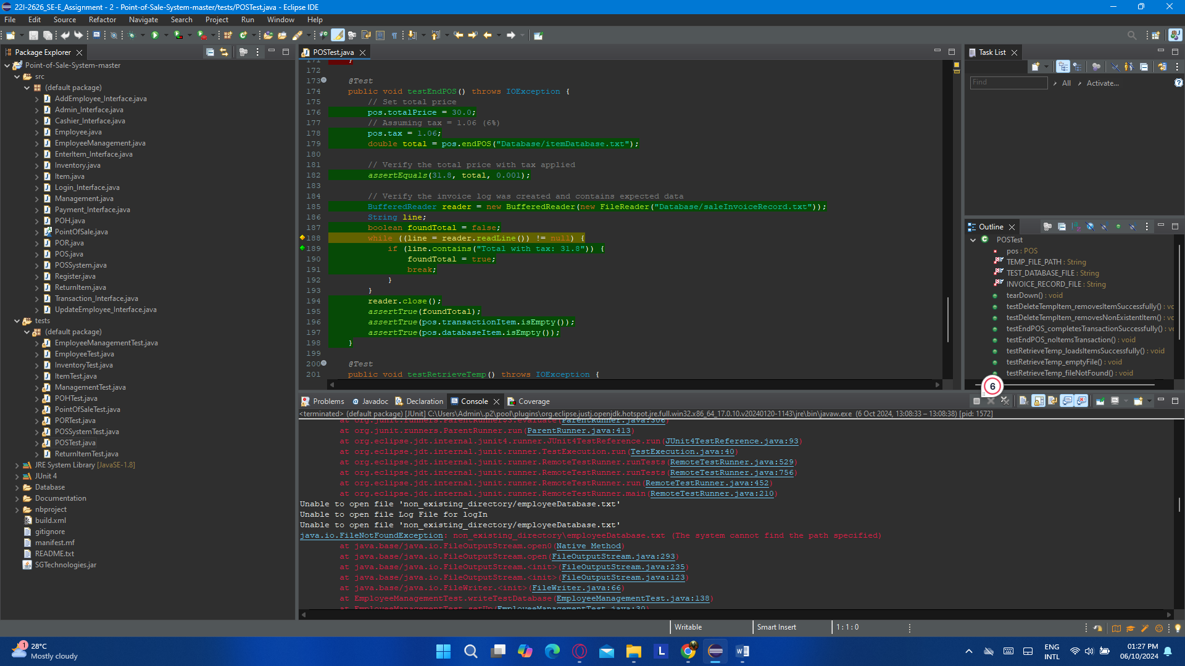

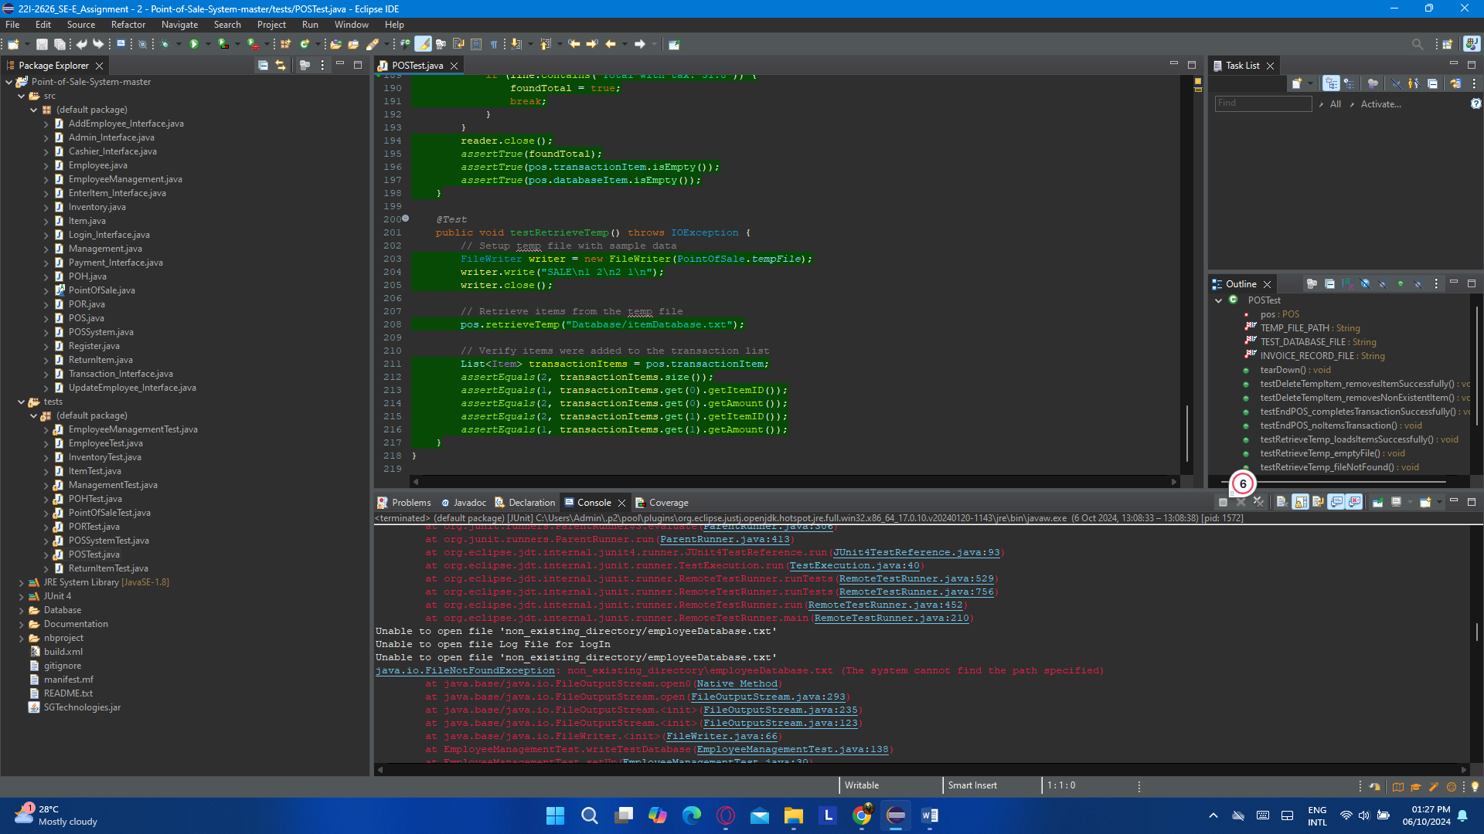

### (k). ReturnItemTest.java

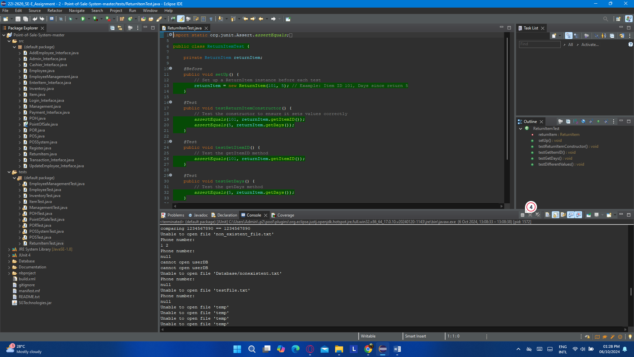

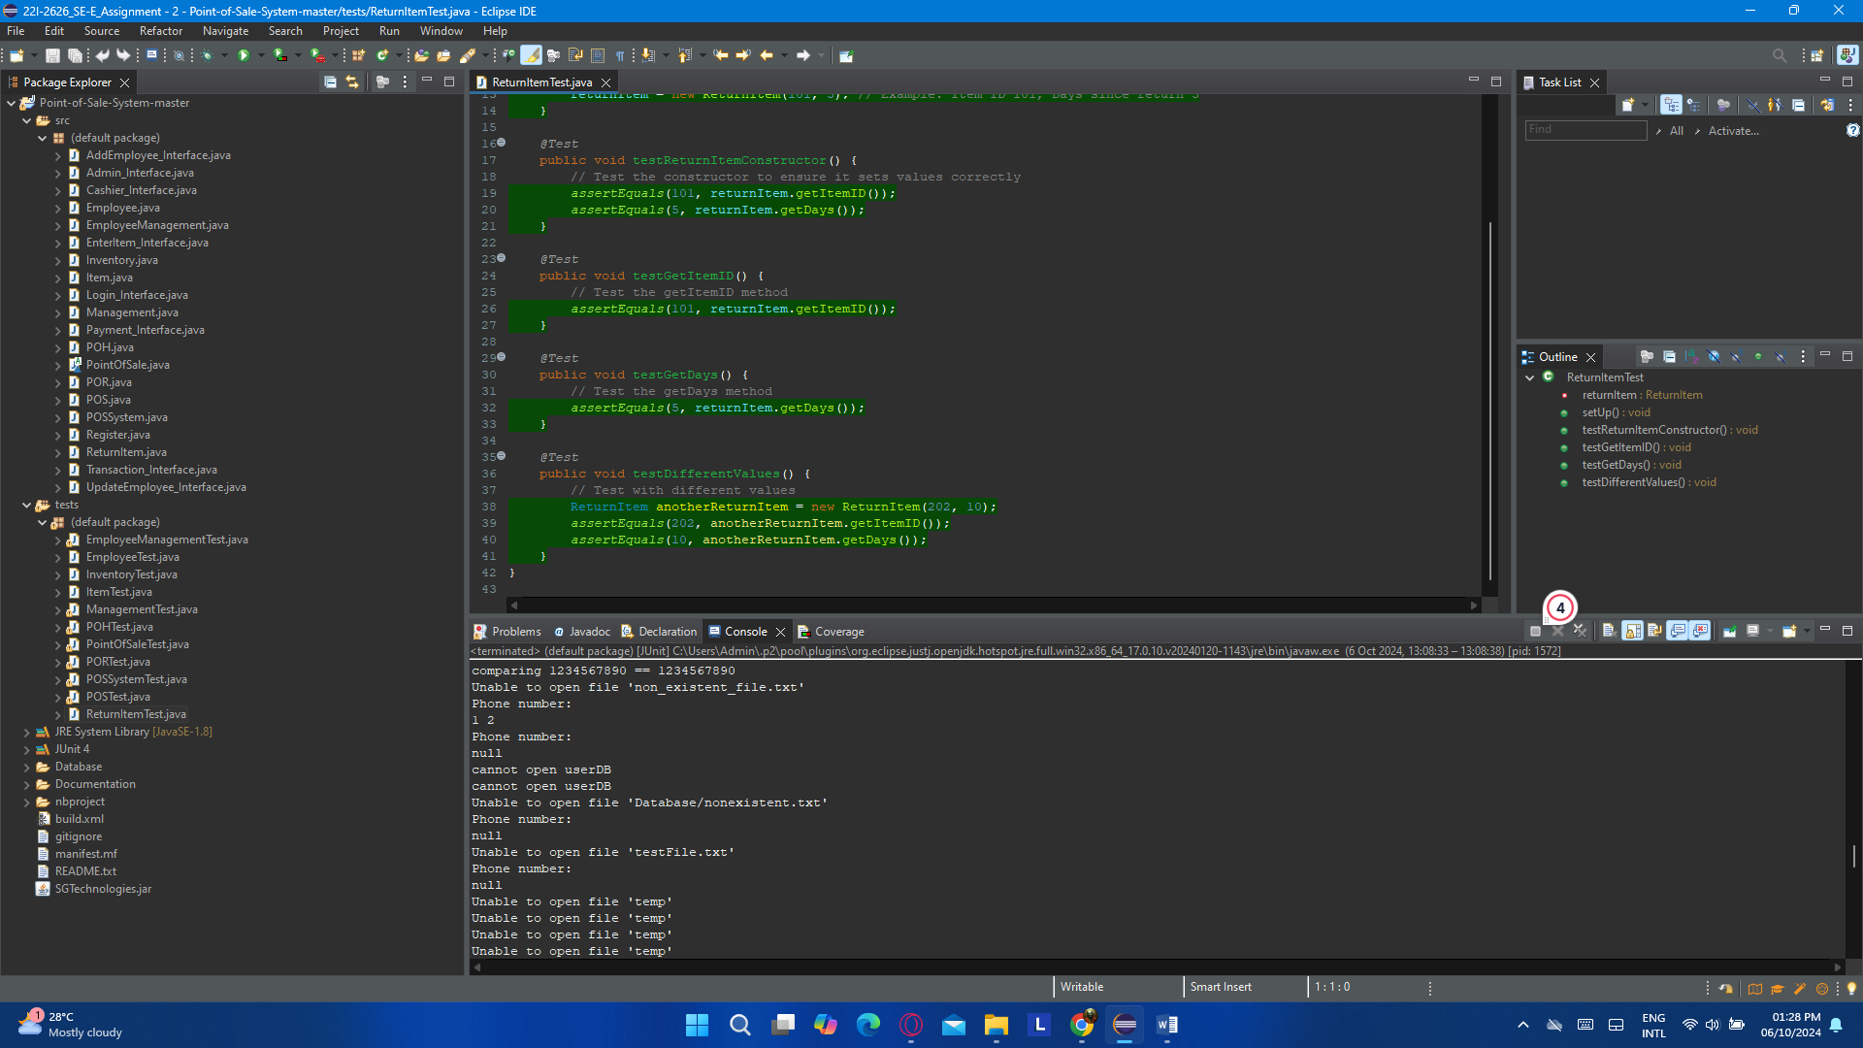

## (ii). Coverage Report

